HEWITT – JOYCE – KEYS Family History

Mark Hewitt Snr and Jane McFadden
Mark Hewitt was born in 1829 at Clonroot, Kilmore, Armagh, Ireland. His parents were Jacob Hewitt and Jane Short.
Jane McFadden was born in 1832 at Portadown, Armagh, Ireland. Her parents were Joseph McFadden and Rebecca Bunner.
Mark Hewitt and Jane Mc Fadden were married on 4th January 1854 in Kilmore, Armagh, Ireland. Both were residents of Clonroot at that time. They embarked from Liverpool on 11th March 1857 aboard the Castilian destined for Australia where they arrived on 10th June 1857. They had their two young daughters with them, namely Rachel and Elizabeth.
Mark obtained a job as a farmer for a Mr J Thompkins at Darebin Creek (Clifton Hill) for a wage of 60/- for 9 months. Later he took up a land grant called Clear Hills at Morang (Mernda) on the Plenty River.
They had a further nine children at Clear Hills, namely Jonathan, Mark, Jane, Marjory, Annie, Joseph, Emily, Rebecca & Francis.
When Mark died age 54 in 1884 Jane and her family sold the farm and moved to Greensborough. There Jane’s son John opened a blacksmith shop in Hailes Street near the Greensborough Hotel. The same blacksmith shop that was still there years later and run by Bert Mitchell.
It is thought that Jane and the family lived at the back of the blacksmith shop and they called it “Clear Hills”. John worked at the blacksmiths until Jane passed away in 1916. The property then went to daughter Francis and her husband Charles Bullen who also was a blacksmith and a farmer. Francis and Charles ran this business until they sold it and moved to Hampton.
Mark Hewitt Jnr and Eliza Joyce
In 1882 Mark Hewitt Jnr (b 1860) married Eliza Joyce (b 1864). Mark was born at Janefield and Eliza at Morang. Eliza was the child of Mary A’Hearn and Thomas Joyce.
They had two daughters, Amelia (b 1883) and Nellie (b 1885) at Yarrambat.
Mary A’Hearn and Thomas Joyce
Mary A’Hearn and Thomas Joyce were married at St Monica’s Roman Catholic Church at Warringal (Heidelberg) on 3rd July 1854. Mary unfortunately died in 1876 aged 44.
Thomas Joyce claimed to be born in Hobart Town, Van Diemen’s Land in 1824 and Mary A’Hearn in Callan, Kilkenny in 1828. Thomas’ parents were Joseph Joyce, bricklayer and Louisa Yates and Mary’s parents were Patrick A’Hearn and Ellen Murphy.

Eliza Joyce and Edward Keys
When Mark Hewitt died in early 1890, Elizabeth married Edward Keys later that year. Eliza had a further six daughters between 1891 and 1904 with Edward namely: Zillah Maud b1891, Edith Emily b1893, Ethel Blanche b1895, Mabel Muriel b1898, Lila Olive Alexandra b1902 and Myrtle Daphne b1904.

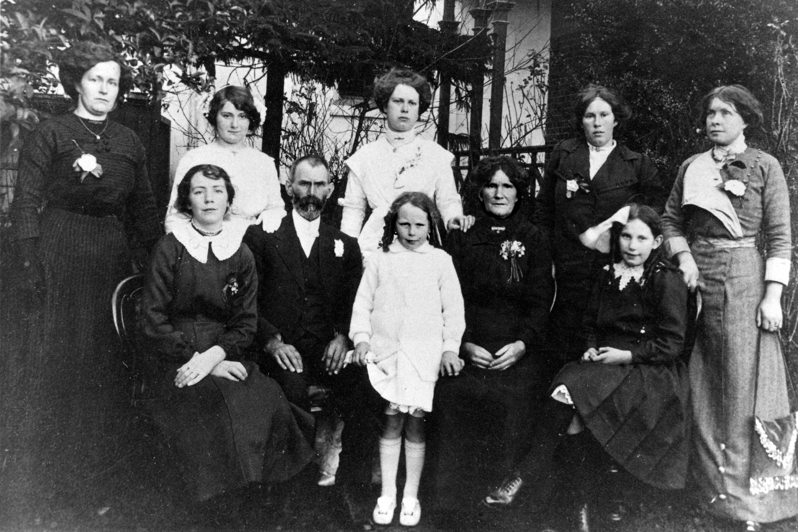
The combined Hewitt/Keys family on 21/08/1912 at Edith’s wedding at the Old England Hotel Heidelberg.
Back row from left: Nellie Butterworth (nee Hewitt), Ethel Keys, Edith Tyrell (nee Keys), Zillah Mehegan (nee Keys), Amelia Roy (nee Hewitt).
Front row from left: Mabel Keys, Edward Keys, Myrtle Keys, Eliza Keys (nee Joyce), Lila Keys.
Amelia Hewitt and William Roy
Amelia Hewitt married William Roy in 1904 and they lived in Main Street in a wonderful old brick home on the site that was later Tom Vickers Pharmacy. Amelia and William had two girls Vera Daphne (b 1905) and Hazel Lorna (b 1908). Both Vera and Hazel went to Greensborough State School No. 2062.
Hazel married Frank Keith Hills in 1933 and was the mother of Lesley (Hills) Hooper. Lesley married the late Raymond Hooper from Briar Hill and still resides locally.
Vera married Joseph LeRoy Poulter in 1927 they had a son Ramon and daughter Lorraine (Poulter) Coates. They lived just up the hill in Main Street from the Hills. Lorraine married Frank Coates and lived most of her life in Stubley Court, Greensborough, later moving to a retirement village in Kilmore where she regrettably passed away in 2014.
Nellie Hewitt and Frederick Butterworth
In 1905 Nellie Hewitt married Fred Butterworth b 1879. They had a son Walter Mark in 1906 and daughter Edith May b 1909.
Walter married Joy Williamson they had Geoffrey and Jennifer. Both Walter and Geoff ran the Authorised Newsagencies in Main and Grimshaw Streets, Greensborough for many years.
May married Reg Smith they had two boys Warren and Gary. Their business is “Gary and Warren Smith Motors”.

