Naming of Barclay Park.

Following a hard fought battle it was a win/win situation for the local community when Banyule Council reversed its decision not to see the park which was once known as Mc Kenzie Court Park ( corner of Plenty Lane and McKenzie Court) sold for residential development. Fully supported by Colin Brooks MP, the local people fought an active campaign and were rewarded on November 7th 2015 with a ceremony renaming the park Barclay Park after the original owners of the land .

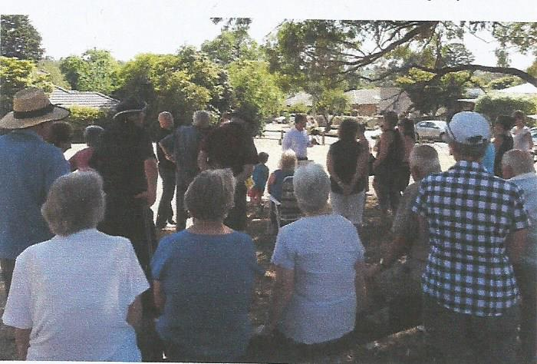
Colin Brooks MP addressing the protesters early 2015.
With smiles on their faces, a good crowd of local people gathered to the naming ceremony on Saturday November 7 2015 to be part of the occasion. There were none prouder that the Barclay family for whom the park is now named.
Eric Barclay in his short speech told of his life running around this park as a youngster, and that his mother and father would be so proud now for the result of the ceremony. Eric went on to that the Council for being far sighted and leaving the park for the coming generation of children to enjoy. He also thanked the crowd for their support, especially those who had travelled as far as Heathcote for the occasion.
The Ceremony was conducted by Mayor of Banyule Cr Craig Langdon ably assisted by the ward Councillor Mark Di Pasquale.
As well as a plaque, a tree was planted to mark the occasion.

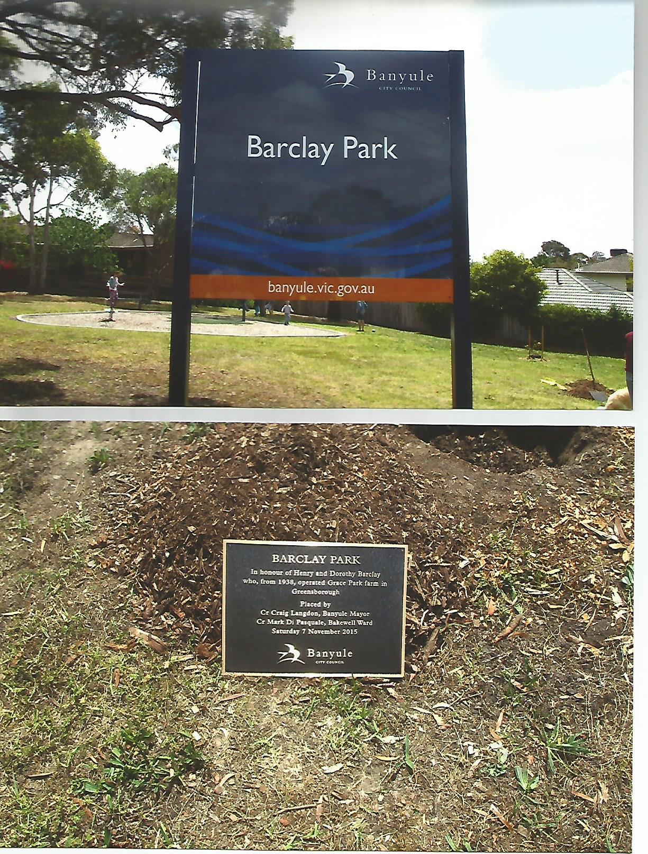

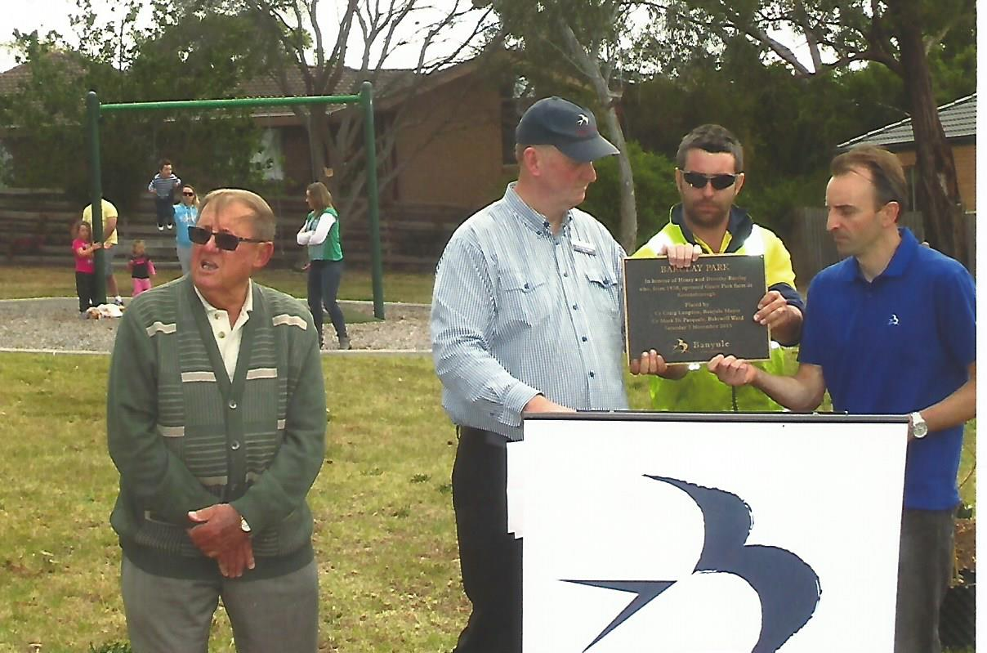
Eric Barclay, Mayor Langdon, Council arbours’ and Cr Mark Di Pasquale holding the plaque. November 7 2015

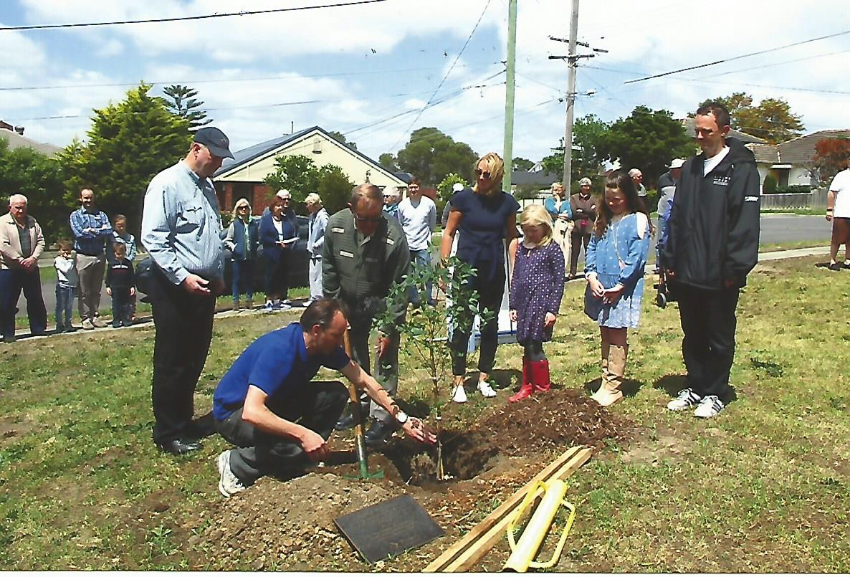
Councillor Di Pasquale planting the tree November 7 2015
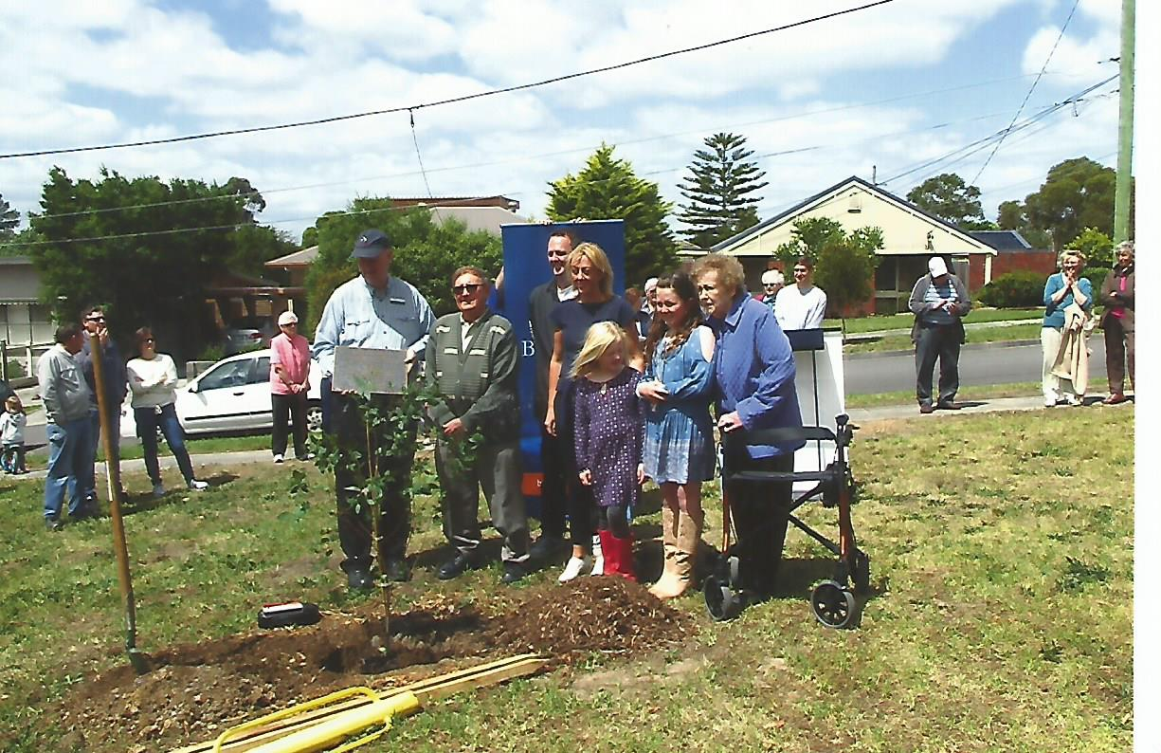
Proud Barclay family with Mayor Langdon around the tree planted in honour of their parents and all that the continuance of the reserve for a children’s play ground.

