Nurses. Rosie Bray

1914-1918

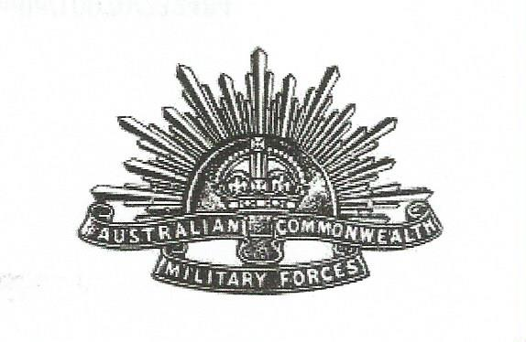

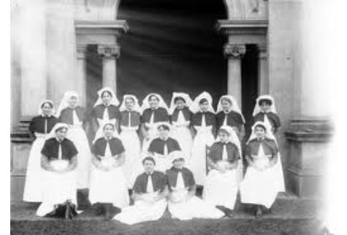
Group of World War One Nurses overseas.
When World War 1 (WW1) began in August 1914, the general opinion in Australia was that the women’s place was in the home. The majority of women did stay at home, but they were not idle. Clubs and groups were quickly formed to knit and provide comfort funds for the troop who had been called to support England, which was home land to many of the population.
However there were professional women who felt drawn to using their skills and joining the overseas fight ‘for freedom’. Most of these women joined the Australian Army Nursing Service which had been formed in 1903.These nurses were made welcome and soon shipped overseas. There were other professional women who were not made welcome. These were qualified doctors, who were thought to be a threat to the male doctors. Undeterred, at least 14 Australian women doctors paid their own fares to Britain and joined the services from there.
Because of their shear grit and dedication Australian Nurses soon were greatly admired that they were received with gratitude at all nursing stations in the battle fields.
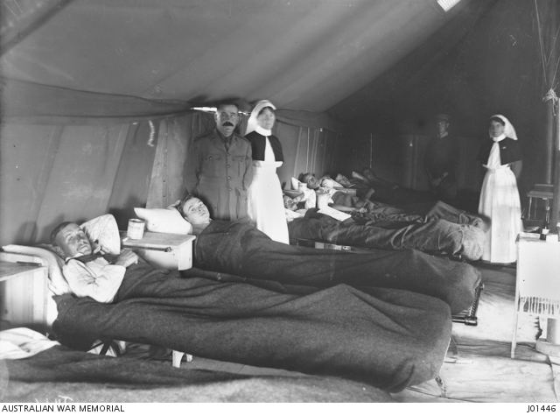
Australian nurses in a draughty tent ward in France 1915

In 1916. Jack. Caddigan and James. A. Brennan wrote a song which soon became a popular wartime song, and every Australian always thought that the song was written for the Australian nurse.

The Red Cross Nurse.
Chorus.
There’s a rose that grows in no-man’s land
And it’s wonderful to see.
Though it’s sprayed with tears, it will live for year
In my garden of memories.
It’s the one red rose the soldier knows
It’s the work of a Master’s hand
‘Neath the wars great curse stand the Red Cross Nurse
She’s the rose of no-man’s land.
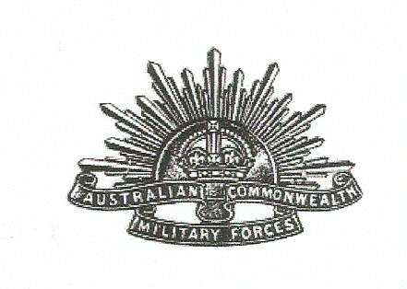
Edith Caroline Munction Miller, although records show that she was born in Bendigo, gave her address as Eltham when she enlisted on August 10 1915 at the age of 33 years. Prior to showing her desire to serve in WW1, Nurse Miller was working at a private hospital after serving at the Royal Melbourne Hospital from 1910-1913. Records are somewhat ‘muddied’ as to the embarkation for overseas service. One official record show that Nurse Miller embarked from Sydney, New South Wales, on board R.M.S. Kashgar on September 2 1916. Brian Membrey compiling his book “ The Great War ,Women in Uniform” writes that Nurse Miller embarked from Port Melbourne on board R.M.S Morea on August 24 1915. She was assigned to number 4 Auxiliary Hospital in Heliopolis, Egypt, spending a period of time there hospitalized with mumps before transferring to England in August 1916 to Number 1 Australian General Hospital. Nurse Miller proceeded to Wimereux France with Number 2 AGH on February 28 1917. She returned to England for return to Australia on December 27, arriving back in Melbourne on February 12 1918.
Edith Caroline Munction Miller was honoured for her loyal service by being awarded the 1914-1915 Star, British War Medal and Victory Medal.
Below. 1914-15 Star. British War and Victory Medal.
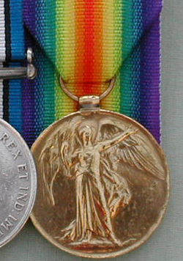
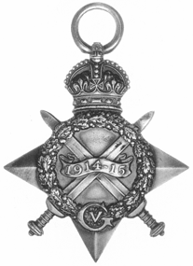
Nurse Miller served at number 11 Australian General Hospital in Caulfield, being discharged on November 25 1918, and continued to work there until 1921, when she married Norman Griffith. She died in 1963 aged 89 in New Zealand.
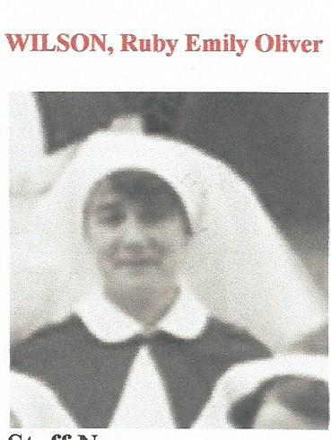

Ruby Emily Oliver Wilson was born in Whittlesea although at the time of her enlistment on October 31 1916 she gave her address as Kerrisdale Victoria. Nurse Wilson had completed her three years training at the Melbourne General Hospital and was 31 years of age.
Nurse Wilson joined the hospital ship HMAHS Kanowna on November 8. 1916 and completed two round trips as a staff nurse before re-embarking for England December 22 1917 on HMAT Ulysses.
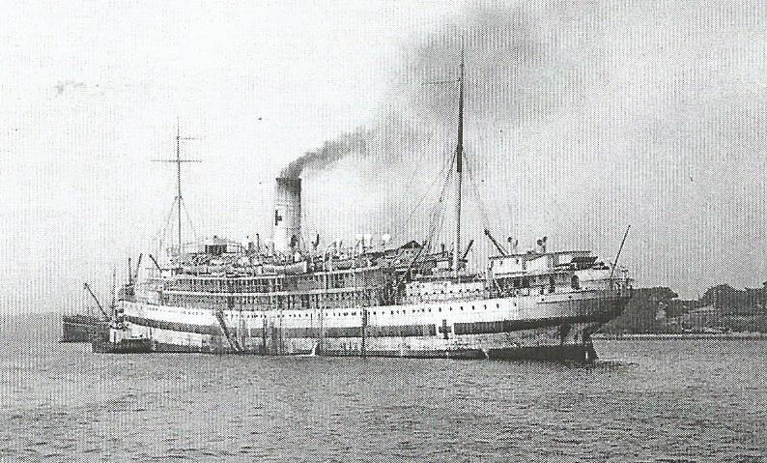
HMAHS Kanowna, dressed as a hospital ship.
Picture taken 1919.

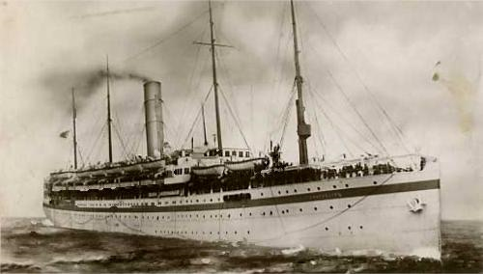
In England Nurse Wilson was assigned to Number 1 AAH at Harefield in December 1917 there she proved to be a most valuable and capable member of the nursing profession and returned to Australia on the SS Lancashire in February 1919, she was discharged in April 1919 and died at Cambrian Hill in 1963.
SS Lancashire . Picture taken in 1918.

At the time of her enlistment on December 11 1916 aged 29 years, Sister Rosalind Eva Ballard was thought to be the only nurse residing in the Shire of Whittlesea to volunteer for overseas service. This was not so, because she was pipped on the post by Nurse Ruby Wilson who gave her address as Whittlesea and who had enlisted two months earlier. Sister Ballard was assigned to the British Indian Nursing Service, she embarked on RMS Mooltan and was posted to the Alexandria War Hospital in Bombay in 1917.
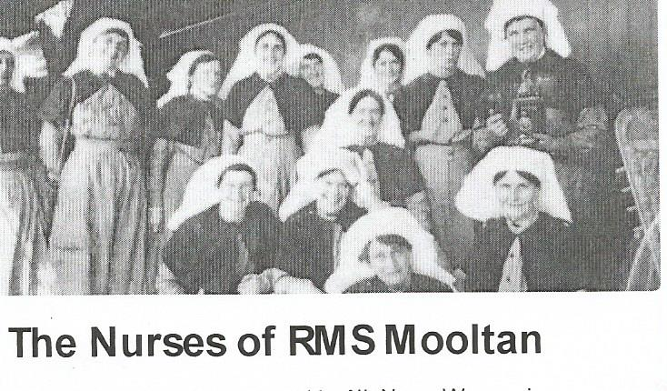
Other stations of service were, the Station Hospital at Daccan, Victoria War Hospital (Bombay) and the Hislop Hospital in Secunderabad. Sister Ballard enjoyed her one month’s leave in England granted to nurses serving in Egypt and India in November 1918. She worked at Number 2 AAH and on April 10 1919 she was granted special leave to attend courses in Domestic Economy at the Battersea Polytechnic in London before returning to Australia November 11 1919. Sister Ballard’s service appointment was terminated in February 28 1920.
Sister Ballard continued her nursing career, as acting Matron of the Mildura Base Hospital, she opened her own private hospital (which she operated for 10 years in Mildura), and she was also on the staff at Epworth Hospital. Sister Ballard enlisted in WW11 (October 1940) as V6574 and was assigned the rank of a Lieutenant taking charge of the Tatura camp dressing station and later Seymour base dressing station at the time of WW11. The Eltham and Whittlesea Shires Advertiser announced on Friday 7 February 1941 (Page 3), “The appointment of Sister Rosalind Ballard of Whittlesea as Matron of the Lady Dugan Red Cross Hostel and Convalescent Home for War Nurses in South Yarra”. Well done Rosalind Ballard.
Matron Ballard died on February 8 1956 at the age of 69 years.

Nurse Florence Eva Harte, although she was born in Ballarat gave her address as Studley Road Ivanhoe when she enlisted at the age of 39 on August 27 1916. Records show no details of Nurse Harte’s qualifications except that she had served at number 11 AGH in Kooyong Road Caulfield. Florence Harte embarked from Melbourne on the HMAT Orsova on December 6 1916 and was assigned to number 1 AGH at Roun, where she remained until June 1917.A transfer to number 46 General Hospital for a few months and a
Return to number 11 AGH before she was repatriated to England in October1918. Nurse Harte was promoted to Sister December 31 1918.

Nurse Harte returned to Australia and her appointment terminated in June 1919. She was awarded the British War and Victory Medal, her location to forward this on remained fruitless and the award was uncollected.
In 1923 Florence Harte married James Bell and her file suggests that she died on March 1 1953 at 77 years in Heidelberg.

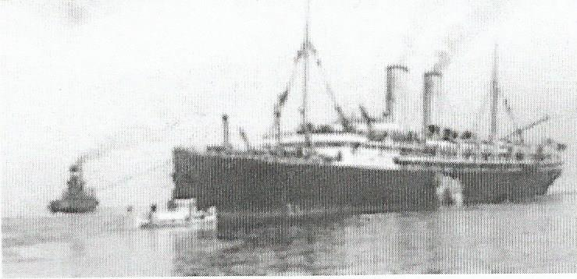

HMAT Orsova British War and Victory Medal

Nurse Ada Hodson, born 1887 in Lilydale, living in Redesdale Road Ivanhoe at the time of her enlistment December 26 1916 at 30 years of age.
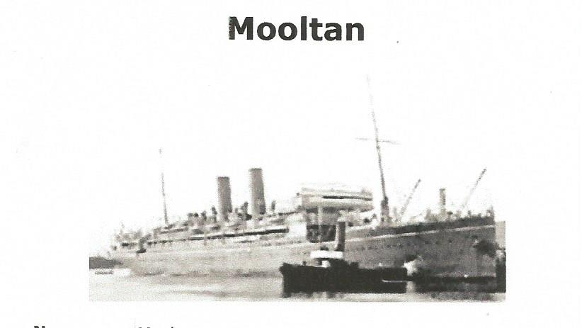
Records show that she embarked on the Mooltan for overseas service the day of her enlistment, which could be incorrect, or the Attestation may have been completed some days after the actual enlistment. It notes that Nurse Hodson had served at little known Army facility, Osborne House in North Geelong before enlisting

Nurse Hodson saw transport duty on ships, Delta, Ellora and Scicla, before going on to extensive duty in India and Afghanistan.
She was promoted to Sister December 26 1918 while still in Bombay
After being granted one month’s leave in England she resigned from her AIF appointment stating medical reasons on January 3 1920.
As well as the standard British War and Victory Medal, Sister Hodson was awarded the Royal Red Cross Medal (second class) for her service in the field during the Afghan War 1919. Ada Hodson retired to nursing in Bulawayo Rhodesia.
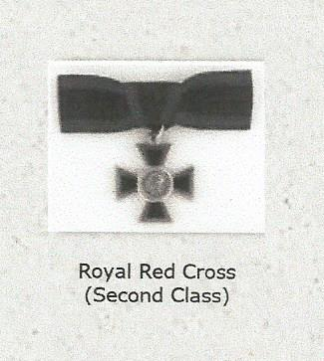
British War and Victory Medal

Nurse Mary Ann Farrell trained at St Vincent Hospital and worked another ten years there in charge of the causality word before enlisting in the Royal Nursing service in 1915. She was 30 years of age and lived in Waterdale Road Heidelberg. Nurse Farrell left for overseas service on the SS Orontes (pictured below)August 4 1915.
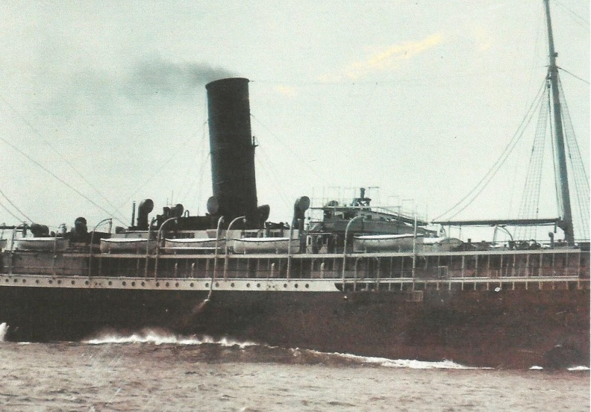
On arrival in the Middle East, Nurse Farrell was assigned to number 3 AGH on Lemnos and returned to Egypt with the same unit in February 1916. She continued serving at Ablassia in Egypt until October when the hospital was shipped to England arriving late in October 1916.
Number 3 AGH shipped to Abbeville, France in May 1917 where Nurse Farrell remained until the following January when she returned to England and worked at number 2 AAH before returning to Australia, arriving in Melbourne April 16 1918. Shortly after Nurse Farrell was demobbed and after a short break re-enlisted with the rank of Sister on July 1918 serving in Bombay India.
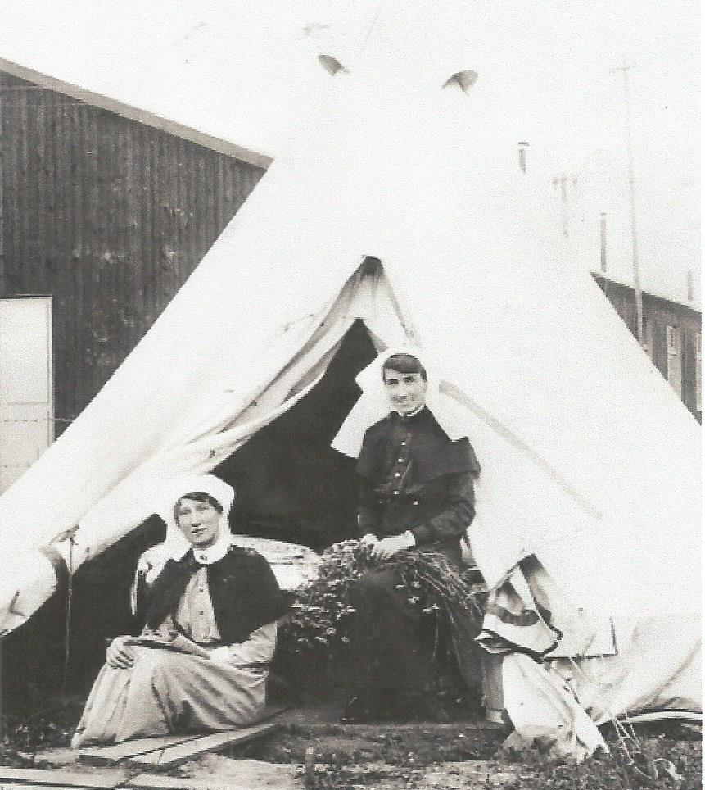
Finally she left the Nursing service in 1920 and she died in 1963.

Nurses outside their tent at AGH 3 in Abberville France 1917

Bassett Jan “Australia in Wartime” in “An Emerging Identity” ed Gurry Tim Heinemann Education Australia pp 145-146.
www.aif.edu.au:8080/showPerson?pid=208412&printFormat=print
Membrey Brian compiler “The Great War Women in Uniform’. No date
Membrey Brian Compiler “The Great War:Women in Uniform” p 19
Gazetted London July 30 1920 and in Australia October 20 1920.
Membrey Brian “The Great War: Women in Uniform” p20.

