SAXAM HOMESTEAD
108 Diamond Creek Road
Greensborough

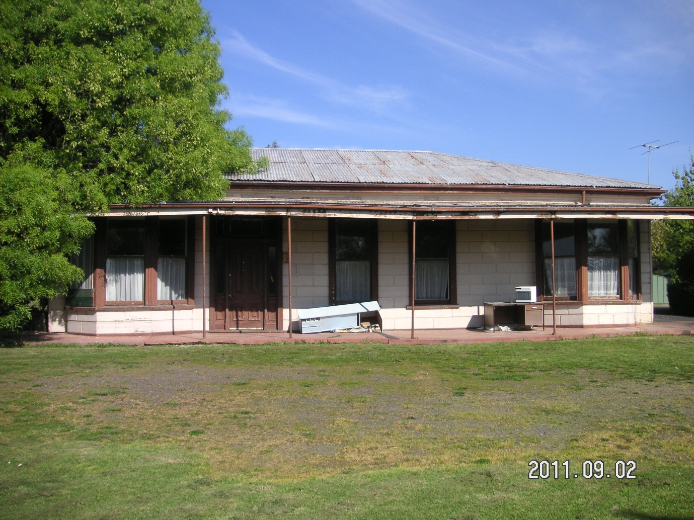
Picture Courtesy of Claire Levi
PREPARED FOR
BANYULE CITY COUNCIL

October 2011

Saxam Homestead

Prepared by:

Nadia Gasparetto
Conservation/Heritage Architect
92 Munro Street, Ascot Vale Victoria 3032 Australia
Phone: (03) 93262554
Mobile: 0418 354 163
Fax: (03) 93262353
E-mail: ngarchitect@optusnet.com.au

And
Claire Levi
History Smiths Pty Ltd
PO Box 1444 Carlton, VIC, 3053, Australia
Tel: (03) 9663 9889
E-mail: enq@historysmiths.com.au
claire.levi@bigpond.com

Contents
Page

Heritage Assessment prepared by Nadia Gasparetto 1

Appendix 1:
Historical and Cultural Assessment prepared by Claire Levi 5

Appendix 2:
Photos of Saxam Homestead 16

Introduction
This is a short heritage report which provides Banyule City Council with recommendations, following the historical research prepared by Claire Levi, historian (see Appendix 1 of this report), to include Saxam Homestead into the Heritage Overlay of the Banyule Planning Scheme.
The advice is based on the historical research into the ownership and use of the place. Claire Levi’s research has highlighted the fact that the remaining homestead (once the main building and part of a number of buildings on the overall site) is the only remaining fabric of a place which contributed to the history and development of St Helena, a significant rural development of the area.
The findings identify this place as being individually significant as one of three remaining rural places in the area and as a representative of the rural development local historical theme as well as the “Promoting Settlement” and “Farming” broader Victorian historical themes.

Heritage Significance
The Place
Saxam Homestead is culturally and historically significant as a place which contributed to the development of St Helena and the broader Greensborough area. It is a representative of the rural development historical theme within the Greensborough areas and therefore culturally and historically significant because:
- It is one of the remaining homestead places within the St Helena area;
- It was established in the late 1880s and therefore one of the first farming properties in the area and representative of the rural development local historical theme;
- It is one of three remaining homestead places and buildings in the Greensborough area; and
- It displays elements which make it part of the broader Victorian themes (Promoting Settlement and Farming);
The Homestead
The building has a degree of substance to its scale and detailing, particularly in its breadth and the scale of the bay windows to either side, that enable it to stand out from typical suburban timber houses of its period and that lend it a notable homestead quality.

The remaining homestead is in a state of neglect. It is so because the building has not been physically maintained. Works required to restore this building are quite extensive, however the building can be restored to its original detailing.
Original detailing which still exist are the main door (refer to Appendix 2 for additional photographs) as well as doors to the rear, bay and general double hung windows, the front wall ashlar cladding, the weatherboards, round section downpipes, quad gutters (although the ogee style may have been the original gutters), the eaves details, the verandah and posts details to the rear, the upper wall vents and the hip roof form.
Intrusive elements relating more to the possible 1950s/60s changes include the steel post verandah form at the front of the building, the concrete verandah floor, the replacement of the roof cladding (originally this would have been slate), extensive internal changes and changes to the rear elevation including the enclosed areas to the side of the existing verandah. Other changes may have included the removal of original chimneys and internal joinery although this cannot be fully confirmed without photographic evidence or further physical investigation.
It would appear that the original hip roof form and the general footprint/layout are original. It is also assumed that the building is located in its original position and was not moved as part of the 1960s development (the existing development surrounding the site).
Even though the main concerns are that the remaining homestead is in a state of neglect with some of its original features missing or altered, the building is the only remaining physical fabric which links the site or place to its original rural development.
So, whilst the architectural significance of this place is not high (in terms of its original architectural/setting integrity) when compared to the historic or cultural significance (because of the building’s current physical condition, the lack of other original fabric and its concealment within the existing 1960s built context), the historical and cultural significance of the place cannot be quantified or fully substantiated without the presence of the existing homestead. Therefore it is important that the homestead be part of the place if Council is to include this site in the Banyule Planning Scheme.

The Context
The context as previously highlighted has also been altered and the homestead is no longer visible from many viewpoints around the property or surrounding roads/highways. Therefore the context in which the building exists has a very low integrity when viewed singularly.
Integrity of the site
The architectural integrity of Saxam Homestead as viewed today is low. This rating is based on the building being assessed solely for its architectural merit. As a contributor of the rural development of the area, however, the historical, cultural and architectural integrity and therefore overall significance of the place is relatively high. It is therefore important that the building remain so that the historical and cultural significance of this place is retained for future generations.

The homestead requires extensive repairs and restoration works but these are works which can be completed with the assistance of photographic or physical evidence. Once restored the building could be utilised for community purposes and its contributory place communicated to future generations with the aid of computerised or interactive displays within the building.

Any possible future developments for this site should ensure that buildings which are visually intrusive, to the original homestead’s setting, are removed and new buildings are designed in a sympathetic manner so that the original homestead is not further compromised, that is, if the building is to be retained and the place listed as an individually significant place.

Conclusion
This assessment has been quite challenging because of the building’s current condition and because of its compromised setting (caused by the 1960s development).

Given, however, the high level of cultural and historical significance of this site and the remaining built form/fabric, it is recommended that:

- The place be listed for its historical, cultural and architectural significance:

- Any future works proposed for the existing homestead building include restoration works in accordance with the Australia ICOMOS Burra Charter; and

- Any future development of the site is sympathetic to the original homestead and views of the original homestead are reinstated where the opportunity arises.

Final Statement
It is well known that places listed at local level are not always architecturally pristine or complete in their form or setting, an argument which is constantly challenged by owners and tribunals etc. However, places which are important to the local community are so because the buildings become part of their culture and their retention enables generations to pass on that history to future generations. They are essentially culturally and historically significant places where their significance is strengthened by the remaining built evidence. They simply provide the evidence of a past which no longer exists or has changed for whatever reason.

I therefore recommend that Saxam Homestead be included as an individually significant building in the Banyule Planning Scheme for its historical, cultural and architectural significance, based on the development of the site as a farm and its contribution to the area.

By including this property in the Schedule to the Heritage Overlay, council should encourage the owners to retain and restore the homestead, if the place is to retain its historical, cultural and architectural significance.

It is therefore recommended that:
- The building have external controls and that the elements highlighted as missing or altered be restored as part of any future works;

- Encourage restoration of the building in accordance with any photographic or physical evidence and in accordance with the Australia ICOMOS Burra Charter;

- External colours controls apply;
- The citation ensure that the aim is to retain the built form as evidence of this farming place;

In addition, Council could encourage the owners to consider:

- Using the building for community functions;

- Planning future development of the site by incorporating sympathetic structures/designs and in appropriate locations so as not to further impact on the integrity of the place;

- Removal of buildings which encroach on the view of the homestead from various points, should the opportunity arise; and

- Installing plaques close to the homestead to displaying information regarding the local history of the place.

Appendix 1: Historical and Cultural Assessment prepared by Claire Levi

Saxam Homestead
108 Diamond Creek Road
St Helena

Figure 1: Saxam Homestead

Project Background
In August and September 2011, the author, Claire Levi, BA (Hons), MA (Public History), MPHA, carried out the commission of the Banyule City Council to conduct a brief project to research the history of Saxam Homestead. This project aimed to investigate Saxam Homestead to determine whether it possesses any historical and/or cultural significance and whether a Statement of Significance is warranted. This resulting report contains sections including: brief background history, property description, architect, building design, use of the place, alterations and chronology. It must be noted at the outset that despite investigation, certain questions about some components listed above (e.g. architect), could not be answered as no information could be located. The report also contains a comprehensive list of sources consulted during the research phase.

Brief Background History
In 1839, the survey of land to the east of the Plenty River began. The land upon which Saxam Homestead is located was sold to F.D. Wickham (1060.0.0 acres) on 5 February 1840. It is known as Crown Allotment XIV, Parish of Nillumbik. The land in this area sold slowly. In the 1840s and ’50s, settlement was sparse and the larger land holdings supported pastoral and agricultural activities.

The area remained distinctly rural in character until well into the twentieth century. A 1933 souvenir guide to the area notes, ‘St Helena has no pretensions to “progressiveness”, but rests content in its peaceful and picturesque setting’. Development boomed after World War II and the Shire of Diamond Valley experienced a major population growth between 1956 and 1964, but St Helena still remained rural until housing development occurred in the late 1990s.

St Helena
The area’s unusual name comes from the island of St Helena, the birthplace of Major Anthony Beale who was one of the first settlers in the area. He is recorded as having, in 1839, a pastoral lease north of Greensborough where he built St Helena Cottage. He lived here with his large family.

Property Description
Saxam Homestead is currently located within the grounds of Churinga, a day centre for intellectually handicapped adults run by St John of God. Churinga, on 8.6 ha of land, has been variously described as being located in Greensborough and St Helena.

The Banyule Heritage Places Study describes Saxam Homestead as ‘a single storey weatherboard building with a corrugated iron hipped roof, with ashlar pattern boards on the front (north) facade. The present verandah appears to date from the 1950s, and has a concrete slab floor and circular steel columns supporting a corrugated iron skillion roof. Semi-octagonal bays with double-hung sash windows flank the entrance door, which has glazed sidelights and highlight. The rear of the building has a recessed verandah with timber posts.’

In the Shire of Heidelberg Rate Books, the land description of Saxam Homestead is given as ‘part XIV, parish of Nillumbik’. (This report has not investigated the subdivision of this allotment.) There is no street number or address beyond this descriptor, which was employed right up until the 1943 rates were assessed. The land upon which the homestead is built was originally 46.3.0 acres in area. This specific land area as a descriptor has been used to ensure that the correct piece of land is being investigated.

A 1945 aerial photograph depicting Saxam Homestead (and the neighbouring homestead, Worthing) shows that Saxam was not the only building on the property: there were outbuildings. Unfortunately the quality of the photograph does not allow for better identification of these buildings. An advertisement of the clearing sale after Saxam Homestead had been sold in 1924 (see Chronology) noted there was a ‘dairying and pig-raising plant’ on the property.
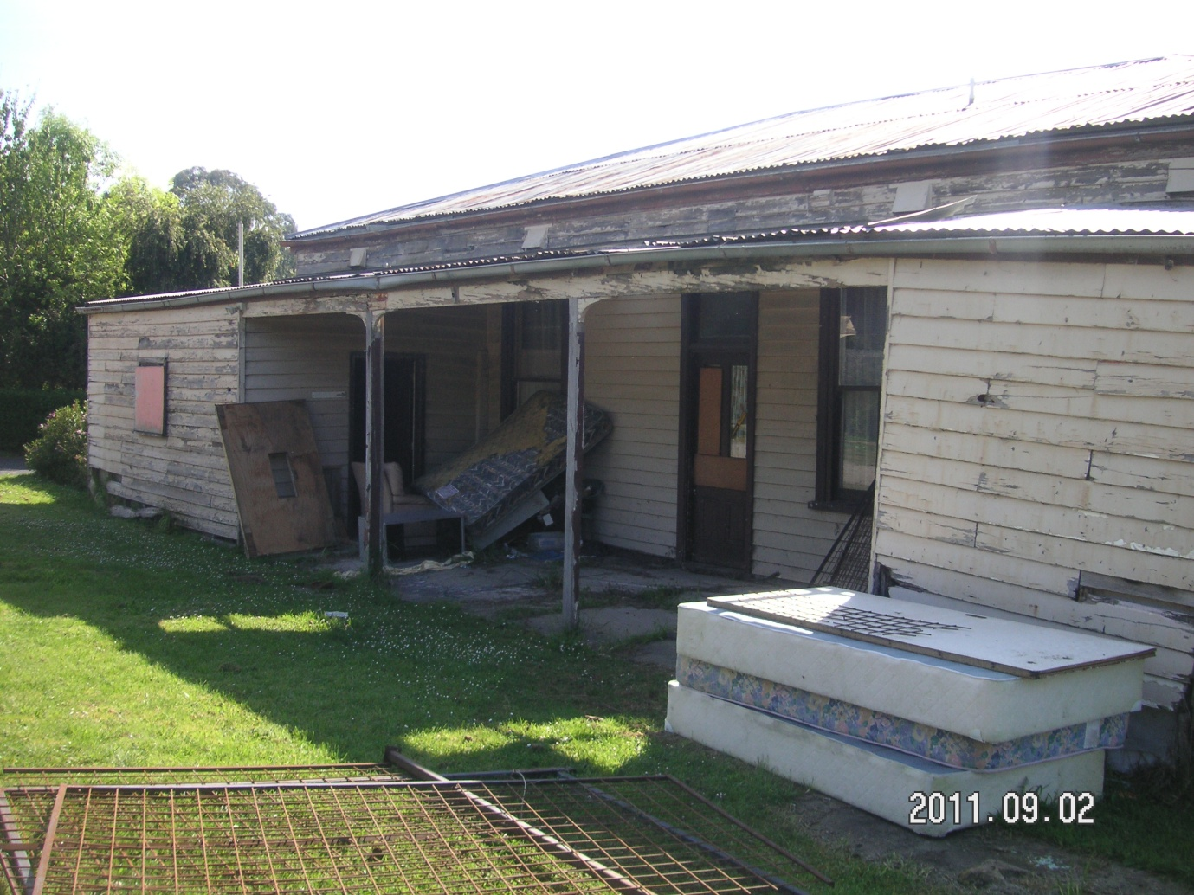
Figure 2: Rear of property showing recessed verandah

Date of Construction
A conservation study of the area was conducted in 1999. This reference believed the original owners of the property to be Mr and Mrs Kaye. An analysis of The Shire of Heidelberg Rate Books shows that Charles Walter Kaye was indeed the owner/occupier of the house, but that he had apparently purchased it from George Anstey some time after October 1895.

George Anstey’s name was present in the 1888 Rate Books (the residence and postal address being described as ‘Greensboro’ (sic). The description and situation of rateable property was ‘House and Land’ near Greensboro. There was no entry mentioning Anstey in the rate books of 1886, when the rates were taken on 8 September. (I consulted the 1886 Rate Books to see if Anstey’s name had been pencilled in over another, but Anstey’s name was not present. Unfortunately, there was insufficient property description information in the books to match up Saxam Homestead with any other properties by property descriptions alone.)

Therefore, Saxam Homestead was probably built sometime between 1886 and 1888.

Alternative Names
No original homestead name was recorded in the documents researched for this report. Saxam Homestead’s name appears to be linked to the second owner of the house: in fact, Charles Walter Kaye’s childhood home. Kaye’s death notice in The Advertiser noted he was the ‘son of the late Squire Kaye, of “Saxham,” Bury St. Edmunds, England . . .’ It is not known when the ‘h’ was dropped from the spelling of the name. Coolyarra was the name given to the building by the St John of God Brothers who gave each of the buildings on the site an Aboriginal name. No information could be found giving the meaning of this word. Information from the Heidelberg Historical Society notes that ‘Churinga’ means ‘Sacred Place’, but this information is not substantiated in any other researched documents.

Architect
No information could be found.

Building Design
As the date of construction has been narrowed down to the late 1880s, the house is of late Victorian design.

Use of the Place
The first-recorded entry in the rate books lists the occupant as farmer, so it is a reasonable assumption that Saxam Homestead was used, exactly as its name suggests, as a farmhouse. This is borne out with an advertisement alerting the public to the clearing sale after Saxam Homestead had been sold in 1924 (see Chronology).

Charles Walter Kaye was well known for breeding Berkshire pigs and, it would appear, had entered his pigs in the Royal Melbourne Show. In 1908 The Argus advertised the sales of stud pigs with ‘an extensive catalogue of high-class swine, comprising drafts from all the foremost breeders of
Victoria . . .’ of which C.W. Kaye, Saxham, Greensborough was one.

When St John of God purchased the property, it was still being used as a farm home. The occupants, from whom the land was bought in 1966, served the St John of God Brothers morning tea on the verandah. According to one brother, the homestead was in the middle of the purchased land.

Once the property had been purchased, the homestead was used first as a life skills training centre and, subsequently, an opportunity shop. It is not currently in use.

Alterations
An internal inspection of the property suggests that building alterations have occurred. Four internal doors have been boarded up (they can be seen from one side of the wall, but no doorways are visible from the other side of the wall), and once-complete walls have had spaces knocked into them to enable direct access between rooms. This has occurred between all the rooms not otherwise divided by passageways. The alterations are crude and detract significantly from the overall integrity of the house.

Chronology
1886–1888 Construction of the Homestead probably occurs during this two-year period.
1885 George Anstey, farmer, is listed as the owner/occupier of the Homestead. He later stands for election in the Greensborough Riding of the Shire of Heidelberg (1891).
1890 George Anstey is listed as owner/occupier.
1895 Charles W. Kaye purchases the Homestead from George Anstey. Charles W Kaye later stood for Council. The name Saxam (originally spelled ‘Saxham’) comes from Charles W. Kaye.
1900 Charles Walter Kaye is listed as owner/occupier.
1905 Charles Walter Kaye is listed as owner/occupier; (six people were living in the house).
1910 Charles Walter Kaye is listed as owner/occupier. In this rate book entry his occupation is recorded as farmer.
1915 Charles Walter Kaye is listed as owner/occupier.
1920–21 Charles Walter Kaye is listed as owner/occupier.
1924 (February) A clearing sale was held as Saxam had been sold. The Eltham and Whittlesea Shires Advertiser and Diamond Creek Valley Advocate ran an advertisement noting:
Messrs McPhail, Anderson and Co. will hold a clearing sale on Tuesday next at one o’clock, at “Saxham” on account of Mr W.A.Santon, who is offering everything for sale, as the property has been sold. The farm is well known in the district, and the stock includes Jersey dairy herd, horses, farming, dairying and pig-raising plant, furniture, sundries and 30 tons of wheaten hay.
1925–26 Horace E. Clarke (occupier); Sand Supply Co. Ltd, 346 Flinders Street, Melbourne (owner).
1930–31 Mrs Agnes Jones (occupier); Swanton & Batchelder (owner). The property is described as a homestead.
1935–36 Mabel G. Wood (occupier); Swanton & Batchelder Wm. H & E.G. (owner).
1937–43 William Sinclair (occupier); William David Watson, 57 Leicester Street, Preston (owner). However, during this period there had apparently been three occupants at various times, because two other names are recorded: Mabel G. Wood (occupation home duties) and William White (occupation farmer). Both these names are crossed out. The owner also changed from Swanton & Batchelder, William and E.G. 488–90 Collins Street Melbourne. This name is crossed out and Watson’s replaces it.
1966 Beresford-Smith family own Saxam Homestead. Land surrounding the homestead was used as a farm. Cattle and horses were being agisted. There were no other buildings on the property, but there was another homestead on the next property.
1966 (August 9) Saxam Homestead and land is purchased by St John of God. The Brothers purchased the land as it was: the land has been neither deducted from nor added to in the forty-five years since this date.
1967 Churinga Special School opens at St Helena occupying the property upon which Saxam Homestead is located.
2011 The homestead is no longer is use.

Nineteenth Century Buildings in Greensborough
Two other nineteenth century buildings remain in Greensborough: Woodlands and Dunbar. Both were constructed during the 1880s.

Heritage Listings | Woodlands – 11 Doon Court, Greensborough | Dunbar – 38 Hailes Street, Greensborough
Banyule Planning Scheme | House and Outbuildings (HO99) | No listing
Banyule Heritage Database | Yes | No listing
Banyule Heritage Places Study (1999) | ‘B’ significance | ‘C’ significance
Victorian Heritage Database | No listing | No listing
National Trust of Australia (Victoria) | No listing | No listing
Register of the National Estate | No listing | No listing

Both properties are more intact than Saxam Homestead.

Criteria for Assessing Significance
New assessment criteria were adopted by the Heritage Council of Victoria on 7 August 2008, superseding the previous criteria that had been adopted on 6 March 1997. The updated criteria are listed below, and a brief discussion regarding Saxam Homestead included where applicable.

Criteria
Criterion A: Importance to the course, or pattern, of Victoria’s cultural history
Not applicable

Criterion B: Possession of uncommon, rare or endangered aspects of Victoria’s
cultural history.
Not applicable

Criterion C: Potential to yield information that will contribute to an understanding of
Victoria’s cultural history.
Not applicable

Criterion D: Importance in demonstrating the principal characteristics of a class of
cultural places or objects.
St Helena developed as a rural area and maintained a primarily rural development pattern almost until the end of the twentieth century. Saxam Homestead is a physical reminder of this principal characteristic (rural settlement and development) as a cultural place.

Criterion E: Importance in exhibiting particular aesthetic characteristics.
Not applicable

Criterion F: Importance in demonstrating a high degree of creative or technical
achievement at a particular period.
Not applicable

Criterion G: Strong or special association with a particular community or cultural group
for social, cultural or spiritual reasons. This includes the significance of a place to
Indigenous peoples as part of their continuing and developing cultural traditions.
Saxam Homestead is important to the residents of St Helena as a tangible link with their rural past. It was once a ‘well known farm in the district’. It is St Helena’s oldest remaining homestead and one of only three nineteenth century buildings remaining in the area.

Criterion H: Special association with the life or works of a person, or group of
persons, of importance in Victoria’s history.
Not applicable

Victoria’s Framework of Historical Themes
Victoria’s Framework of Historical Themes was developed by Heritage Victoria in 2010. ‘The Framework’s purpose is to highlight what is distinctive about Victoria and to increase awareness and appreciation of the state’s heritage . . . to ensure that objects, places and events can be understood, assessed or presented within the context of a broad theme, rather than as singular items of interest.’ This section of my report lists only the Framework’s Victorian themes, but relevant to amplifying these are several local themes that were developed through the 1999 Banyule Heritage Places Study such as: pioneer farming, timber cutting, gold mining, rural development, land boom, Heidelberg School Artists and writers, and mud-brick housing and suburban development. Of these local themes, rural development is the one which the establishment and early history of Saxam Homestead most accurately reflects. This links with the broader Victorian themes that pertain to Saxam Homestead:

2.7 Promoting Settlement (part of theme two: Peopling Victoria’s places and landscapes)

4.4 Farming (part of theme four: Transforming and managing land and natural resources)

Heritage Protection Lists
Banyule City Council: Saxam Homestead is not included in the Heritage Overlay; not listed for review in the Banyule Heritage Review Final Report (2011)
Banyule Heritage Database: no listing
Heritage Victoria: no listing
National Trust of Australia (Victoria): no listing
Register of the National Estate: no listing

Previous Recommendations
In the 1999 Conservation Study, Saxam Homestead was listed as being of ‘C’ Signficance. ‘C’ listings are ‘places that contribute to the architectural or historical character and cohesiveness of the City of Banyule and as such are either of local importance or interest. These structures are generally residential buildings, and contribute to the visual cohesiveness of the City. They are structures that are close to Grade B buildings, both in their physical location and their period and type, but have had substantial alterations made to their original fabric, such as the replacement of the original roofing material, the removal of an important architectural element, or alterations made to their decoration. These works are in large part reversible, and if removed their visual contribution would be enhanced. While they do not warrant individual protection under the planning scheme, they should nevertheless be retained.’

Conclusion
There is no doubt that Saxam Homestead has local significance, contributing to the history of St Helena and representing two themes as identified through Victoria’s Framework of Historical Themes. It is important because it contributes to the understanding of the area’s past and post-contact European development.

However, the poor state of the property has implications for its future: who will ultimately be responsible for its repair and maintenance?

The reason to protect Saxam Homestead is that there are very few surviving examples of nineteenth century homesteads in the area. Protecting Local Heritage Places: A national guide for Local Government and the Community discusses why a community might want to protect heritage places. Several reasons are given, but those which are particularly applicable to Saxam Homestead are that it provides a link with the past and is a reminder of special moments in lives, history or culture, and it is part of St Helena’s special identity. The guide sums up the rationale for the retention of buildings as follows: ‘Keeping these places enables the community to experience again and again the pleasures they offer. Once lost, they are gone forever. No record or photograph can ever substitute for an actual place’.

The author believes that a Statement of Significance is warranted for Saxam Homestead.

Sources Consulted
Primary Sources
Beale, J.L., ‘Memoirs, history 1808–1883’ (Manuscript) held at SLV
Sands and McDougall Directories (on microfiche at SLV)
Shire of Heidelberg Rate Books (at the Public Record Office of Victoria)
Smith, J. (ed.), Cyclopedia of Victoria (1903)
Sutherland, A., Victoria and Its Metropolis: Past and Present (1888)
Raworth, B, Letter of advice to Resolution Property Group, 12 February 2014

Secondary Sources
Allom Lovell & Associates in association with John Patrick Pty Ltd, Banyule Heritage Places Study (1999)
Amor, R.L., Heidelberg Sketches (2005)
Australian Heritage Commission, Protecting Local Heritage Places: A national guide for Local Government and the Community (first published 1998; updated online edition 2009)
Bick, D. & C. Kellaway, Shire of Eltham Conservation Study (1992)
Butler, G. Heidelberg Conservation Study; Part 1 Heidelberg Historic Buildings & Areas Assessment – Individual Building Citations (1985)
Context Pty Ltd, Banyule Heritage Review: Final Report (2011)
Cummins, C. (ed.), Heidelberg since 1836: a pictorial history (Heidelberg, 1971)
Edwards, D.H., The Diamond Valley Story (1979)
Garden, D.S., Heidelberg: The Land and Its People (Carlton, 1972)
Heidelberg Shire Council, Heidelberg, the beautiful (1921)
Heritage Victoria, Victoria’s Framework of Historical Themes (2010)
Marshall, M., Nillumbik Now and Then (2008)
Planning Property Report, generated from www.dpcd.vic.gov.au/planning (26.8.2011)
The Compiler (J.W.V.), ‘Back to Heidelberg Municipality Souvenir: Heidelberg Old and New 1860–1933’ (1933)

Research at Local Historical Societies
- Heidelberg Historical Society – no information under ‘Saxam’, ‘Coolyarra’, ‘Churinga’, ‘St John of God’. There were no relevant maps.
- Nillumbik Historical Society – have no documentary information on the homestead.
- Greensborough Historical Society – no response to email enquiry, but spoke with the President, Noel Withers, and we discussed the homestead on the adjacent property to the north of Churinga (Worthing) , the internal alterations of Saxam Homestead and the photo of the interior of the homestead reproduced in The Diamond Valley Story. We discussed the other remaining nineteenth century buildings in Greensborough and the 1945 aerial photograph of Saxam Homestead.

Research via Personal Communication
- Marie ? Receptionist, Churinga; has been working there since 1975
- Br Ray Hornby
- Br Brian O’Donnell
- Phoned the only Victorian-based Beresford-Smith in the White Pages Directory – no relation to the former owner of Saxam Homestead

- Phoned O’Callaghan Commercial Pty Ltd (agency from whom the Churinga land was purchased); this led to Peter O’Callaghan, the son of the man who owned McGee O’Callaghan, the business that sold the property to the St John of God Brothers in 1966. Archives from this business have been destroyed.
- Anna Whitelaw, author of an article ‘Unprotected, Saxam may be lost forever’, Banyule & Nillumbik Weekly (19.7.2011)
- Noel Withers, President Greensborough Historical Society
- Michael Lovick, Archives and Information Special Projects Officer, Banyule City Council
- Ted Brincat, Archivist, Nillumbik Shire Council

Public Record Office Victoria
School Files (Non-Government Schools), no. 1916 Churinga, Greensborough
VPRS 10300/P0001/13
Shire of Heidelberg Rate Books (Shire of Heidelberg VPRS 2870; Greensborough ward 1937–1964 VPRS 3791)

Research at State Library of Victoria
Miles Lewis’ Australian Architectural Index no relevant entries under ‘St Helena’, ‘Greensborough’ or ‘Kaye’
Local History Index – this led to:
- ‘Directions for walk from Greensborough to Diamond Creek via Brown’s Hill (10 miles)’ in Melbourne Walker, vol. 20 (1949), pp. 96–8
- ‘La Trobe Press Cuttings’, vol. 3
- Bibliography file under ‘Shire of Eltham’
- ‘Directions for walk from Eltham to St Helena, Scrubby Creek and Diamond Creek (9 ½ miles)’, in Melbourne Walker, vol. 18 (1947), pp. 57-8
- Maps 1. Greensborough 1860
2. Greensborough, Parish of Morang 1860–1880
3. Subdivisional auction sale of Flintoff’s Estate
4. Re-surveys of country lands [in the] parishes of Greensborough and Nillumbik 1877
5. Bonnie Doon estate in the home like village of Greensborough 1908
Note: None of the above sources yielded any useful information about Saxam Homestead

Online Resources
- Trove (National Library of Australia) website
- Victorian Government Gazettes – search under ‘Greensborough’, ‘St Helena’, ‘Kaye’ and ‘Anstey’, ‘Churinga’
Note: No information

Appendix 2: Additional Photographs
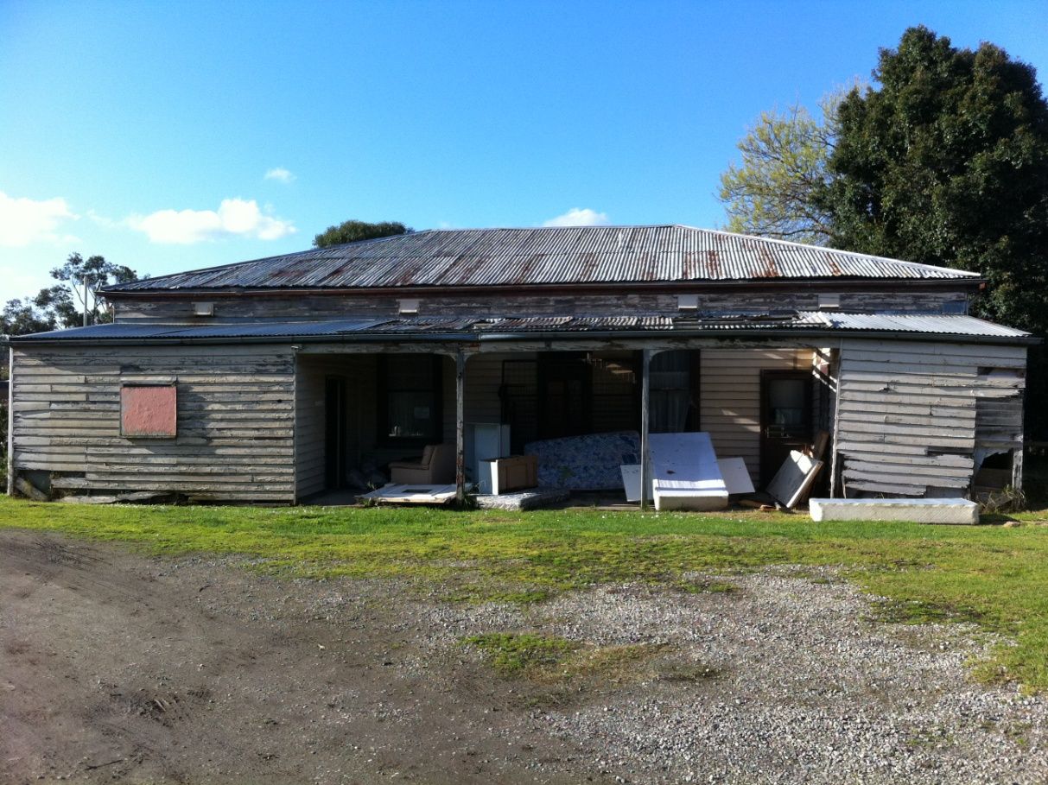
Rear Elevation – Saxam Homestead - July 2011
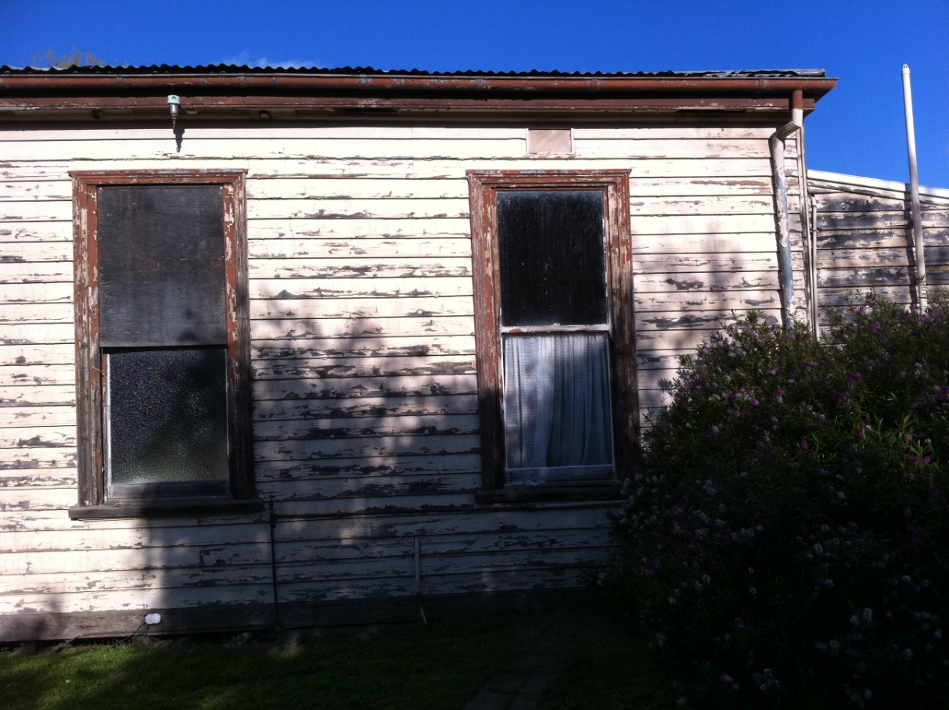
Side Elevation - Saxam Homestead – July 2011

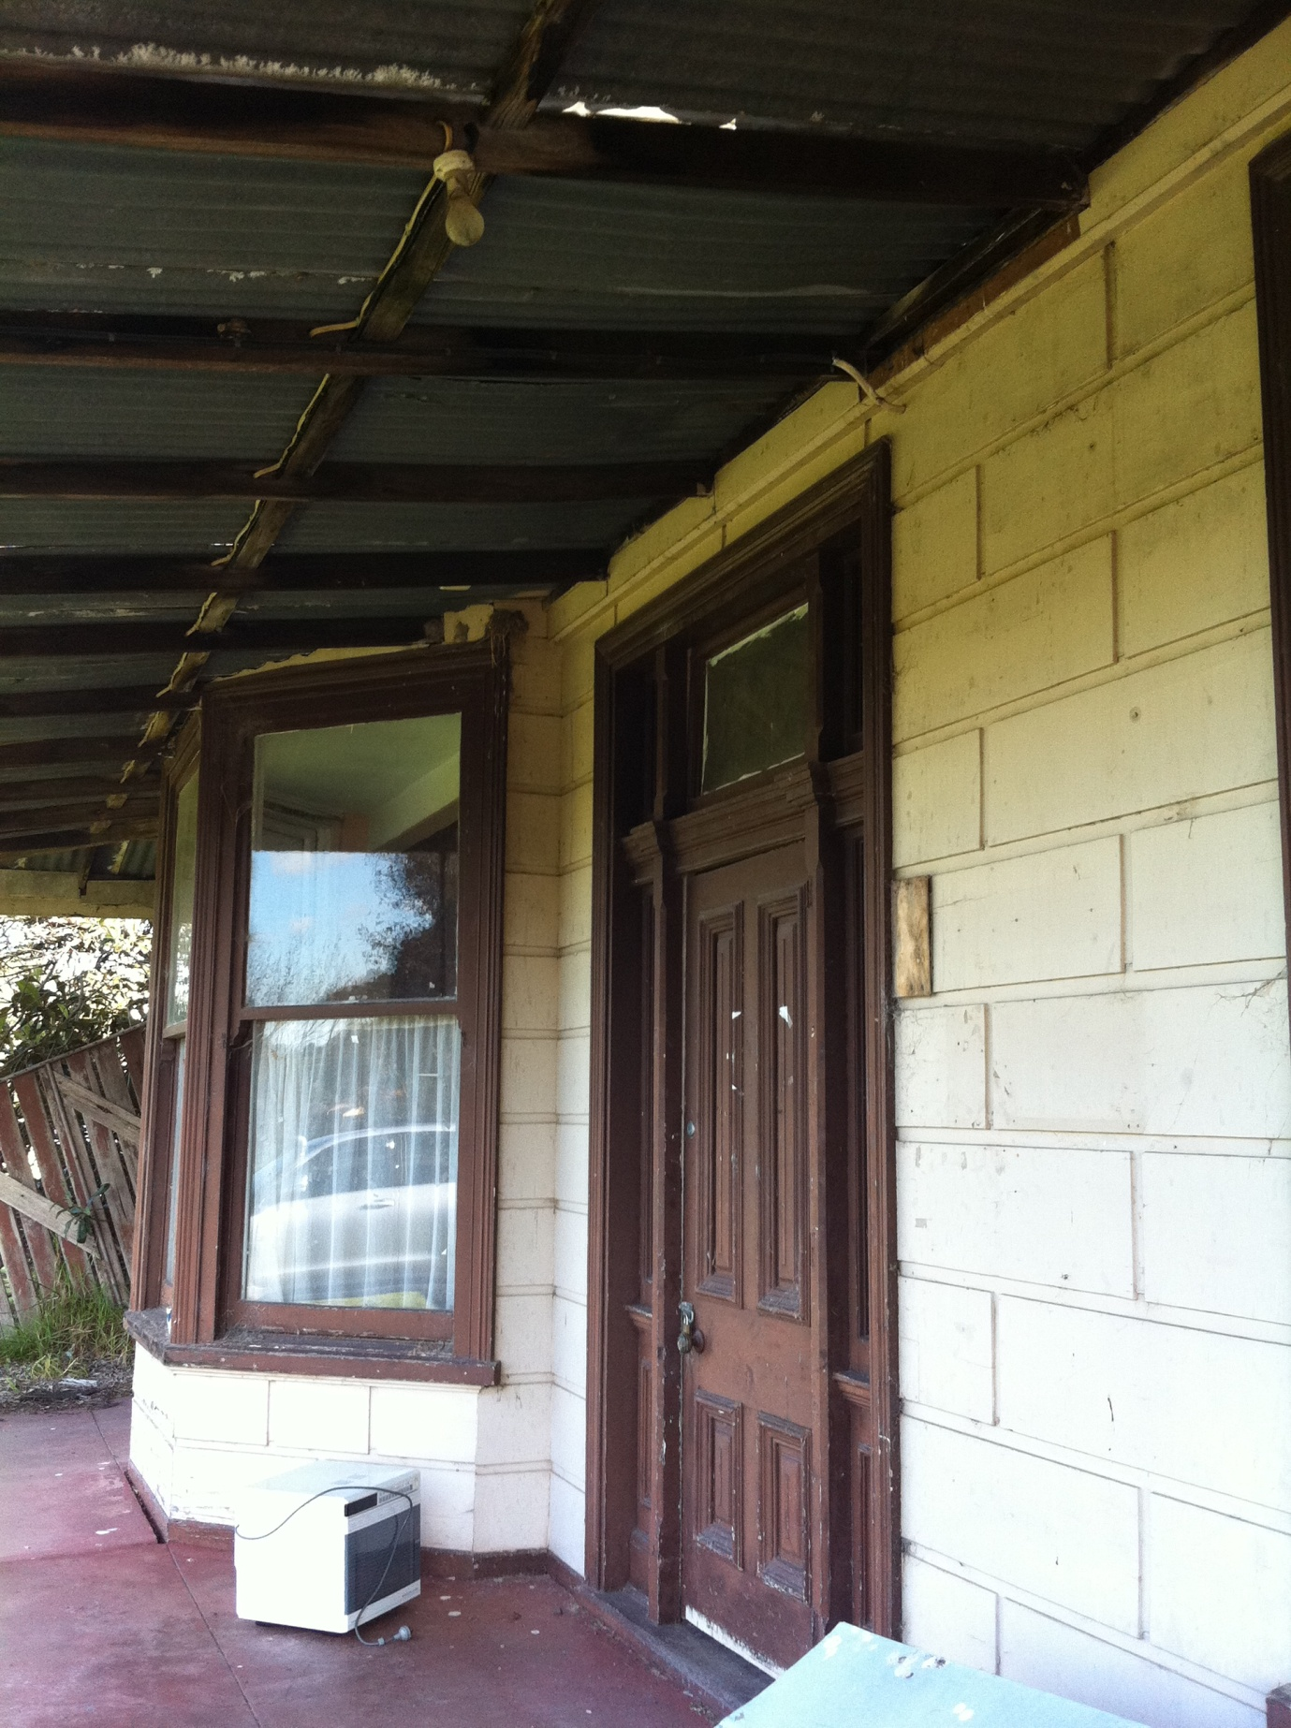

Front Elevation – Door/Bay Window Details – Saxam Homestead – July 2011

Claire Levi, Saxam Homestead (appendix to this report)
Bryce Raworth advice, 12 February 2014
Claire Levi, Saxam Homestead (appendix to this report)
Allom Lovell & Associates in association with John Patrick Pty Ltd, Banyule Heritage Places Study (1999), vol. 1, p. 21. [Note: I looked at this document as PDF on disc.]
The Compiler (J.W.V.), Back to Heidelberg Municipality Souvenir: Heidelberg Old and New 1860–1933, n.pag.
J. Barnard, ‘Greensborough’ and ‘St Helena’, in http://www.emelbourne.net.au/home.html. Greensborough < http://www.emelbourne.net.au/biogs/EM00673b.htm> St Helena < http://www.emelbourne.net.au/biogs/EM01302b.htm>
Major Anthony Beale’s pioneering life is recalled in his son’s (John Lindsay Beale’s) memoirs, held at the State Library of Victoria. There are also articles about it in The Age (12.1.1929, ‘Victoria’s Link with Napoleon’) and The Argus (15.5.1940, ‘St Helena. Victoria’s Link with Napoleon’).
Allom Lovell & Associates in association with John Patrick Pty Ltd, Banyule Heritage Places Study (1999), vol. 2, part 2, section 2, p. 108. [Note: I looked at this document as PDF on disc.]
From the collection of Mr Noel Withers, President, Greensborough Historical Society. Department of Lands & Survey, Aerial Survey of Victoria 1945, Yan Yean C3B. http://www.lib.unimelb.edu.au/collections/maps/historical/1945melb/l_sheets/839c3b.jpg
A study was also completed in 1992, but there is no individual entry for Saxam Homestead.
The 1895 Rate Books – rates that year were recorded on 12 October 1895 – show that Charles W. Kay’s (sic) name was penciled in over George Anstey’s name.
Charles Walter Kaye’s death notice in The Advertiser (15.7.1932), p.2.
Information from Heidelberg Historical Society Walk (12.11.1978).
‘Sales of Stud Pigs. Royal Show 1908’, The Argus (29.8.1908), p.2. There was another sale advertisement in The Argus in 1917 where Saxham was again mentioned as a stud (22.9.1917), p.4. Kaye won third prize at The Royal Melbourne Show for one of his Berkshire pigs in 1919. The Argus (23.9.1919), p.8
Telephone communication with Br Ray Hornby (26.8.2011).
The Argus, Tuesday 4 August 1891, p. 8, column 1.
Personal communication with Mr Noel Withers, President, Greensborough Historical Society (19.9.2011).
The Eltham and Whittlesea Shires Advertiser and Diamond Creek Valley Advocate (1,2,1924), p.2.
Researching the rate books becomes increasingly difficult after this date. Information is recorded on cards rather than in books and due to a large number of cards (over 3300 for each year) researching this way is ineffective. Sands and McDougall directories were consulted in place of the rate books; however residents of Greensborough are listed alphabetically with no address details. Researching residents could not be done using this source. There are no entries for St Helena up to 1966.
Email communication with Br Brian O’Donnell (29.8.2011).
Personal communication with Marie (26.8.2011).
Email communication with Br Brian O’Donnell (29.8.2011). A residential special school had already been established in 1953, moving out to Churinga on 30 June 1967 (School Files no. 1916 Churinga, Greensborough. VPRS 10300, P0001, Unit 13)
Personal Communication with Mr Noel Withers, President, Greensborough Historical Society (19.9.2011)
The Eltham and Whittlesea Shires Advertiser and Diamond Creek Valley Advocate (1,2,1924), p.2.
Anna Whitelaw, ‘Unprotected, Saxam may be lost forever’, Banyule & Nillumbik Weekly (19.7.2011).
Heritage Victoria, Victoria’s Framework of Historical Themes (2010), p. 3.
Allom Lovell & Associates in association with John Patrick Pty Ltd, Banyule Heritage Places Study (1999), Vol. 1, p. 9 [Note: I looked at this document as PDF on disc.]
Allom Lovell & Associates in association with John Patrick Pty Ltd, Banyule Heritage Places Study, vol. 2, part 1, Datasheets A–K (July 1999), p. 2.
Australian Heritage Commission, Protecting Local Heritage Places: A national guide for Local Government and the Community (first published 1998; updated online edition 2009), p. 5.

