The Fallen Soldier’s Memorial

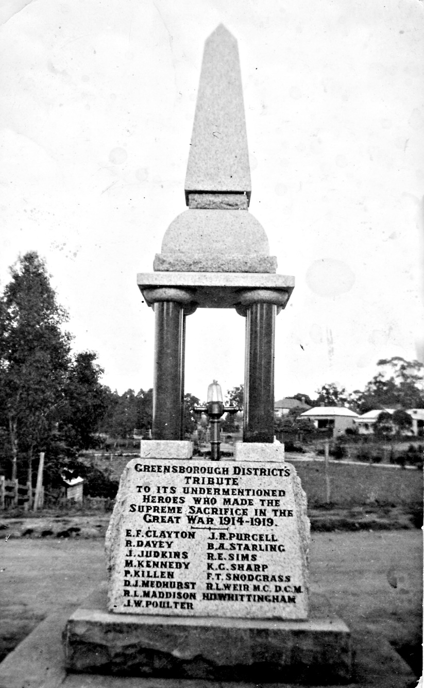

Greensborough War Memorial Park

The Greensborough War Memorial was erected in 1919 as a tribute to the fifteen men of the district who lost their lives in the Great War (1914-1918).
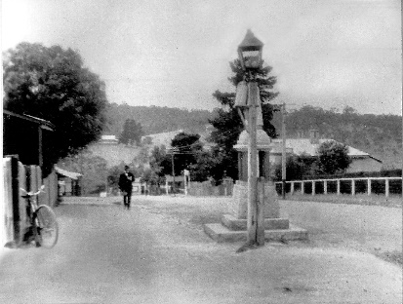
It is designed as a drinking fountain.
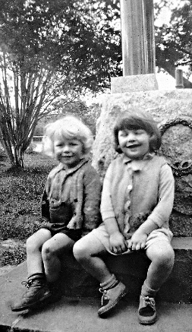
Originally located in Main Street, the Fallen Soldiers’ Memorial was moved in 1927 to Greensborough Lower Park, near the tea-rooms (now Diamond Valley Learning Centre).

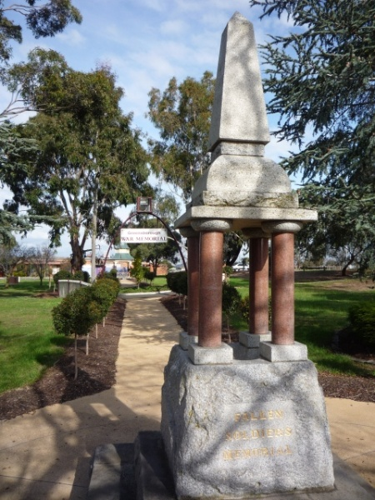
It was moved to Greensborough War Memorial Park in Henry Street possibly in the 1950s.
Today War Memorial Park is the venue for ANZAC and Remembrance Day ceremonies and the adjacent sports ground is the home of the Greensborough Football and Cricket Clubs.
The inscription on the Fallen Soldiers’ Memorial reads:
Greensborough District’s Tribute
to its undermentioned heroes
who made the supreme sacrifice
in the Great War 1914-1919
E.F.Clayton J.R.Purcell
R.Davey B.A.Starling
J.Judkins R.E.Sims
M.Kennedy K.C.Sharp
P.Killen F.T.Snodgrass
D.J.Medhurst R.L.Weir M.C., D.C.M
R.L.Maddison H.D.Whittingham
J.W.Poulter

The following stories of our Fallen Soldiers have been researched using the Australian War Memorial/National Archives Australia websites, the Digger database and newspapers via Trove. Thanks to family members who have provided information and photographs. Additional information is always welcome and can be sent to GHS via info@greensboroughhistorical.org.au

Ernest Frederick Clayton
Serial No. 69 Rank: Private
Unit: 39th Batt
Ernest Frederick Clayton was born in Talbot Victoria in 1896, the son Frederick Clayton and Amy Ann Burkett. At the time of his enlistment the family was living at Greensborough. Ernest was 19 years old and working as a labourer when he enlisted with his brother Charles Clayton on 4th March 1916. They served together in the 39th Battalion.
After training in Ballarat he travelled on HMAT Ascanius and saw active service in France and Belgium. He was accidentally wounded in March 1917, appointed a temporary Corporal in June 1917.
Ernest Clayton died of wounds 29th July 1917 at Belgium. He is buried/commemorated at Kandahar Farm Cemetery.
He was awarded the British War Medal and Victory Medal. His parents received a Memorial Plaque and Scroll.
Charles Clayton’s daughter Mavis Cochrane was interviewed for the local paper: ‘Grieving brother an unlikely hero, by Jim Tennison. Charles Clayton loved his big brother Ernest. As teenagers, both signed up in 1916 for the Great War. But only one was to return from the bloodbath of France and Belgium. The flip of a coin meant Charles saw his older brother killed in action. Yet it could easily have been the other way round. The tragedy happened at Messines on July 28 1917, when the Allies and Germans fought on the Western Front. The brothers from a family of 11 children were among 115,000 Victorian men to volunteer for service. Charles and Ernest were with the famous 39th Battalion. A forward party was needed that day to go into no-man’s land. Charles Clayton’s daughter Mavis Cochrane said: “The officer in charge asked for volunteers and Ernest stepped up. Of course anything Uncle Ernest did, Charles would also do. But the officer wouldn’t send two brothers out on such a hazardous job, so he tossed a coin. Ernest went out with a small party which was quickly under heavy fire. He was hit. When the stretcher bearers went to get him a shell exploded over their heads. The bearers were killed and Ernest died about an hour later from the shrapnel wounds. Dad just went out of his mind and started giving the enemy hell with his Lewis machinegun. Although the gunners either side of him were killed, he just kept firing and it’s estimated he took out 200 Germans.” Charles’s bravery was hailed by his comrades. But because all the officers had been killed, he could not be awarded a medal. Mrs Cochrane said her father never recovered from his brother’s death. He didn’t care about not receiving a medal she said. “He said no man should want a medal for killing his fellow man.” Charles was 73 when he died in 1971. He left a wife and six children.’
Ernest Frederick Clayton is commemorated in Greensborough on the Fallen Soldier’s Memorial and the Greensborough and District Honour Board at the Greensborough RSL.

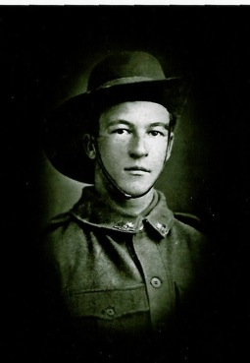
Robin Henry Davey

Serial No. 3797 Rank: Private
Unit: 21 Infantry Battalion - 1 to 12 Reinforcements (June 1915 - April 1916)

Robin Henry Davey was born in 1897 in Brighton, Victoria, the sixth of nine children of John Henry Davey and Elizabeth Watson. He attended East Kew State School. After leaving school he assisted his father, on his dairy farms at East Kew, Ivanhoe and Greensborough.

He enlisted in the 6th Infantry Brigade, 21st Infantry Battalion, and 9th Reinforcements on 22nd of July 1915, when he was 18 years old. He embarked on the ship ''Warilda" on
8th February 1916 and fought in France. He was killed at Moquet Farm, Villers Bretonneux on 26th August 1916.

Robin’s Army records have his Christian name listed as “Robert” and the medal given to
his parents after the war has this name inscribed. His mother wrote to the Army asking if it could be changed but it was too late for the change to be made. Some of the war records are also under the name of ‘Robert Davey’.

In 1917 his mother received a letter from Ray Membrey, who had been in the same battalion with Robin but had been injured and captured in France. The letter was sent from Germany to the Australian Red Cross in London.

“Dear Mrs. Davey,
I have just heard from my mother and she says that Bob is missing. I am so sorry but I do hope he has turned up by now. He is not with me but there’s a chance that he may be in some other camp in Germany as I was laying wounded in a shell hole for five days before I was captured. Of course he may have been captured before me and taken to another camp. I hope so for your sake. I have lost my left arm so am being exchanged to England. If he does happen to be a prisoner he will be treated decently, that’s one consolation. I can’t tell things I would like to in this letter - when I get back I will write and let you know all about it.
Trusting you will hear of him soon.
Yours sincerely, Raymond Membrey”

by Sylvia Tupper (nee Davey)

Robin Henry Davey is commemorated in Greensborough on the Fallen Soldier’s Memorial, Greensborough Primary School Honour Board and the Greensborough and District Honour Board at the Greensborough RSL.

James Judkins
Service No. 7507 Rank: Private
Unit: 1st Battalion
James was born in Woodend in 1895, the son of Percy Judkins and Annie Craig. At the time of his enlistment he was living at Mangalore. He was 22 years and 2 months old and working as a Farmer when he enlisted on 26th April 1917.
After training he embarked on HMAT Marathon A74 on 10th May 1917 and landed in France. He was taken on strength in the 1st Battalion and saw active service on the Western Front in France.
James’ father Percy in buried in the Greensborough Cemetery. His next of kin was Margaret Dixon (Aunt), but James medals went to Percy Judkins (Father) letter 29th June, 1921. He received the Memorial Plaque, British War Medal and the Victory Medal.
James is commemorated on the Greensborough District Honour Board at the Greensborough RSL. James is on the Greensborough War Memorial, also Woodend WW1 Servicemen & Women allocated a tree on the Avenue of Honor for James - 59 East.
James was killed in action in France on 11th August 1918.

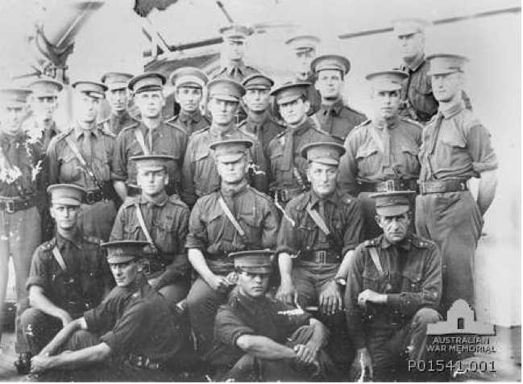
Malcolm Stuart Kennedy (shown standing far right)
Service No. n/a
Rank: Captain
Unit: 5th Light Horse Regiment
Malcolm Stuart Kennedy was born in Kew in 1892, the son of Robert Kennedy and Clementina Sobeski Stewart Robertson. His family was living at ‘St Clems’ Greensborough. Malcolm had played 17 games of football with Melbourne in 1911-12. Malcolm Kennedy was a serving soldier at the outbreak of war, having enlisted on 3rd January 1914, aged 22. A graduate of Royal Military College Duntroon, Lieutenant Kennedy was transferred from 15th Light Horse to Machine Gun Section in April 1915.
He embarked on HMAT Persic A34, landed in Gallipoli in July 1915 and suffered a gunshot wound to the wrist in August 1915; he was invalided to Alexandria for treatment. In February 1916 he obtained a ‘distinguished pass’ at the School of Musketry and qualified in the mechanism of the Lewis Gun.
Malcolm spent six months seconded to the War Office (April-October 1916) and appointed Captain 7th December 1916. He attended training as a GSO (General Service Officer) where he was “8th in order of merit – capable and very keen. Has a good deal of character. Should make a good Staff Captain and subsequently GSOIII.” (Report, Staff Course Cambridge, Dec.1916).
Captain Kennedy proceeded to France in February 1917 where he was detached for duty at 1st Division Headquarters as DSO.
Malcolm Kennedy was killed in action 2nd January 1918 in France. He suffered wounds to neck and chest. The official report of his wounding reads: “Capt. M.S.Kennedy was mortally wounded by a shell on the night of January 2nd 1918 at about 8pm. He was on his way to visit Battalion Headquarters and with three others was going northwards on the east side of Onraet Wood. As the road was under shell fire, the party was running … a shell burst at Captain Kennedy’s feet wounding him badly just below the right ribs and also in the neck … he was carried on a stretcher to the Advanced Dressing Station at Wyschaete and on reaching there was unconscious. He was taken from there by motor ambulance to the Main Dressing Station where he died about 10 p.m., regaining consciousness for a short time only.” (M.C.Viney, Lieut Col., 1 Aust Div.)
He is buried at Dranoutre Military Cemetery Belgium. Red Cross Report from Pte J.C.Dempsey: “I was present at his [Capt Kennedy’s] funeral in Dranoutre Military Cemetery when he was buried by Padre Dexter with full military honours – a firing squad of over 100 being in attendance.”
He was awarded the 1914/15 Star, British War Medal, Victory Medal and Memorial Plaque. In 1967, Malcolm Kennedy’s brother Clement Kennedy applied for Malcolm’s Gallipoli Medallion.
Malcolm Stuart Kennedy is commemorated in Greensborough on the Fallen Soldier’s Memorial and the Greensborough and District Honour Board at the Greensborough RSL.

Peter Killen
Service No. 1968 Rank: Private
Unit: 14th Battalion
Peter Killen was born in Stawell in 1884, the son of James Killen and Sarah McGinley. At the time of his enlistment his wife Lily and two sons were living at North Fitzroy, but when Lily is given as next of kin, her address is c/o Post Office Greensborough. He was 30 years old and working as a driver when he enlisted on 15th January 1915. After training he travelled on HMAT Hororata A20 and landed in the Dardanelles. He was taken on strength in July 1915 and saw active service in Gallipoli.
Peter Killen was killed in action 21st August 1915 at Lone Pine. He is commemorated at Lone Pine Cemetery.
Peter’s wife was notified on 16th September 1915 that he was missing following a report from another soldier that he was wounded. There was no confirmation of his death and letters from Lily Killen to Base records Melbourne indicate her anxiety and grief at not knowing her husband’s fate and her financial difficulties. Lily and her sons James and Peter jnr are granted pensions from July 1916. Peter Killen’s death was finally confirmed by a Court of Enquiry in May 1916.
He was awarded the 1914/15 Star, British War Medal, Victory Medal, Memorial Plaque and Scroll. In 1967, his son James Killen applied for his father’s Gallipoli Medallion.
Peter Killen is commemorated in Greensborough on the Fallen Soldier’s Memorial, and the Greensborough and District Honour Board at the Greensborough RSL.

Robert Lindsay Medley Maddison
Service No. 6951 Rank: Lance Corporal
Unit: 24th Battalion
Robert Maddison was born in Rockhampton in 1898, the son of Lewis Maddison and Helen Isabel Elms. At the time of his enlistment the family was living at Greensborough. He was 18 years and 3 months old and working as Farmer when he enlisted on 16th August 1916. Robert named his father next of kin, Lewis Maddison of “Hareah” Eltham Road, Greensborough.
After training he embarked on HMAT Ascanius A11 on 11th May 1917 and landed in France. He was taken on strength in the 24th Battalion and saw active service on the Western Front in France.
Robert’s brother Hastings served in France and at Gallipoli, he returned to Australia on the 7th May 1919.
Robert Maddison received the British War Medal, Victory Medal, Memorial Plaque and Scroll.
Robert Lindsay Medley Maddison is commemorated on the Fallen Soldiers’ Memorial and the Greensborough District Honour Board at the Greensborough RSL.
Robert was killed in action 1st September 1918 in France

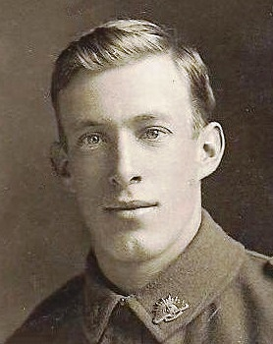
David John (Jack) Medhurst
Service No. 3190 Rank: Private
Unit: 8th Battalion
David John (Jack) Medhurst was born in Lilydale in 1894, the son of David Thomas Medhurst and Martha Ruston. At the time of his enlistment the family was living at Greensborough, where David snr ran Medhurst’s fruit shop and wrote for the local paper. Jack was 21 years old and working as an orchardist when he enlisted on 26th July 1915. He embarked on HMAT Commonwealth A73 and landed in Marseilles. He was taken on strength 24th February 1916 and saw active service in France.
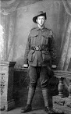
The following letter from Jack was received by his father and published in the local paper in July 1916. Three weeks later Jack was killed in action: “Letters from the Front. A NARROW ESCAPE. The following letter has been received from Private Jack Medhurst, from somewhere in France, by his father in Greensborough. Dear all at home, Just a few lines to let you know that so far I am still safe and sound. I recently got three letters from home in a bunch. They were very welcome. I have not yet received any of the presents you have sent me, mentioned in previous letters. Well, there is not much news to tell you, although we had a bombardment the other night. Fritz got angry with something, and tried to blow us off the map, but he didn't get this child, although it was near enough. You would have smiled to see us crawling on our tummies along the wet trench. I was wet through when we got to our post. We were sitting in the trench, and Harold Potts was in front of me, when a great shell whizzed overhead and burst. It was that close that it lifted my hat, and the flare burnt our faces. I can tell you that I felt myself to see if I was all there, and Harold says he saw things for the rest of the night. It was a lovely display of fireworks, but we all got out safe. Our battalion is known as "the lucky 8th." The other day we went to raid a trench, and crossing no man's land we were shelled the whole time, but none of us got hit. It was hot work while it lasted, but we got out of the scrape without losing a man. We are billeted in a loft belonging to a farmhouse. We are jolly comfortable, and there is plenty of straw for bedding. None of our chaps can talk French, and our ''landlady" - all the men are away at the fight - can't talk English, but we get on all right by signs, and it's amusing to see the old lady lining up with her plate at dinner time for some stew. We have a piano here, and Fred Starling makes things hum. There's plenty of noise, if not much melody. I saw Doug Whittingham the other day, but had not the chance to speak to him. He was just going into the trench as I was leaving. I saw Jeff Hughes, and we had a long pitch. He hadn't seen any of the 'Borough boys since he left, so you may be sure there was plenty to talk about. It's very cold here, plenty of snow, and a great contrast to Egypt, but we all like over here better. We have had a great treat. A detachment was taken over to England for a spell. I am sending an "Anzac" book from London. I must ring off now. With best love to all at home - Yours, Jack.” Heidelberg News and Greensborough, Eltham and Diamond Creek Chronicle (Vic. : 1916-1918) Saturday 8 July 1916. Retrieved from Trove 17/7/2014.
David was killed in action 28th July 1916 in France in the vicinity of Pozieres.
David John Medhurst is commemorated on the Villers-Brettoneux Memorial and in Greensborough on the Fallen Soldier’s Memorial, Greensborough Primary School Honour Board and the Greensborough and District Honour Board at the Greensborough RSL.

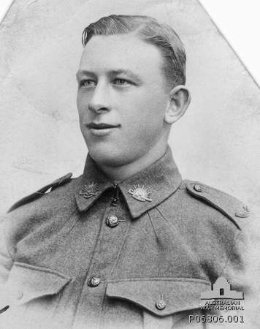
James William Poulter
Service No. 5078 Rank: Private
Unit: 22nd Battalion
James William Poulter was born in 1899 in Greensborough, the son of William Haylock Poulter and Mary Alice Dalrymple. At the time of his enlistment the family was living at Greensborough. He was 18 years old and working as a driver when he enlisted on 14th February 1916.
After training James travelled on HMAT Ayrshire A33 and landed in England on 2nd September 1916; on 21st September he was admitted to hospital suffering tonsillitis with several further admissions that year. He was taken on strength in March 1917 and saw active service in France.
James suffered a gunshot wound to his right shoulder on 18th September 1917 and was evacuated to England for treatment. By February 1918, James had been sent to Longbridge Deverill and Sutton Veny, a training base and convalescent hospital; March and April of that year saw James at Fovant Camp. These camps are all situated on Salisbury Plain.
James rejoined his battalion in June 1915 from the Training Battalion. He was again wounded in action - this time gassed - in July 1918. He was again hospitalised and treated for two months. He rejoined his unit on 26th September 1918.
James William Poulter was killed in action 4th October 1918 at PLACE. He was 19 years old. He is buried at Prospect Hill Cemetery Gouy, France
He was awarded the British War Medal, Victory Medal and Memorial Plaque.
James William Poulter is commemorated in Greensborough on the Fallen Soldier’s Memorial, Greensborough Primary School Honour Board and the Greensborough and District Honour Board at the Greensborough RSL.
James had a street named in his honour in Greensborough. What is now Jessop Street was formerly James Street and before that Chapel Street.

James Richard Purcell
Service No. 5080 Rank: Private
Unit: 22nd Battalion
James Richard Purcell was born in Greensborough in 1896, the son of Edward Caledonian Purcell and Mary Julia Gerrock. At the time of his enlistment the family was living at Greensborough. He was 19 years old and working as a labourer when he enlisted on 11th February 1916.
After training he travelled on HMAT Ayrshire A33 and landed in Plymouth. He was taken on strength in December 1916 and saw active service in France.
Soon after, James was admitted to hospital for over three weeks suffering with mumps. He rejoined his battalion in February 1917.
James Richard Purcell was killed in action 3rd May 1917 at Bullecourt. He is buried at Queant Road Cemetery, Buissy France.
He was awarded the British War Medal, Victory Medal and Memorial Plaque.
Following his father’s death in 1922, James’ mother received a small pension of 20 shillings per fortnight.
James Richard Purcell is commemorated in Greensborough on the Fallen Soldier’s Memorial, Greensborough Primary School Honour Board and the Greensborough and District Honour Board at the Greensborough RSL.

Kenneth Gordon Sharpe
Service No. 2440 Rank: Private
Unit: 3rd Pioneers
Kenneth Gordon Sharpe was born in Lobethal South Australia in 1890, the son of Robert Sharpe and Agnes Lockhart who later lived in Greensborough. At the time of his enlistment Ken and his wife Eunice were living in North Fitzroy. He was 26 years old and working as a wool carder’s assistant when he enlisted on 4th July 1916.
After spending time at the Isolation Camp Ascot Vale, Ken Sharpe embarked HMAT Karoo A10 and disembarked in November 1916 in Plymouth England where he spent six weeks with the Pioneer Training Battalion. He was taken on strength in March 1917 and saw active service in France.
Twice in August 1917, Ken was admitted to hospital and again in January 1918. He was wounded in action (gassed) on 26th May 1918 and rejoined his unit a month later. Ken was gassed again on 29th September and sent to England for treatment. By the end of October, he was diagnosed with influenza. He developed bronchio pneumonia and was moved to Fovant Military Hospital in Wiltshire where he died on 8th November 1918.
Kenneth Gordon Sharpe is buried at St George’s Parish Churchyard Military Section at Fovant and commemorated on his parent’s headstone at Boroondara General Cemetery Kew, Victoria. The official AIF burial report states: “The deceased was buried with full military honours the coffin draped with the Australian flag being borne to the graveside on a gun-carriage proceeded by a firing party and band from no.4 Australian Command Depot. Six of deceased’s late comrades supported the Pall. The funeral was attended by 2 Officers and 10 NCOs and Men of No.4 Command Depot. Wreaths from officers and comrades of No.4 Command Depot …and 3 comrades were placed on the grave. Headquarters A.I.F. Depots in United Kingdom were represented at the funeral.”
Ken’s brothers William Sharpe (Service no. 5417) and John Gillespie Sharpe (Service no. 12396) were also present at his funeral.
He was awarded the British War Medal, Victory Medal and Memorial Plaque.
Kenneth Gordon Sharpe is commemorated in Greensborough on the Fallen Soldier’s Memorial and the Greensborough and District Honour Board at the Greensborough RSL.

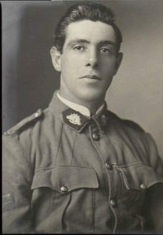
Reginald Emerson Sims
Service No. 998 Rank: Sergeant
Unit: 37th Battalion
Reginald Emerson Sims was born in Horsham in 1891, the son of John Emerson Sims and Eliza Jane Sims. At the time of his enlistment the family was living at ‘Camelot’ Greensborough, believed to be at the end of Simms Road Montmorency. He was 25 years old and working as a Post Office sorter when he enlisted on 22nd January 1916.
After training in Warrnambool and Geelong, Reg was promoted to Corporal and embarked on HMAT Persic A3. He landed in England. He was taken on strength and saw active service in France. In February 1917, Reg Sims was hospitalised for ten days with influenza. He was appointed a Temporary Sergeant in March 1917. He was wounded in action (gunshot wound to foot and arm) in September 1917; by December Reg spent time in Training Camps and as an assistant instructor. In January 1918 he was taken on strength in France.
Reginal Emerson Sims was killed in action 10th August 1918 at Proyart (Somme). He is buried at Heath Cemetery Harbonnieres.
Red Cross records contain several ‘eye witness’ accounts of Reg Sims’ death. This from Private Stanfield (No.3395) 37th Battalion: “Casualty was sniping on the Proyart Road. He was getting up to have a shot when he was hit by a machine gun bullet in the abdomen severely wounding him. I was sniping next to him and I immediately went to his assistance and helped to carry him out. I put him on a stretcher and was relieved by four stretcher bearers who took charge of him and they had not got very far when a shell exploded a direct hit killing the casualty instantly. I saw his body afterwards. He was severely wounded all over. He was buried just where he fell and I saw the cross that was to be put over the grave. He was buried alongside Lieut. Col. Knight” [Ernest Knox Knight also KIA 10th August].
Reginald Sims was awarded the British War Medal, Victory Medal and Memorial Plaque.
Reg Sims is commemorated in Greensborough on the Fallen Soldier’s Memorial and the Greensborough and District Honour Board at the Greensborough RSL. He is also commemorated on the Eltham War Memorial.

Frederick Thomas Snodgrass

Serial No. 1097 Rank: Lance Corporal
Unit: 5th Infantry Battalion
Frederick Thomas Snodgrass was born in 1895 in Yea, Victoria, the son of Archibald Augustus Hare Snodgrass and Emily Louisa Ward Davey.

When he enlisted at Kerang on 5th October 1914 he gave his uncle’s name as his next of kin, with the notation (no parents). In fact, his father was serving overseas in the 1st Australian Remount Unit in 1914 and then in the 4th Light Horse Regiment in 1917.

He embarked on HMAT Orvietto A3 and saw active service in France and Belgium.
He was admitted to hospitals in England and Cairo for diphtheria twice during his service and was wounded in action three times and mentioned in dispatches in April, 1917. “This soldier was a member of the special section of the Intelligence Platoon, which was detailed to reconnoitre the enemy position, previous to a raid. He reconnoitred No Man’s Land in the daylight, and after the raid was most active in searching No Man’s Land for wounded comrades and evidence. He also, after his duties were finished, volunteered for and carried out the duties of stretcher bearer.”

Frederick Snodgrass was killed in action 20 September 1917 at Belgium. He was buried 300 yards west of Glencorse Wood.

On his file are letters requesting information from the next of kin given on the enlistment form - his uncle, Ernest Davey, a cordial manufacturer in Kerang, as to where to send his victory medals. Ernest replied that Frederick had no brothers or sisters living; his mother was also dead, and he had no knowledge of his father, so the medals should be sent to him at Kerang. However the army ascertained that his father was still living and had returned to Australia from the Veterinary Hospital on 27th January 1920 and so the medals were to be sent to him. The receipt for his memorial plaque was signed by his father A. A. H. Snodgrass on 23rd September 1922.

Probably the reason that Frederick has been included on the Greensborough War Memorial is because another uncle, John Henry Davey, lived at Plenty Farm, Greensborough. Quite likely Frederick was one of the nephews that were employed on the dairy farm from time to time. John Davey’s son Robin had also been killed in the war and his name was being inscribed on the War Memorial so the family thought it was fitting that Frederick’s sacrifice should also be remembered.

He is commemorated at Menin Gate Memorial, Ypres, Belgium. Frederick is commemorated in Greensborough on the Fallen Soldier’s Memorial.
Sylvia Tupper (nee Davey)

Benjamin Alfred Starling
Service No. n/a Rank: Second Lieutenant
Unit: London Regiment - Royal Fusiliers
Benjamin Alfred Starling was born in Greensborough in 1878, the son of John Henry Starling (snr) and Jane Gapper. At the time of his enlistment his family was living at Main Street Greensborough where his father was a shopkeeper and post master.
In 1892, Benjamin Starling received a State School scholarship to attend Hawthorn College and later Melbourne University where he completed a Bachelor of Engineering, conferred in 1900. Ben had worked on railways in Gippsland before travelling to Malaysia (Malay Free State) to work on railways there before the outbreak of War. He travelled to England to enlist.
He joined the London Regiment, Royal Fusiliers.
Benjamin Alfred Starling was killed in action 23rd March 1918 France. He is commemorated at Roclincourt Military Cemetery. His death date coincides with the First Battle of the Somme 1918, namely the battle of St Quentin 21st -23rd March 1918.
He was awarded the British War Medal and Victory Medal.
Benjamin Alfred Starling is commemorated in Greensborough on the Fallen Soldier’s Memorial, Greensborough Primary School Honour Board and the Greensborough and District Honour Board at the Greensborough RSL.
After his death, his family received correspondence from a Solicitor in England stating that in his Will, Benjamin had left everything to a widow by the name of Rosina Amelia Taylor. The family was very surprised by this as there had never been any mention of her in any of Benjamin’s letters, although Rosina herself claimed to have been his fiancée for the past three years. Some further research revealed that in 1915, Rosina’s husband had filed for divorce, naming Benjamin Starling as the co-respondent!
Ben’s older brother John Henry Starling (jnr) was Secretary to the Governor General, transferred to the Prime Minister's Department in February 1912 and was appointed Chief Clerk in September 1917. He had a distinguished Public Service career.

Richard Lewis Weir
Service No. 537 Rank: Private
Unit: 21st Battalion
Richard Lewis Weir was born in 1894 in Northcote, the son of Adam Weir and Ellen Potter. His next of kin Catherine O. (Crosswell) Weir was his step mother. At the time of his enlistment the family was living at Bundoora. He was 20 years old and working as a farmer when he enlisted on 28th September 1914. His father died in March, 1915, six weeks before Richard embarked.
After training he travelled on HMAT Ulysses A38 and landed in Gallipoli on 29th August 1915. He was taken on strength and saw active service in Gallipoli and France.
In November 1915, Richard was admitted to hospital for a week suffering influenza. When recovered he proceeded to join the British Expeditionary Force and disembarked in Marseilles in March 1916. From December 1916, Weir was promoted through the ranks to Corporal (1st February) and Sergeant (16th May). Following hospitalization in France with scabies in August 1916, he was granted a 10-day furlough to England. In November 1917, he was awarded the Distinguished Conduct Medal and selected to attend officer training in England. He qualified as an officer in May 1918 and was appointed 2nd Lieutenant. He proceeded to France in June 1918 and was awarded a Military Cross in July 1918.
The citations for his Distinguished Conduct Medal in November 1917 and the Military Cross in September 1918 follow:
Sgt Richard Lewis Weir, 14th October 1917: “For conspicuous gallantry at Broodseinde on Oct.9th. After all Officers had become casualties, this NCO immediately took charge and collected his men who had become very scattered and led an attack on an enemy machine gun position on the edge of Daisy Wood which was holding up the company. After putting this gun out of action he led his men to a position north east of Daisy Wood and established there until relieved by the 49th Battalion on the night of 9/10 Oct.” (Brigadier- General J. Paton)
2nd Lieut Richard Lewis Weir: 8th July 1918: “Near Villers Bretonneux on the morning of 4th July this officer led his platoon during the attack. On reaching the objective his command being harassed by snipers and machine gun fire from a small system of enemy trench; he crawled out in broad daylight and reconnoitred the position with a view of mopping it up. He then organised his rifle grenadiers and with the assistance of a trench mortar forced the enemy to withdraw. In the evening he led his platoon against this trench system occupied it, killing 7 of the enemy and capturing one machine gun. The following morning in the face of machine gun fire he pushed out new posts. This officer displayed great dash and courage.” (Brigadier-General C.H.Brand)
Richard Lewis Weir was killed in action 26th July 1918 at Villers Brettoneux. He is buried at Villers Brettoneux Military Cemetery.
Red Cross records provide the following eye witness account of his death: ‘"I saw Lieut. Dick Weir of A.I. hit in the stomach in front of Villers Bretonneux at night (about 10-10.30 p.m.) whilst leading a fatigue party at the time. He was carried back by two of the men to the R.A.P. and died on the stretcher on arrival there. He was buried at the Austral Military Cemetery and a cross and head stone were erected. The news of him [being] awarded the ‘M.C.’ came through on the night he was killed. Lieut Weir was a fine fellow and a good soldier, well-liked by the men". (M. J. W. Irwin, 186, 21 Battn. A. Coy)
Richard Lewis Weir was awarded a Military Cross, Distinguished Conduct Medal, the 1914/15 Star, British War Medal, Victory Medal, Memorial Plaque and Scroll. On 1968 his brother Alexander Weir applied for Richard’s Gallipoli Medal.
Richard Weir is commemorated in Greensborough on the Fallen Soldier’s Memorial and Greensborough Primary School Honour Board.

Henry Douglas Whittingham
The Whittingham boys: Four went to War but only three returned: by Rosie Bray
  - Sons of Walter Stanley and Elsie (called Lily) Whittingham.
To have one son serving king and country in the Great War (1914-1918) was considered to be patriotic. To have two sons serving was called committed, and to have three sons in the armed forces was thought to be commendable, however to have four sons in uniform and overseas was admirable, and that was the situation in the Whittingham family during World War One.
The Whittingham family were a typical rural family, who had moved from Alice Downs Queensland and had settled in the Greensborough area. They took up a holding, were a hardworking and respected family in the district. However, because of the pressure of the day for the young men to ‘go to war and fight for the Empire’, one cannot imagine the feelings of the parents when they signed the enlistment papers. Were they sad or glad, and would they ever see their sons again?
WW I did change the Whittingham family. One son did not return and one son brought home an English bride.
All four Whittingham boys were born in Blackall Queensland, but they enlisted from Greensborough, and always considered to be Burra Boys.
Two Whittingham sons (Henry Douglas and John Cecil) enlisted on the same day August 20 1914.
Henry Douglas Whittingham
Serial No. 1592 Rank: Private and gunner
Unit: 6th Battalion and 2nd Field Artillery Brigade
Henry Douglas Whittingham gave his age at 19 1/2 years and his occupation as a farmer with three months training as a cadet.
Henry Douglas Whittingham became a gunner in the 4th Battery Field Artillery Brigade and sailed for Overseas Service from Melbourne on October 19 1914 on HMAT Hororata A20. His father, W.S. Whittingham, signed his enlistment papers.
Unfortunately Gunner H.D. Whittingham service was killed in action on April 15 1917 aged 21 and 5 months in Lagnicourt. France. His body lays in Queant Road Cemetery, Buissy, Pas de Calais France and his name can be located at panel 12 in the Commemorative Area at the Australian War Memorial.
H.D Whittingham was well known in the Greensborough district as a fine athlete excelling in foot running and he was also known to have had a brilliant brain. The memoriam notices in the Melbourne Argus (1848-1957) Monday April 15 1918 p 1, show to what extent the family felt the loss of a son, brother and uncle and friend.
Greensborough people remember his sacrifice with his name on the Fallen Soldier’s Memorial in War Memorial Park Greensborough. Along with his brothers he is also commemorated on the Greensborough Primary School Honour Board and the Greensborough and District Honour Board at the RSL.

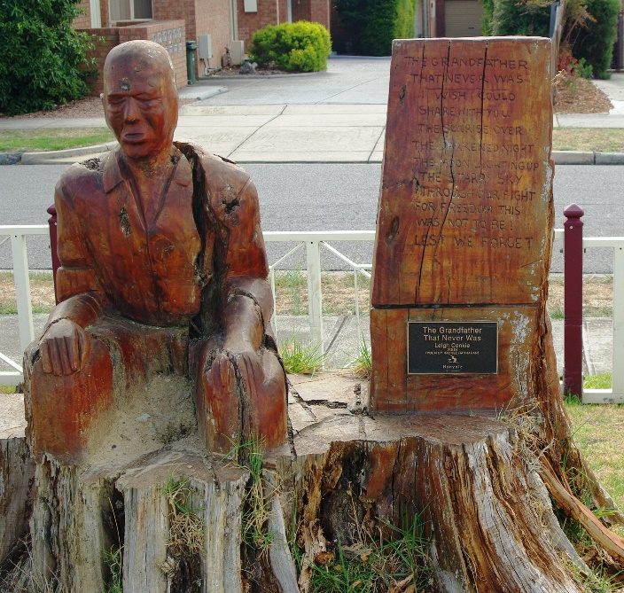
Greensborough War Memorial Park Sculptures
Artist – Leigh Conkie
The removal of unhealthy trees from the park in 2003 led to an opportunity to create decorative public art works from the remaining stumps.
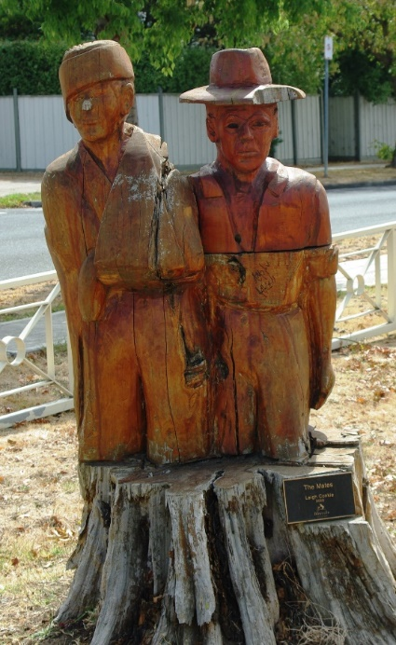
Chainsaw artist Leigh Conkie was commissioned by Banyule Council to create 12 individual figurative sculptures that represented the use of the park as a War Memorial. Support and inspiration for the project came from the Greensborough RSL and the public in general.
The sculptures remember the lives lost and the important contribution the Armed Forces have made to Australia.
Two of the sculptures represent Leigh Conkie’s father Charlie Conkie, who served in World War II, and his grandfather father, Billy Turner who served in World War I.
(Source for text: Greensborough War Memorial Sculptures: Leigh Conkie, 2004, Banyule City Council)
Photographs courtesy Marilyn Smith

