GREENSBOROUGH RSL HISTORY
The first recorded history of a meeting involving WW1 veterans was at the house of Alex Spence in Briar Hill in 1929. Those known to attend were Alex Spence, Reg Riglar, Gus Lines, Reg Jackson, Alf Gee, Vic Coe, Frank Gibb, Jack Andrews and without doubt, others who are not known. From the records available it appears that the main item of discussion was what to call the club as those of the day appeared to think that Briar Hill would develop quicker than Greensborough. Unfortunately all of those known members who attended this inaugural meeting in 1929 have passed away, the last being Vic Coe who passed away in 1988.
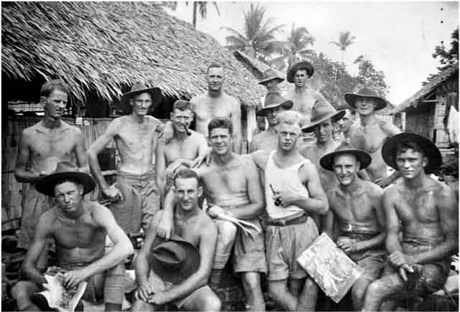
No records are available about what occurred between 1929 and 1931. So what business was discussed during this period is anyone’s guess. The first charter was issued to Greensborough RSL Sub-Branch by the Returned Sailors, Soldiers & Airmen’s Imperial League of Australia in 1931. This is a known fact but no names of a President (R,Hardely) or Secretary (D.V. Todd) appear on our honour boards until 1934.
It is rumoured that there was dissension amongst those early members, and a break away group left to form the Montmorency RSL. This, however, cannot be proven but it may explain why the original charter was not replaced until March 1961 in the name of Greensborough RSL Sub-Branch. The reason for this is unknown.
Early meetings took place in members’ homes until it was agreed to hold meetings in the foyer of the local Masonic Lodge. Other memories are of meetings being held at the Ashrill Movie House. Both of these are correct as the Masonic Lodge met on the top floor of the movie house. Minutes of these early meetings have been lost, so what was discussed or actions taken by the Sub- Branch are not known. After WW2 it was obvious that the Sub-Branch undertook a membership drive. Letters were sent to all Returned Service Men inviting them to a meeting with the notion of gaining new members. One of these men was Allan Beecham, who has now been a member for over 50 years. The extended club now set out looking for a permanent home and two blocks of land were bought from Alf Shaw who operated a service station on the site of what is now Diamond Valley Cycles. In 1952, when bought, these blocks cost the grand sum of 402 pounds each.
This remains our current site today. In the 1950’s a Nissan Army Hut was erected on the site by members as their meeting hall. As numbers grew it became apparent that bigger rooms were needed. In the early 1960’s the Nissan Hut was demolished and a new building using concrete blocks and cement sheeting was built by the members. In 1961 this structure was moved to the back of the block and the hall was built by the members. At the completion of the hall it was found that part of the hall had been built on the adjoining property that was owned by Horrie Burkett. This required a cash settlement to be made to Horrie Burkett for the purchase of the piece of land that the hall was built on. So finally the new hall with the old concrete building attached was officially opened by Gus Lines OBE in 1962.

