The Early Squatters of Lower Plenty and Montmorency
(Between 1836 to 1840). Outline of talk presented
by Peter Van Eeken on 18/3/2016.
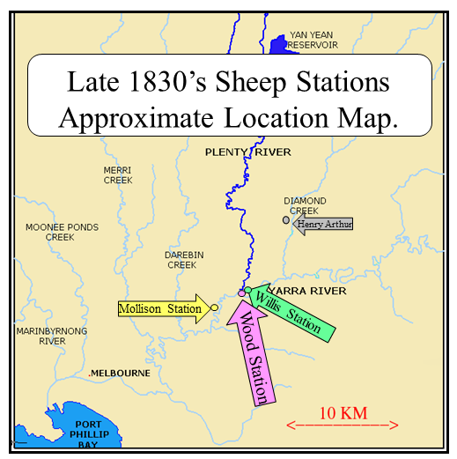

On 28/3/1837 Governor Bourke passed through Mollison’s and Wood’s Stations, noting good stands of Stringy Bark, Box and Mountain Ash. His description is suggestive of why the future Montmorency Farm was so named due to the thick expanse of tree growth along the Plenty River which Joseph Tice Gellibrand so named in February 1836. The name “Montmorenci” was first used in March 1840 when the land was advertised for sale (and sold to Stuart Donaldson who later became the first premier of N.S.W. on 6/6/1856). Perhaps the name was used so as to entice prospective purchasers, suggesting the land was beautifully and thickly forested as that of town Montmorency, on the outskirts of the city of Paris of those times.
The title of this talk is a slight misnomer as 'Lower Plenty', 'Montmorency' and 'Heidelberg' were terms not in use until 1840 at the earliest. Governor Bourke’s log entry on 28/3/1837 draws one’s curiosity and fascination to think back to those early times and understand more of the goings-on and footsteps of the first European feet to walk around the area of the confluence of the Yarra and Plenty Rivers. This area was traversed by the early surveyors Robert Hoddle who requested his draftsman Thomas Henry Nutt to survey the Plenty River in February 1838. However, it was before Governor Bourke and the later surveyors, that the land was explored and utilized by squatters Henry Arthur, Alexander Mollison, John Wood and members of the Willis Family.
It was in June 1835 that some surmise John Batman signed a treaty with a group of some 45 aborigines about 4 miles or so upstream on the Plenty River, up from its confluence with the Yarra. Joseph Tice Gellibrand (one of Batman’s confederate members of the infamous Port Phillip Association) was lured to and named the Plenty River in mid-February 1836, due to the fact it had the largest flow of water of any tributary into the Yarra. Another of Batman’s Port Phillip Association confederates, Henry Arthur, arranged for Batman to land some sheep at Port Phillip on 30/8/1835. John Batman landed some 2,500 sheep on that day, a portion of which belonged to Henry Arthur and his business associate Michael Connolly. It can be presumed Arthur assigned some convicts (or ex-convicts) to take his sheep to his allotted Port Phillip Association Land Portion 8, where he established a sheep run that he held until 1841. Arthur did not set foot on Port Phillip until February 1836 which is indicative of the role of convicts/ex-convicts, who were the real establishers of the Port Phillip District in the first 12 months after Batman signed his “Treaty” of 6/6/1835. Arthur built a homestead overlooking the future Diamond Creek Township in today’s Challenger Street. Sources are few and scarce and depending on what you read, Arthur and Connolly ran between 100 and 1,000 sheep on the station. It was after Arthur sold his run in 1841 that the then Arthur’s Creek tributary became more commonly regarded and referred to as part of the larger Diamond Creek. Arthur was declared a bankrupt in 1843 and died in Longford Tasmania on 9/6/1848.
On 5/6/1837 Thomas Walker (a major and future land owner in Heidelberg): ”proceeded on Friday afternoon on an excursion up the Yarra Yarra. We were accompanied by Mr. Edward Willis (son of Mr. A. Willis, of Wanstead, Van Dieman’s Land) to whom I was introduced by Mr. McIntyre, of Willis, McIntyre and Co., Sydney. It came to rain shortly after we left, and night also closing in, we did not get so far as we intended, but had to stop for the night at a settler’s Mr. Mollison’s, where we slept on the floor before the fire, but with cloaks and blankets enough to keep us warm, so that I never slept more soundly. I think no class of people live in a rougher way than many of the settlers do here at present. Mr. M. is erecting a hut, which will be well enough when finished, but in the meantime it is open and comfortless; no furniture has he except a bench or stool, a broken cup or two, tin panicans, a couple of knives and forks, and a plate or two”. (Taken from Walker’s self published article of 1838 “A Month in the Bush of Australia” Page 50ff). Later, various books and authors had trouble specifically identifying who this Mr. MOLLISON, referred to by both Bourke and Walker, was. It is only by reading an article in the supplement of the Argus of 3/6/1945 (Page 20s) that one can read a quote of Alexander Mollison in his 1942 letter to his sister Jane in London: "Five years ago I first landed on the banks of the river Yarra-Yarra and found only half a house and some tents, and it was nearly two years later when the town allotments were sold and people began to build." It is this letter that proves Alexander Mollison was the Mollison encountered by Bourke and Walker. It also makes one wonder who built the half house and tents that were left behind on the Yarra Yarra? Was it Mr. Henry Arthur or his band of unknown hired help? One will never know and if it was, why did they leave them behind abandoned? At the very end of 1937 Mollison moves overland to take ownership of his nearly acquired Colliban Station near Woodend… leaving the Yarra Yarra he writes to his sister Jane: "My party consists of 30 men and a superintendent or overseer, besides two native blackboys. We have with us five thousand sheep, 600 horned cattle, 20 horses, two little pigs, and 40 working bullocks, besides an infinite number and variety of dogs. So you see there are enough of us to enliven the solitude of the forests and to astonish the poor natives and the kangaroos. Our provisions and baggage are carried by four bullock drays and two horse carts.” With such a retinue it gives some indication why Robert Walker was able to sleep soundly before Mollison’s fire some six months earlier.
Captain William Wood, of ‘Snakebanks’, Van Diemen’s Land,
wrote to the Colonial Secretary 20th May 1836:
I take the liberty of representing to you that finding great difficulty in procuring land for my family (seven sons in number) in this Colony, I have sent one of my sons (J. N. Wood) to Port Phillip with a flock of sheep, and that whenever it may please His Excellency the Governor of New South Wales to allow land to be sold there, he is ready to bid for it, or to become a renter, or to submit to any other plan or regulations that may be determined on by him. John Nicholas Wood spent his first months in the Port Phillip Colony on the Werribee River under the guidance of the Wedge Family. He was present at the first public meeting for the colony’s temporary method of government on 1/6/1836. This meeting was at John Batman’s house with John Faulkner also in attendance. The meeting agreed to place a 5 shilling bounty per head on wild dogs and that it be illegal to teach the aborigines to use firearms. In the next month, Wood led a party along the Werribee River to search for the murderer of a Mr. Frank and his employee had taken place. It was this incident that led Governor Bourke to send down William Lonsdale to head an enquiry into the death, an enquiry that established a Melbourne template for later enquiries. Around this time Wood established his sheep run on the east bank of the Plenty River at its confluence with the Yarra. James Willis (on 8/6/1837) stated Wood’s to be a good natured little fellow though his manners are not the most refined.
Six weeks later, Woods was to be instrumental in saving Willis’s life when James had contracted a life threatening infection. On the 18th April 1837, it was Old Tom, a shepherd of Wood’s, who assisted the Willis Brothers in moving into the Plenty River some two miles upstream from the Yarra. Wood was to buy a half acre of land in Melbourne on 1/6/1837 and was to become an overseer for Mr. Ebden. In early 1838, six escaped convicts, in an armed raid on the station of Mr. John Wood, took flour, meat and a small double-barrelled pistol. These ‘bushrangers’ were convicted of also stealing Mr. Farkner’s boat from the Yarra Yarra and some 100 years later, the Greensborough resident, Mr. Partington, was to allude to the above when he once stated: The Montmorency forests were the hideouts of the local bushranger population.
The Melbourne Court Register of 11th Dec. 1838 shows Mr. Wood’s complaint before William Lonsdale Esquire toward a John Cronan on the 8th inst., at Melbourne who did allow an entire horse of inferior breed to go at large in the town. Cited in the Port Phillip Gazette on Wednesday May 8th 1839, Page 2, is this advertisement: To Let: One Thousand and Six Acres of good Grazing Land, on the Darebin Rivulet, about twelve miles from Melbourne. For particulars apply to Mr. John Wood. In 1839 John Wood was secretary to a committee organising horse races near Melbourne. There is scant or no indication of John Wood’s activities in the 1840s until you read the article in The Sydney Morning Herald 16th April 1850 Page 2. Here it informs the reader of the death of John Nicholas Woods in Sydney after visiting friends and a ten day drinking bout. He died owing a publican some £40 to £50 in debts. Died, on the 20th ultimo, at the residence of Mr. A. Layard, Sydney, JOHN N. WOOD, second son of Captain William Wood, of Hawkridge, Snake Banks, Van Diemen's Land. Hobart Colonial Times 14/9/1849 Page 2.
The last of our squatter arrivals set camp behind the now Lower Plenty Hotel on 18/4/1837. They were Edward, James and Arthur Willis who made immediate acquaintance and assistance from John Wood, their neighbour. The four were eager to assist each other and explore the Plenty River northwards, noting the thick forests in the process. It was James who was to bestow history with his wonderful three month account of life along the Plenty River. He always loved his visits to the settlement (ie: Melbourne) to catch up with mail and gossip. His final account of his time on the Plenty is via a letter to be found in ‘The Willis Papers’ held at the State Library. On 24/3/1939, as he was leaving the area (having notice to ‘quit’ due to the imminent land sales) he warns the reader about the possibility of taking his hut: “I’d scarce recommend you. For the fleas will soon make it prodigiously clean. That their bloody attacks are not meant to befriend you. This useful bit of information mind is given gratis. For the thriving squatter to the flea good bait is”.
Arthur Willis did not last long on the Plenty having “tasted enough of the pleasures of squatting”. Arthur was older than the two Willis Brothers (he was their uncle) and had many and varied business and company interests in London, Sydney, Hobart, New Zealand and now Melbourne, being one of the first agents to send a wool ship direct from Melbourne to London (on 15/1/1839). Arthur had his son managing affairs in London and was very successful in establishing and linking numerous business pursuits between London and the colonies. He was a director of the Port Phillip Bank too. After spending a decade in the colonies, he returned to London (with two servants) on The William Jardine on 1/2/1845. His brother Richard had already preceded him sailing back to their Wanstead ancestral home in February 1839. Arthur would have known the parents of John Wood, along with Stuart Donaldson, who later bought Montmorenci. John Wood’s mother, Marie Hyacinthe Genevieve de GOUGES, was an extremely beautiful woman and her family very high up in the French Royal Courts. One wonders if this link has any association with the creation of the name Montmorenci, but such will remain a mystery to ever changing folders of history.
It is Edward Willis who will be forever looked on as a somewhat father figure of sheep in the local area, and more especially in Geelong where he and James settled in the early 1840s.
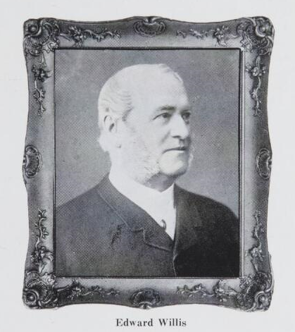

In association with Captain Charles Swanton, Edward was to establish ‘Koolomurt’, one of the finest merino studs in Victoria. He tried his hand at other business enterprises, such as wool broking and coal, was on local Geelong boards of the Anglican Church, Infirmary and Benevolent Asylum. He also presided at sessions of the Geelong Police Courts. Edward sent his sons to be educated in England where he himself returned in 1894 to retire, dying a year later on 9th August 1895. His brother James was to become Geelong’s first town treasurer and work as a Court Clerk and Warden before dying on 28/3/1873 at his home ‘Euroa Cottage’ Punt Road, South Yarra.

