Rosie Bray.
Multicultural, Arts Victoria.
‘What happened at the Pier’.
Journeys of migration exhibition held at the Eltham Library
On May 21st 2016 .
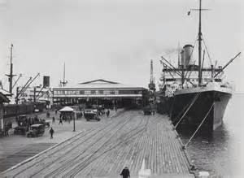

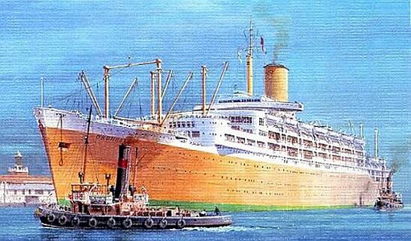
It was like old home week at the Eltham Library on Saturday May 21st 2016.
The room was abuzz with excitement.
Some friends renewed friendships, whilst others made friends quickly, all because they had one major thing in common. Most of them were migrants who landed in Melbourne soon after World War Two came to an end.
There were ohs and ahs and laughter at the exhibition photos mounted on the surrounding walls. Every now and then “Remember this” could be heard.
People were allowed an hour to view these visual memories before the public forum “From Displacement to Social Inclusion” began at 3pm.
Greensborough Historical Society’s contribution to the event was the history of the Whatmough family and how they settled in Australia.
Guest speakers were introduced by the Exhibition Curator Lella Cariddi Pictured below

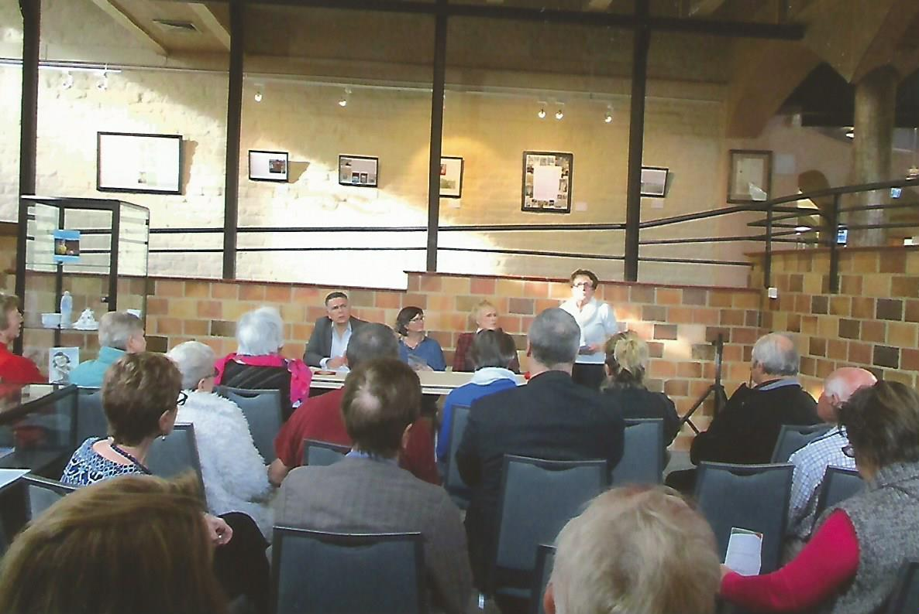

First of the Forum Speakers, Philip Morrissey.
A Murri scholar and Academic Coordinator of the Faculty of Arts Australian Indigenous Studies Melbourne University.
Philip took the attendees back to 1926, the last of the big massacres in which the indigenous population were involved in. He emphasised that this was a part of aboriginal displacement and must be recognised as, not separate but part of Australia’s history. Philip asked those present to understand the sense of belonging and how the indigenous people would be feeling at this time.
Second of the Forum Speakers was Dr Gwenda Tavan
A senior lecturer and current head of the department of Politics and Philosophy at Latrobe University.
Gwenda took us back to a time of displacement and resettlement and how the newly landed migrants (her grandparents included) learned to find a home and make a living for their families. Gwenda told that there were also many sad stories, and one of these was the case of Nancy Prasad. Gwenda was so curious about the ending of this case that she researched and met Nancy many years later, and she was delighted to report that Nancy had made a great life living back in Australia,. She worked for Qantas Airlines, later happily married and had 4 children.
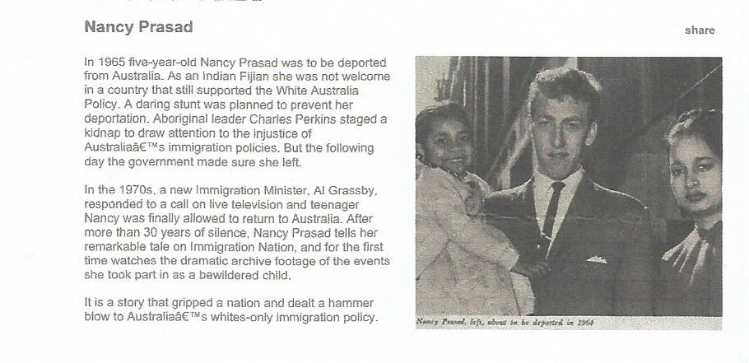
The third Forum speaker Zora Frank , was not listed on the invitation, but she certainly had a migrant story to tell and had all the audience laughing and crying with early memories of their arrival in Melbourne.
Zora, told tales of being a citizen of four countries, and her times in a refugee camp in Italy. She really had the most amazing recollections of resettlement in Australia and how she became a well known dressmaker. Lots of the people present could relate to these times and there were many questions at the end of Zora’s talk. Below. Philip, Gwenda and Zora with Lella on the side line.
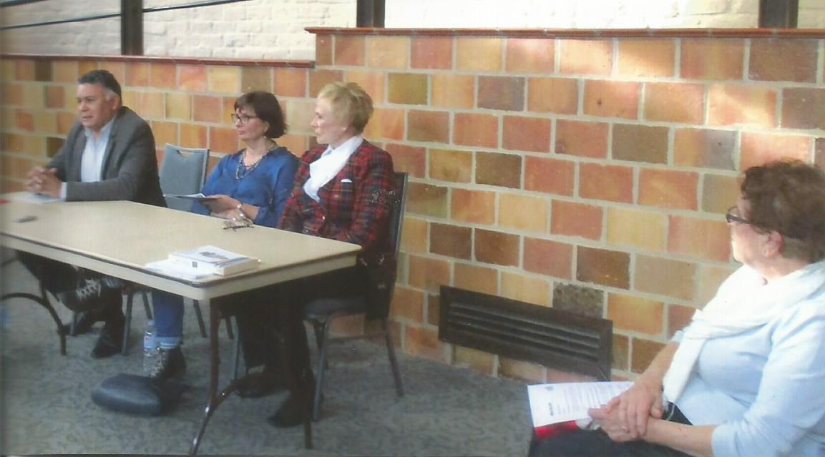
Below. Dr Gwenda Tavan and Noel Withers (President of Greensborough Historical Society).
