SPLATT – STARLING Family

**We need your help !**

Society member, Val Wilson (nee Rolfs) has contributed much to the Society with her research on many of the districts early settlers and indeed many of those are related to her own family. Val has an extraordinary talent for local history research and took us by surprise when she asked us for help with the photo below - surprise, because it is usually us asking Val. So here goes Val. Let's see who else can help.

|  |
| --- |
| [http://2.bp.blogspot.com/-aIEjBYGV364/TrCCkD6zB9I/AAAAAAAAAJg/sI1shEnWZTg/s200/Splatt_Starling_Family_cropped-3.jpg](http://2.bp.blogspot.com/-aIEjBYGV364/TrCCkD6zB9I/AAAAAAAAAJg/sI1shEnWZTg/s1600/Splatt_Starling_Family_cropped-3.jpg) |
|  |

Val has already identified two of the gentlemen in this wonderful old photo, namely:

* **Barl Splatt**  
  *(Back row: 3rd from right)*
* **Johnny Starling**  
  *(Middle row: 1st from right)*

Other possible information is the location may be Greensborough and it might be associated with the local 'Roads Board' or "Railway League" of the day.

---------------------------------------------------

**Update: 4th November 2011**

The Society's President, Noel Withers, has trawled through his huge collection of historic photos of the district and has offered other possible names for the record:

* **Louis Amiet**  
  (*Middle row: 3rd from right) - Head teacher at Greensborough Primary School (1895-1917)*
* **Johannes Adam Bosch**  
  (*Back row:1st from right) - Land holder where the 'Batman' apple tree is today*

Val has also provided some extra details which she now thinks the reason for the group is that they may have belonged to the Railway League. This group tried to persuade the Government, who were surveying land between Whittlesea and Heidelberg, to deviate the railway route through Greensborough but there was no love lost between Greensborough and Diamond Creek over more than railways. John Starling (in the photo) is well documented in local newspapers of the day as a protagonist for many local issues.

---------------------------------------------------

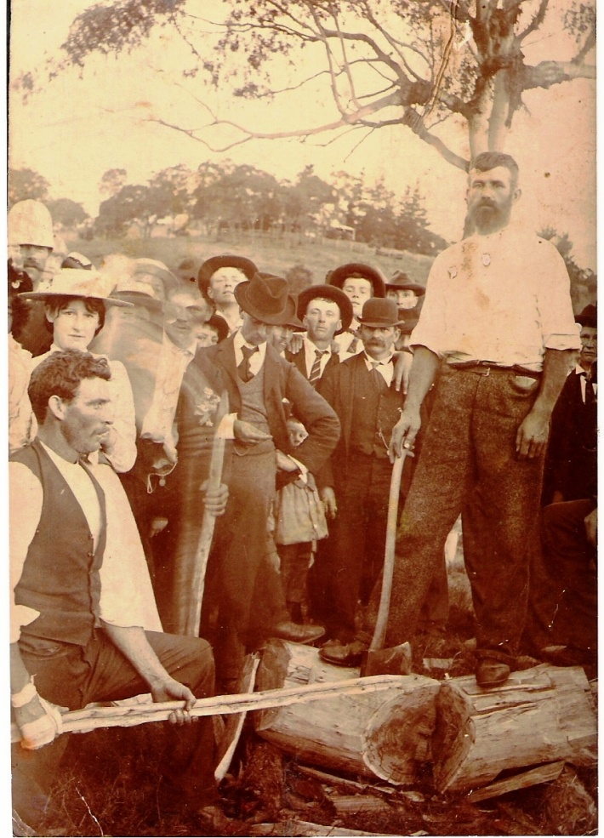 Barl Splatt

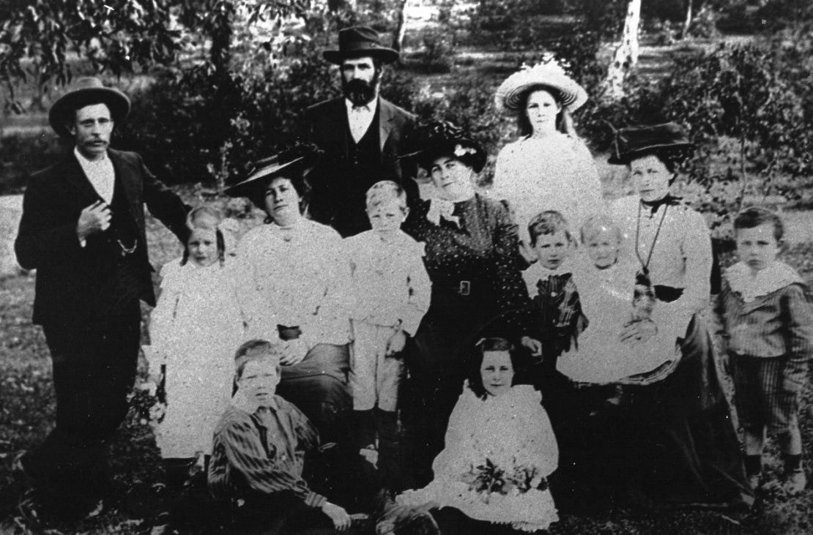

Barl Splatt and family

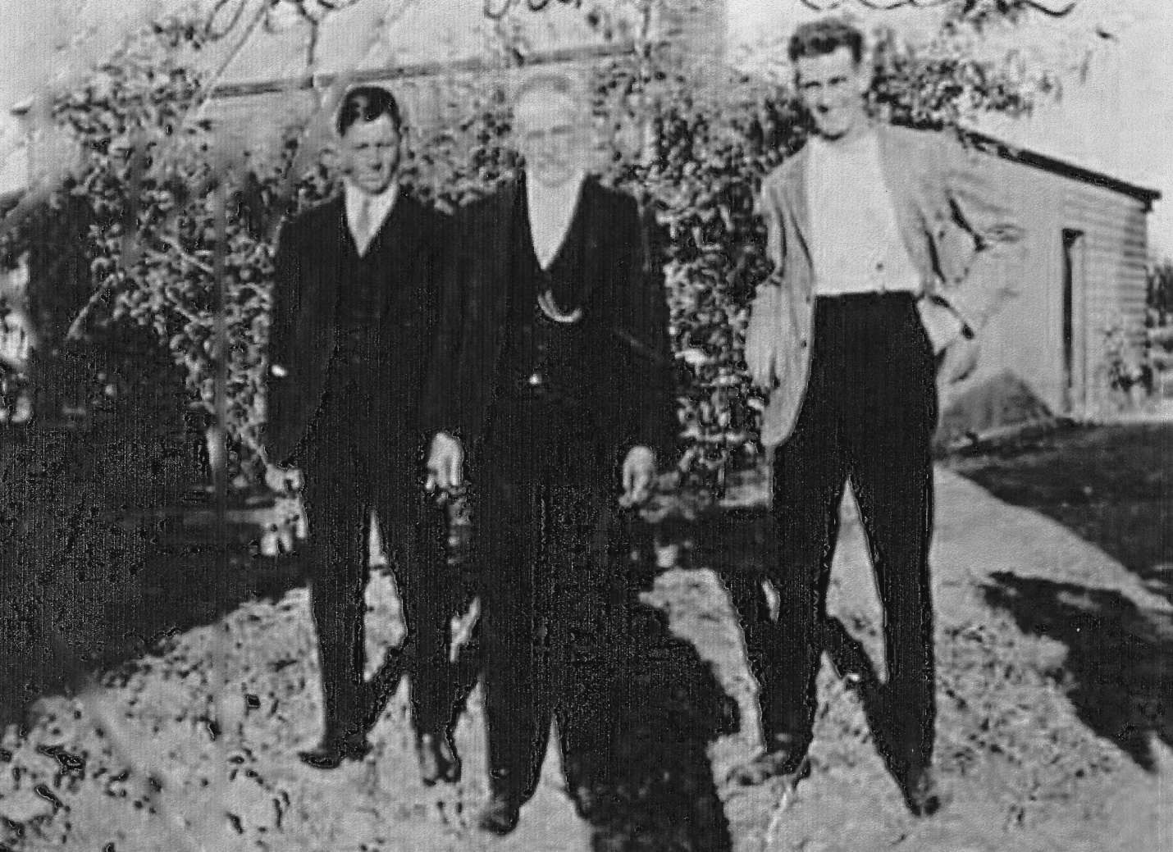

Barl Splatt with sons Joe and Clem