ALEXANDER JOHN MCDONALD’S GREAT WAR
Alexander John McDonald, who had been born near Whittlesea, was keen to go to war and enlisted as early as 18 September 1914. He was aged 21, fit and a 5’ 5½” tall farm worker, so was snapped up for B Squadron of the Victorian 8th Light Horse Regiment.

In the early expansion of our forces caused by the large number of volunteers, the 8th Light Horse along with the 9th (composite Victorian & South Australian) and the 10th (Western Australian) were grouped to make up the 3rd Light Horse Brigade in October 1914.
The 8th initially comprised a Headquarters unit, three Squadrons of mounted riflemen, and a supporting machine gun section. During the war it received 31 Reinforcement drafts and all up 2,724 men served in the 8th at some point.
The Light Horse wore their ‘Rising Sun’ badge on the turned up left brim of the slouch hat, with an emu feather as a plume. Later most moved the badge to the hat’s front and wore the brim down for better sun protection. To improve Regimental appearance chestnut horses went to A Squadron, bays and light browns to B Squadron and dark browns to C Squadron.
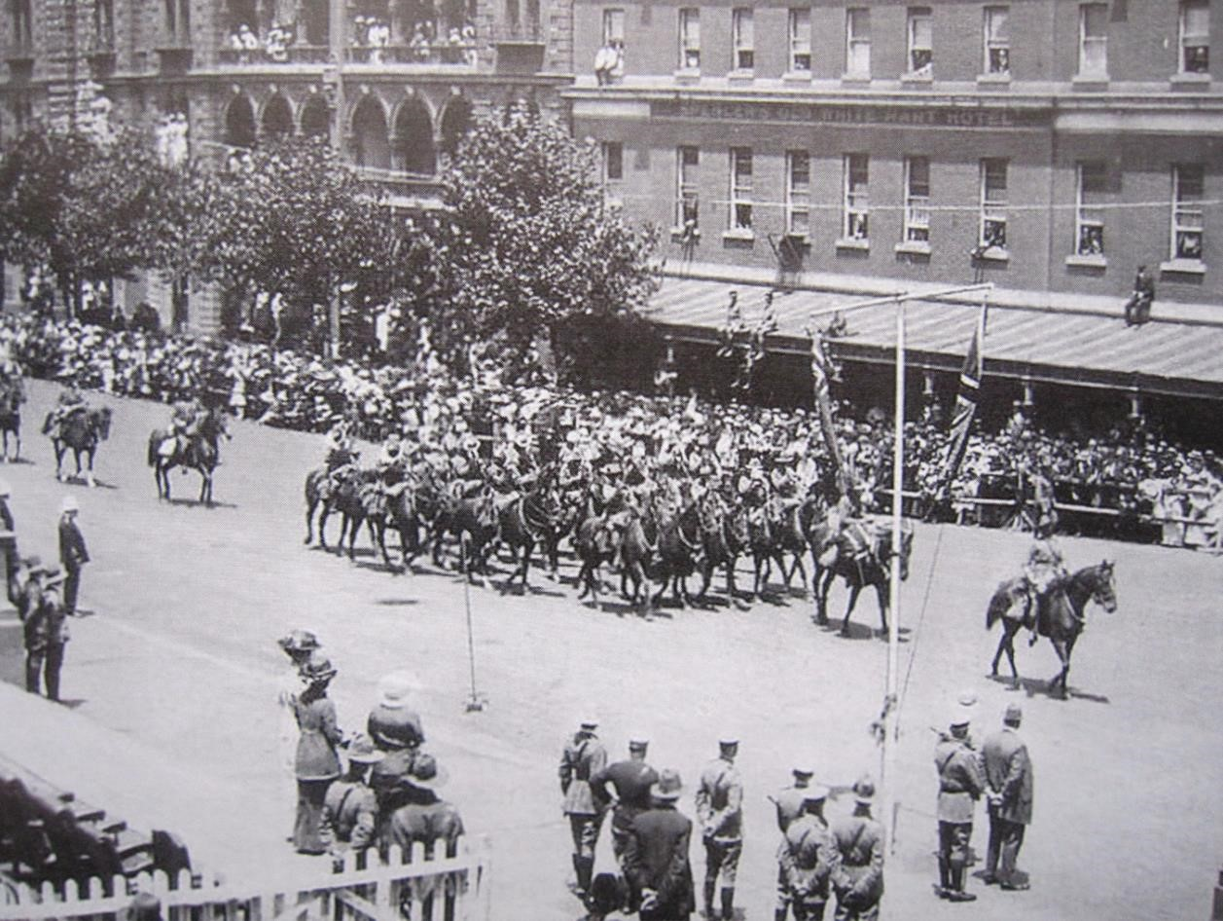
This photo of the 8th Light Horse Regiment parading through Melbourne in January 1915 shows the horses grouped by similar colour.
Alexander was with the 8th when they embarked with their horses on the Star of Victoria on 25 February 1915, comprising 48 officers and other ranks in Headquarters, 28 in the machine gun section, 154 in A Squadron, 157 in B Squadron, and 154 in C Squadron, a total of 541 all up. They reached Colombo, Ceylon on 18 March and Aden on 28 March, finally arriving at Suez, Egypt on Good Friday, 2 April.
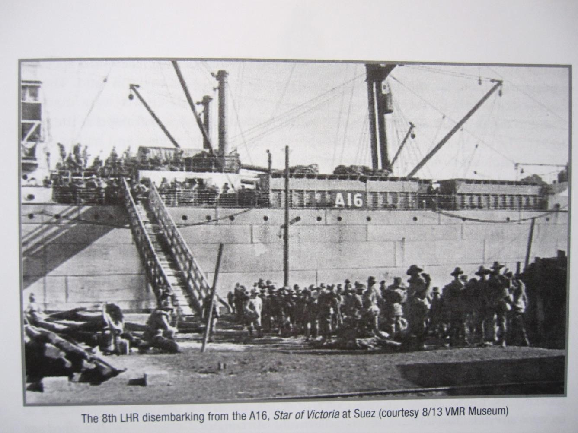
After only a few weeks in Egypt the 8th watched the Australian infantry leave Mena Camp for Lemnos Island and the invasion of Gallipoli. The 8th then moved camp to Heliopolis. Soon, wounded from Gallipoli were arriving at 1 Australian General Hospital which operated nearby.
Gallipoli

On 16 May 1915 a detail of less than 40 men was left to care for the horses while the 8th took ship without them for Gallipoli on HMT Menominee. Each Squadron of the 8th was six officers and 148 other ranks.
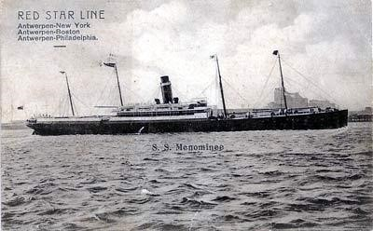
The 3rd Brigade arrived at Anzac Cove on 21 May and landed without incident. On 25 May they relieved the Wellington Mounted Rifles at Walker’s Ridge opposite the Turkish position at The Nek. A Turkish attack on 29 May was beaten off with loss, the 8th’s first significant action.
The arduous conditions and poor food took a toll of men’s health and some were invalided back to Australia.
Eventually ¾ of those evacuated from the Peninsula were sick, not wounded. Back in front line, on 30 June the
8th repulsed a Turkish attack from The Nek, inflicting hundreds of casualties for the loss of seven killed and 19 wounded.
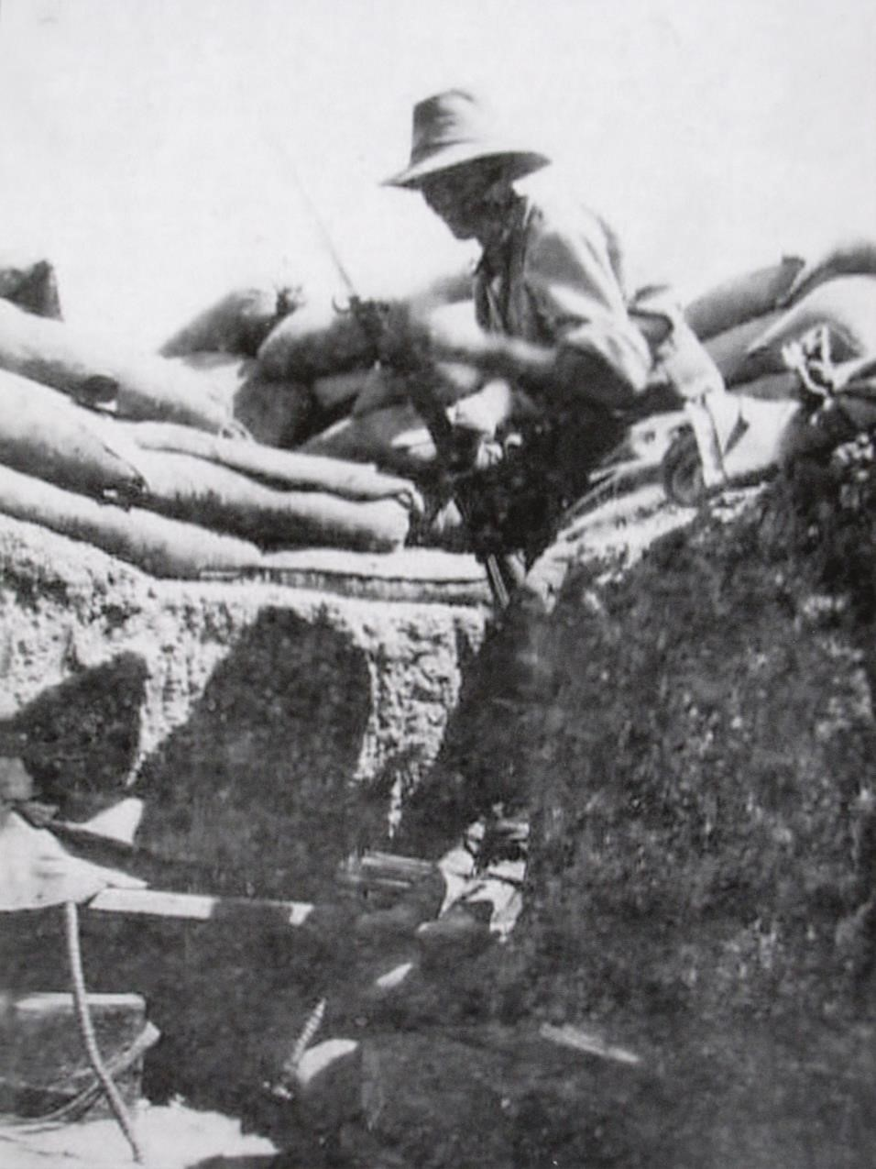
An 8th Light Horse Regiment trooper at Gallipoli.
Note that, while serving in the trenches, he is not wearing an emu plume in his hat.

The disaster for the 3rd Light Horse Brigade came when in August 1915 a new offensive was planned to the north, at Suvla Bay, to be supported by the New Zealanders attacking Chunuk Bair and the 3rd Light Horse Brigade mounting a diversionary attack at The Nek hoping to capture the Baby 700 hill behind it. Sadly, any lessons that might have been learned from the failed Turkish attack there on 30 June were ignored.
The attack on 7 August was made in four lines by the 8th and 10th Light Horse. Each wave was made up of up of between 150 and 200 men. The preliminary artillery bombardment finished seven minutes too soon, giving the Turks plenty of time to reoccupy their trench and prepare for the anticipated assault. At 4.30am the first wave from the 8th was mown down within 10 yards of starting their charge. Two minutes later the rest of the 8th attacked and were also slaughtered.
The third wave from the 10th went over at 4.40am with the same result. Some efforts were made to stop the fourth wave from the 10th but it too joined the rest. It was an utter, bloody shambles.
At 9am what was left of the 8th Light Horse was withdrawn to the rear to reorganize. They had lost 163 killed and 93 wounded, that’s 255 men out of a total strength of 498. The 10th lost 84 killed and 52 wounded, near half their effective strength.
So, was Alexander McDonald in the charge at The Nek?
While not all of the 8th participated in the charge, clearly the great bulk of them did, as efforts had been made to include every possible man to improve the chance of success.
Descriptions of the charge consistently focus on saying that each wave was annihilated, implying that every man was either killed or wounded. One trooper from Alexander’s B Squadron later wrote that of 150 men from the Squadron only 15 returned alive. These statements are very dramatic and the slaughter of the charge was graphically depicted in Peter Weir’s 1981 film ‘Gallipoli’.
C.E.W. Bean, our official historian, recorded that all 10 officers who had led the first line had been killed, as were half the men in it, with another quarter wounded. That indicates that one quarter, somewhere around 50 men, in the first line, were not hit, just forced to ground by the overwhelming Turkish fire.
Alexander’s service record does not indicate that he was wounded at Gallipoli, but he may well have been in the charge and been one of those 50 or so who actually weren’t hit.
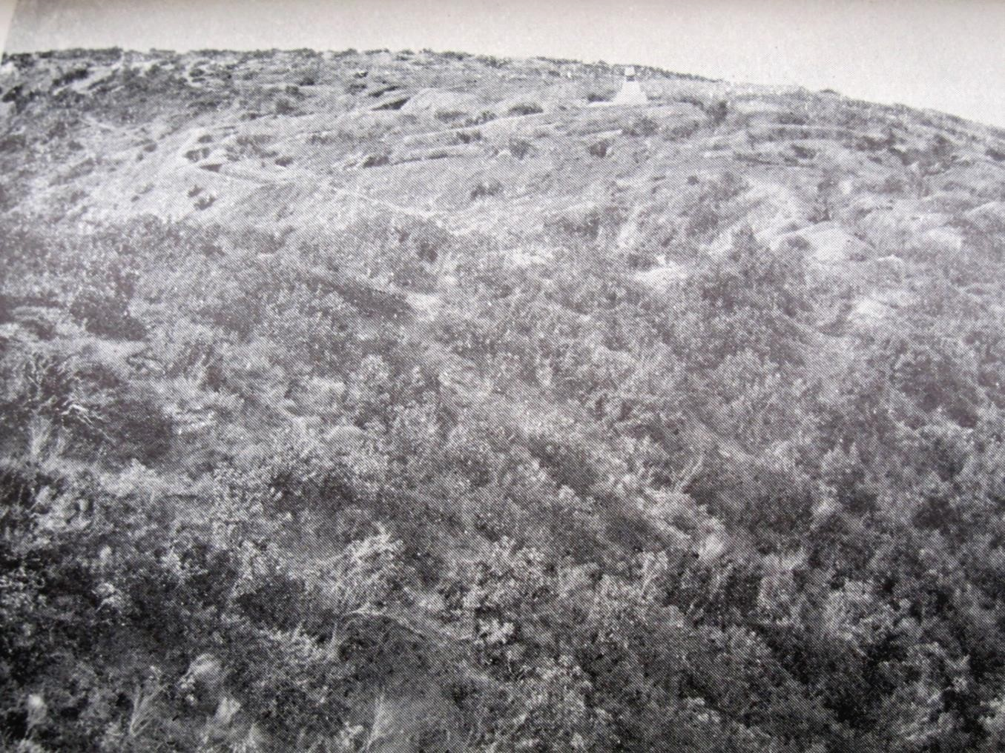
Photo of The Nek taken in 1919. The Australian trench is at the top left, the Turkish trench is where the memorial has been placed, at the top right, with the charge attempted across the ground between them. The uphill nature of the charge, difficult terrain and prevalent low scrub are all apparent.

Suffering influenza, Alexander was evacuated from Gallipoli on 27 August 1915 to the 25th Casualty Clearing Station on Imbros Island. By then the 8th was a shadow of the 498 men it had comprised three weeks earlier. On 28 August the 8th was reduced to just 78 fit men and was withdrawn to the rear. By 7 September they were only 35 strong and badly needed their 6th Reinforcement, of 33 men, which arrived on 17 September.
Alexander’s active war was over. From Imbros he was sent to England where on 22 September he was admitted to the No. 2 Southern General Hospital. At some point he developed an ulcer in the right eye, no doubt ruining its sight. On 17 March 1916 he embarked for home on HMT Ascanius and was honourably discharged from service in Melbourne on 25 July 1916.
After The Nek better times were ahead for the 8th. On 18 October 1915 Lt. Col. Leslie Maygar was posted from the 4th Light Horse Regiment to be the new Commanding Officer of the 8th and became its longest serving commander until his death on 1 November 1917, during an enemy air raid the day after the Battle of Beersheba.
The 8th spent some time in the front line trenches from November and were evacuated on 19 December 1915 during the great withdrawal from Gallipoli, which freed up sufficient Turkish forces for them to again consider an attack on the Suez Canal.
The 8th went on for another three years to serve with distinction, and with their horses, for the rest of the war against the Turks in the Palestine Campaign.
By far though, their greatest loss had been at The Nek on 7 August 1915, when Alexander John McDonald had been with them.

Post War Years

Alexander was awarded the 1914/15 Star in 1920, and the British War Medal and the Victory Medal in 1922. He also received a small pension to partially compensate him for his injuries.
The last reference to Alexander McDonald in his service history is a letter he sent from Strathmore Private Hospital on 24 April 1967 requesting the commemorative Gallipoli medallion then being issued. At the time he was 74 years old and living in Whittlesea.

References:
‘They Rode into History – The story of the 8th Light Horse Regiment, Australian Imperial Force 1914 – 1919’ by Max Emery, Slouch Hat Publications, McCrae 2009

‘The Official History of Australia in the War of 1914 – 1918 Volume 2 The Story of Anzac’ by C.E.W. Bean, Angus and Robertson Ltd, Sydney 1939

Photos included in the story are from these references, except the photo of HMT Menominee which came from www.dublin-fusileers.com.

