An early history of Plenty Valley fm 1987 – 1998

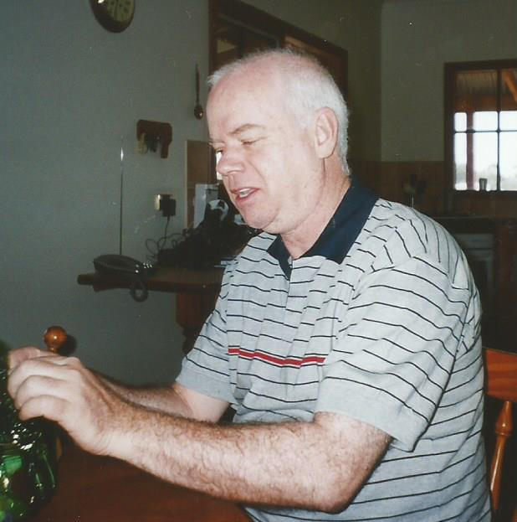

Ian Lamont hard at work
First Station President 1987—1991, Station President 1993—1998.

Community Radio is a visionary concept, but what is community radio all about?

In the words of Michael Law, one of the founders of the Australian public broadcasting sector, community radio “is a non-profit radio service that offers the community access to radio that would not be available through the existing ABC and Commercial sectors.” In other words, community broadcasting is a grass roots level resource, for and of the local community it serves.

In early 1988, a very short article appeared in the Diamond Valley News inviting interested people to attend a meeting with members of the Youth Services Department of the then Diamond Valley Shire, to look into the setting up of a local community radio station. Approximately 30 people attended that meeting in March of 1988.

The first transmission was a test broadcast and was conducted on the weekend of 18/19 July 1988. Outer North Eastern Community Radio (as the aspirant was then known) utilised a caravan set up as a mobile studio, located adjacent to a 30 metre elevated water tower (the ‘Chupa-Chup’ or ‘Golf Ball’) then located in Apollo Parkways.

The second transmission took place from Wattle Glen, this time for seven days from 3-9 October 1988. A third test transmission was conducted from 7-13 November 1988 from the old Yarrambat Primary School (now demolished to make way for a school car park).

Much activity took place in late 1989 and early 1990, with the submission of the application (approximately 100 pages) for a Broadcast Licence. In March 1990 the group went before the Australian Broadcasting Tribunal to present the application. The Australian Broadcasting Tribunal (now ACMA) acknowledged the group’s application as the most professional and best presented of the eight cases under evaluation and informally approved the issue of a licence.

A fourth test in December 1990 saw the commencement of the final test broadcast, this time simulating planned programming and staffing schedules. Although arranged to last from the 3rd to 16th of December, the ABA gave confirmation of the group’s warrant prior to the end of the test, and the station commenced its regular broadcast routine commencing December 17 1990, from 5pm – 12 midnight weekdays and 7am – 12 midnight on weekends.

All who were involved in those early years (and even today) had an immense sense of achievement and pride that they all contributed to the establishment of a non-profit community radio service for the local community.

Aside from obtaining a full time licence, there were many achievements in those early days, with some innovative programming and firsts for community radio in Melbourne.
These include :

- broadcasting (live) local football during the season
- becoming the first community station in Melbourne to be a recognised emergency services station for disasters
- setting up a musical scholarship project for a local musician
- recording and re broadcasting a weekly Salvation Army church service
- broadcasting the weekly Diamond Valley Council meetings
- coverage of State and Federal elections
- training projects for unemployed youth
- annually recording the Greensborough Inter-Church Council’s Festival of Family carols, to be rebroadcast on Christmas Day
- a one hour link-up with a community radio station in London with both stations broadcasting simultaneously
- networking overnight programming with another community station in Croydon

Outside broadcasts also formed a major part of the station’s connection with the local community, covering the Eltham Festival, Whittlesea Show and Diamond Creek Town Fair.

A comprehensive training program contributed to a uniform standard for presenting, and a team of competent and professional technicians ensured, for the most part, uninterrupted broadcasting. Ethnic and not-for-profit groups were encouraged to contribute to programming and the eventual construction of a live-to-air studio, provided a well utilised space for local bands and classical music performers.
Other community initiatives included a music request program for local nursing homes; a weekday, morning magazine for interviews and news segments on local issues; a weekly current affairs program focussing on municipal government; and a weekly program hosted by the Araluen Centre, a local disability services and support organisation.

Plenty Valley fm also provided a platform for individual success for a number of presenters, who would later go on to secure a career in media. Notably, Peter Hellier now with the TV program ‘The Project’, Cameron Baud a TV News journalist with Channel 10 and later with Channel 7 as a police reporter, and several others who went on to present on commercial radio.

Since the early days of public broadcasting, some community stations have folded, due to lack of finance, facilities or creative management. Plenty Valley fm (88.6) continues today, broadcasting from Mill Park, and given that the station is now housed in less space than the original studios at Yarrambat, initiatives such as the live-to-air studio no longer exist. Under the rules of a Constitution, the station continues to be run by a committee of management.

As inaugural station President and then first Station Manager, I oversaw the achievement of the community aims of public broadcasting, as they applied to Plenty Valley’s licence. The early days were very rewarding and most enjoyable, with the station supported by a team of volunteers, including presenters, technicians and members of the local community.

Ian Lamont

First Station President 1987 to 1991
First Station Manager 1993 to 1998

