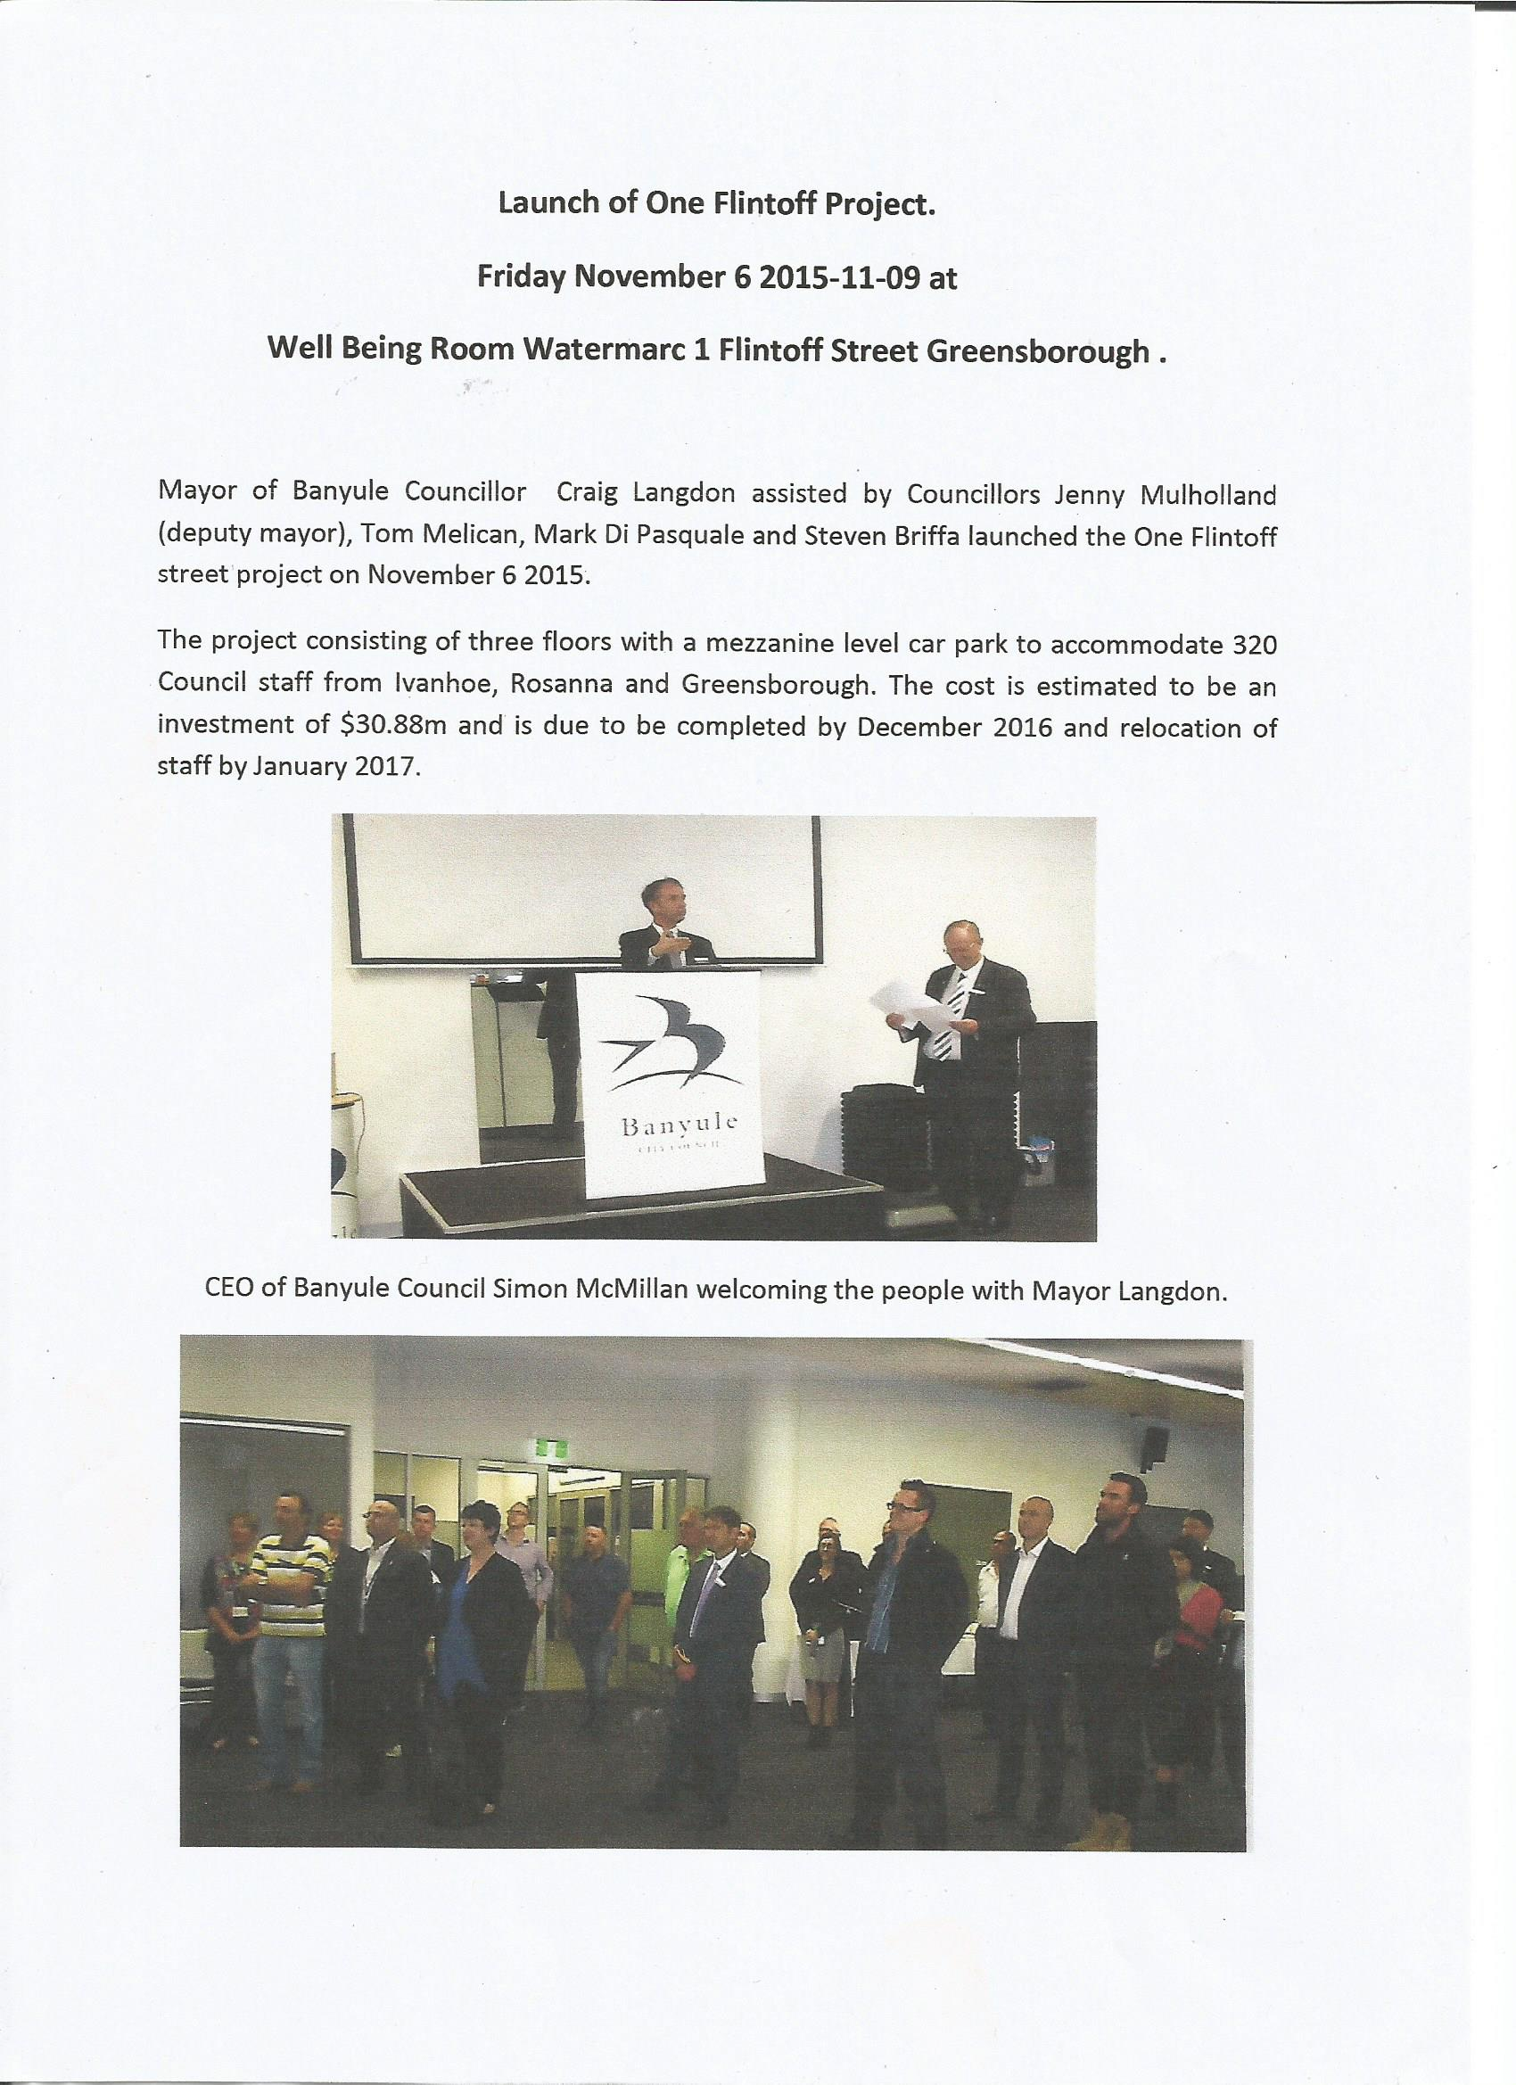
CEO of Banyule Council Simon McMillan welcoming the people with Mayor Langdon.

