Interview with Gloria Stevens (nee Wightman)
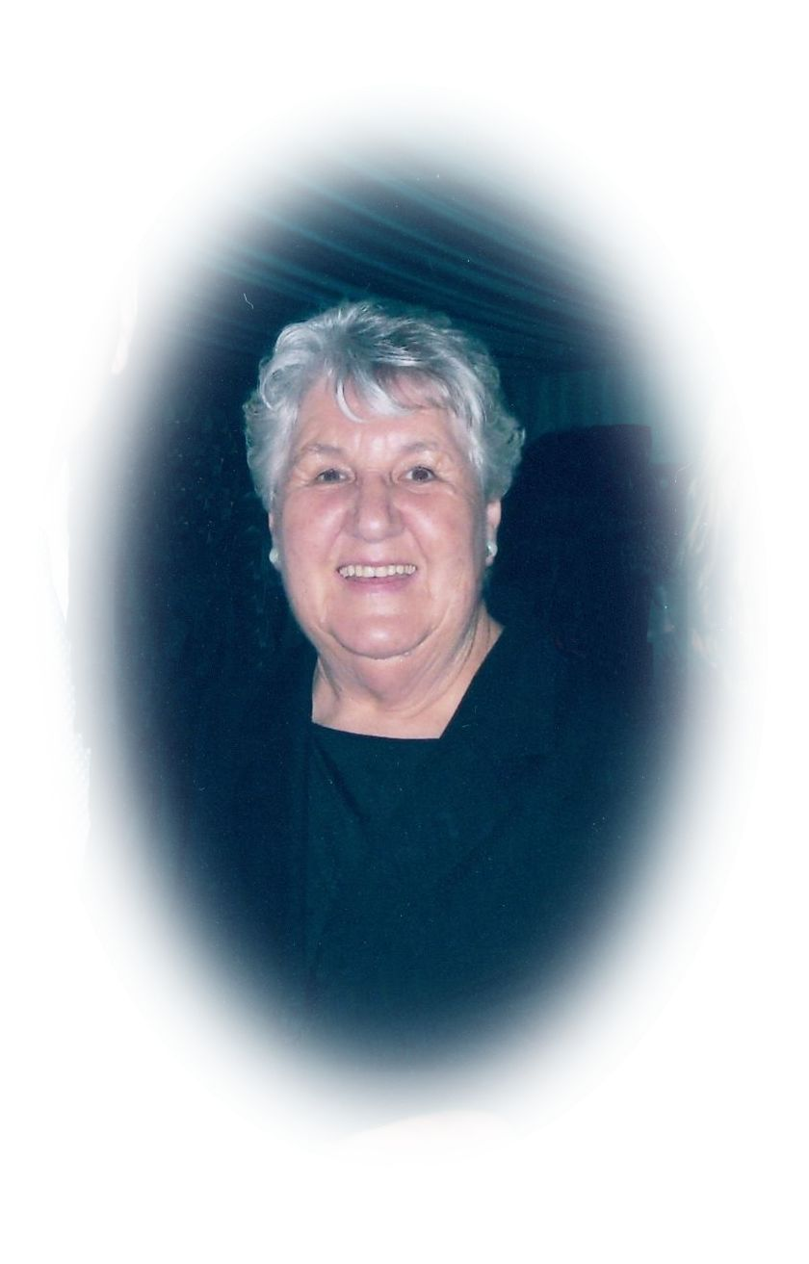
Wednesday July 13, 2016.
By Marilyn Smith and Dawn Bennetts.
This is Gloria’s story about ‘Early Greenhills’.
I am Gloria Stevens (nee Wightman). My father and mother, Charles Edward Wightman born 1908 in England and Laura Violet Harding born 1911 in South Melbourne, were married in 193I. I was the first born of four children, then Norman, Raymond, and Laureen. I was born in 86 Beauchamp Street, Preston in the front bedroom of my grandmother’s house. We lived there until I was about four and a half. I remember my grandparents and mum and dad, we were a very loving family.
Our family moved from Preston to Greenhill Road in 1938. We lived in a tin shed that my father had built, on the south east corner of Greenhill Road and Crest Street. I was seven and my brother Norman was five.
Gloria Stevens
Dad built the tin shed prior to him building our home and it was a happy time and it never worried me that we lived in a tin shed with a dirt floor - not much house work to do, we just swept the floor with a gum tree branch. I don’t remember whether dad built mum the wash house with a copper up where the house was to be built, or how she washed, but knowing my dad, he would have built the wash house. She had a copper and trough to wash in. There was a wood fire stove for cooking, hot water and for warmth. We had a big round tin bath (not a proper bath) we used to have a bath in, Norman and I could sit in it but mum and dad would have their knees up. So that was the beginning of how we started off in Greenhills. Dad always had a car, he had the car from down in Preston. He did have a motorbike with a side car that he and mum would go around in, but when Norman and I were born he bought a car.
I was very happy to come up to Greenhills. I loved it from the minute I got there. Norman was two years younger than me. I had already started school at Tyler Street, Preston, so I would have gone to Briar Hill School in 1939. Norman was born in 1934 so he could have started school in 1939. I remember taking him to school. I was very proud of my little brother and he was the sweetest little boy. He had big brown eyes and olive skin. Even though I was only little, I thought he had skin like a peach. We would walk to school - I would take his hand. He had brown pants, jacket and cap. I can remember so vividly taking him with other kids to school. We would walk down Greenhill Road and cut across Henderson’s paddock to Britnell’s Road it was called then, and that would cut off the corner from St. Helena Rd, which was Old Eltham road in those days, which was near where Abbott’s lived - which was near the school. Norman and I were in the lower room that went to grade four, then grades five to eight in the other room. As my name was Wightman, we were at the end of the alphabet when lining up, and when Dr. Cordner came around to give the vaccinations, the kids were walking around holding their arms and some crying. When they said Gloria and Norman Wightman next to go down to the shelter shed, I took Norman by the hand and went straight out the gate and home we went.
I remember all the Briar roses (the name Briar Hill came from that) were everywhere, lots of them down the lower side of Britnell’s Rd.
A girl from school told me the German’s were coming to get me and eat me all up, so I thought the German’s were like big giant rats - didn’t know they were humans, and she would taunt me with this and chase me all the way home. One day I got sick of this and pushed her off the road and into the big ditch with all the Briar roses....so she never chased or told me the German’s were going to get me again.
Norman and I were very happy at Briar Hill School. There were just two rooms and once the war came I can’t remember who the teachers were. Miss Hope was there when I started, but I don’t remember who the Headmaster would have been. I remember the war starting in 1939 and many of the teachers went to war. They brought the old people out of retirement and there was a headmaster called Mr. Mawson and Miss Fraser and Miss Hope that I’ve talked about. Mr Mawson was quite an ill man I think now looking back. He would walk from Greensborough station to Briar Hill School, and sometimes he wasn’t well enough to make it. It wasn’t an unusual thing for us to go to school and find no teachers there, but the big children like Wally Tingle and a few others would be there and we did work, but also played around a lot in the summer playing cricket and rounders and in the winter, football - but nobody played up all day at school and then we went home. Mum and other parents didn’t know that we would get to school and there would be no teachers, but we never broke windows or did anything destructive. There were no phones to ring home. When Mr. Mawson left I think a fellow called Mr. Finlay arrived, but I left after 6th grade and went to Eltham High when the war finished. Briar Hill School went to 8th grade and all the kids left and went to work.
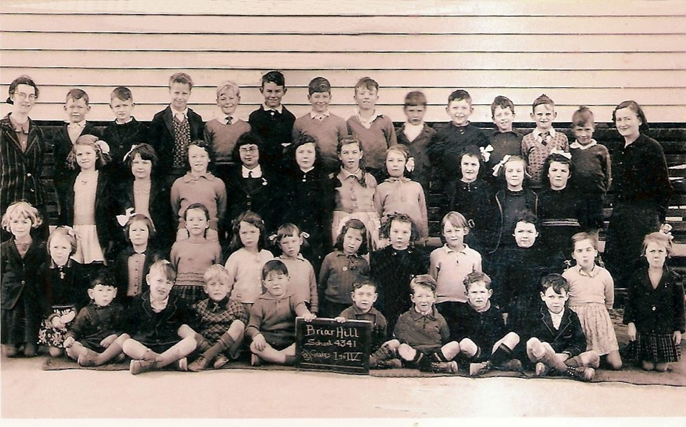
Briar Hill State School 1939.
Gloria – 3rd row from front, 2nd pupil from left.
Living in Greenhills, we played around the mines near Mine Street. I never went in because I don’t like going underground. I would go down, but never to where it narrowed in, so they hadn’t blocked them off at that time. There were not many houses around then, but I think it was after Keith and I were married when they filled the mines in and started building houses there.
There was a big dam nearby which I think might have been there for the mines, because you need a lot of water when you are gold mining. The dam was in there somewhere - there were no streets when I was a kid, just paddocks. We had metal boats to use on the dam. Don’t know who built them because most of the men went to war. I don’t know how deep the dam was but it was very dark because of all the gum leaves falling in. I was petrified of those boats tipping up in the middle. I could swim, but thought there was no bottom to it. When I cut my knee on one of those boats, Mr Bishop (Dawn’s grandfather) helped me put it together. He put tar on it and healed it up that way because you couldn’t get to a Doctor. Mr Bishop also rescued me out of so many trees when I couldn’t climb back down.
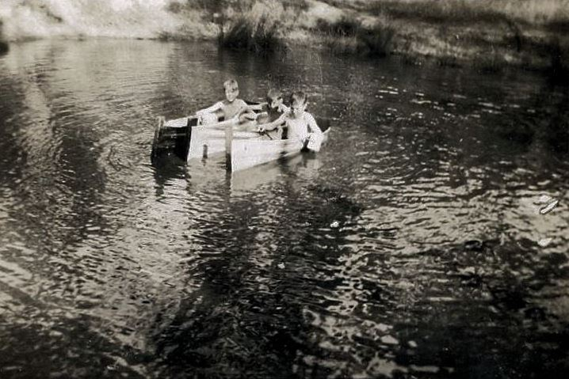
Tin boats on the dam in Greenhills
Most of the old houses were weekenders. The people that had them came out from the city for a holiday or for the weekend. There were a lot of old houses there. Mr. Buck’s house that was next to us in Crest Street (we were on the corner of Greenhill road and Crest street - 62 Greenhill Road), I found out in later years, was brought out on a dray by draft horses. At the time there was only Mr Buck’s house in Crest street, and on the other side was a little white house that Mr. & Mrs. Quilty owned. They were the only houses in that street as far as I can recall.
Mrs Brown’s house was down the bottom of Crest Street next to the lane with no name – some called it Brown’s Lane. Other residents around the area were Lamperd’s who had a farm.
In Greenhill Road (going towards Diamond Creek Road end) there was the Neville family that built a large new house on the corner of Crest Street, they had a poultry farm, then there was a family called Bishop living in an old house, (72 Greenhill Road). The Trevithick family lived on the corner of Mine Street they owed a big lot of land and they had a poultry farm. There was Harry, Peter and Betty. I remember going to school with Betty Trevithick. Betty was my true friend and I was her true friend and we’re still very close friends.
There was the Mills family (95 Greenhill Road) – they had quite a few children and I think maybe they went to Greensborough School. There was another house there that Bes and Reg Knight built later, and people called Stainer lived further down (111 Greenhill Road) towards Diamond Creek Road. There was an old house next to Stainers that had been the old Billiard Hall in Greensborough. That house was empty for years and I don’t know who owned it.
Going the other direction in Greenhills Road towards St Helena Road (Old Eltham Road) there were not many houses either. My father bought our land from Ben and Joe Partington and they lived in a little cottage in Greenhills Road (5 Greenhills Road) down near St. Helena Road. It was a little old house with a dirt floor and it was about the only house down that end. The walls were made of wattle and daub. At one stage I think the Peart family lived there, then later the Birrell’s.
Mitchell’s lived on the corner of Greenhills Road and Bruce Street. That was the original house of Cliff’s mother. She was a widow, and there was Cliff, Alex, Barbara and Laurence. The next house I think a fellow called Ashby lived there. He built a lot of houses on the left hand side of Greenhills road going down to St. Helena road - he must have been a builder because I remember my father working for him. This house was later Chapman’s? / Churchman’s house.
Next to that there was a laneway that ran through to Carnon Street, and the water tank for Greenhills was situated off that laneway.
Then there was a Guest house (57 Greenhills Road). Mr. Lewis Hogg and Mrs Hogg owned it. Dad called him Lewis, but his wife was always called Mrs. Hogg. People would come out for holidays and sit out on the front veranda having afternoon tea and looking out at the Dandenong’s. The trees hadn’t grown very tall then and the view was so much better. Over the road from Hogg’s house was a little white house on the down side of the road. A family called Higgins lived there at one time. The toilet had been built facing Greenhills Road. One of the boys that lived there had a habit of going to the toilet and sitting on the loo with his pants around his ankles, reading the paper and the sun streaming in on him - and the people sitting on the veranda having their afternoon tea could see him. Mrs Hogg was very upset but nothing she could do about it! Drakeford’s were the next owners of the Guest House. I remember the Drakeford’s quite well but don’t remember going to school with Joan or Bernie Drakeford, so they may have been at High School when I was at State School.
At one time when that little white house on the down side of the road was rented out, the lady living there ran a brothel. I didn’t know it was a brothel, I said to my mum - ‘That lady has a lot of daughters with different coloured hair.’ Also a lot of American’s went to the house. Mum didn’t say anything.
After Drakeford’s sold the Guest House, people called Attoni’s bought it, and just had it as their home. Mr Attoni used to grow the best vegetables, especially tomatoes!
In Greenhills Road nearly opposite our place, (61 Greenhills Road) there was a family called Hart. They were relatives of Allan and Norma Bishop who I went to school with, and at one stage also lived in that house - before later moving to Carnon Street (View Street). The Peart family also lived for a while at 61 Greenhills Road in those early years.
Around war time, soldiers used to come up regularly from Watsonia to do training around the area. They would bury the maps near a large gum tree. I remember on one occasion Alex suggesting that we hide the maps from the Army service men, that was a night and a half! With over one hundred service men from the Watsonia barracks in trucks and officers scratching their heads, because they didn’t know where to go as they couldn’t find the maps. My dad was away at war, and if he’d known, I would have been eating my breakfast off the mantel piece for a long time - we had no idea how important it was they had to do the manoeuvrers so they could go and fight.
It was difficult going down Greenhills road in the wet. It was too muddy and you would get bogged. If you had a baby in a pram, the mud would just stick and you couldn’t get it off when it was wet - you had to let it dry and chip it off. On the down side of the hill and Crest street was all clay.
Around in Albion Crescent was Lionel Bakers family. Down that end all the holiday houses ended up rented places.
When the war started my dad went off to war but I don’t know anyone else in our area that went. Some men stayed because they were in essential services, such as Jim Baker, Lionel Bakers father and Dawn’s grandfather (Ern Bishop). There was a shortage of houses around the city so a lot were rented out after the war that hadn’t been rented when the war was going.
I remember Charlie Miller was the milky. He would come around on his horse and cart and he would fill your billy up. He had big stainless steel containers, and mum had an enamel billy. She wasn’t going to have a steel one like everybody else had. We would go down to Vic Edmond’s in Greensborough for our meat. Mum would send me down to shop and in the war we had string bags which would stretch to the ground by the time I got home.
I think it was for Mothers Union? but I’m not sure.... I would knit socks and gloves for the soldiers - felt a bit sorry for the ones that had to wear the socks I knitted, but I guess they were happy to have them and camouflaged nets made with a shuttle and the string bags made the same. Not a lot of shops then, but I loved Greensborough the way it was. No shops in Greenhills Road back then. At Briar Hill School we went through a gate to go to Mrs. Humphries shop, which was also her house, to get lollies. Betty Trevithick told me she got library books (Western’s) for her father from there as well. I remember going down to the picture theatre in Greensborough on a Saturday afternoon seeing Deadwood Dick and all those serial things that were on. All I remember about the theatre was that the chairs were joined together but did move around - not bolted down. I think it might have closed for a time, because we used to go on the train down to Ivanhoe pictures.
I learned to swim in Greensborough pool in the river. All that’s left now are some strips of concrete. Once we learned to swim we would go down without parents, we did lots without parents and it’s a wonder we didn’t get killed.
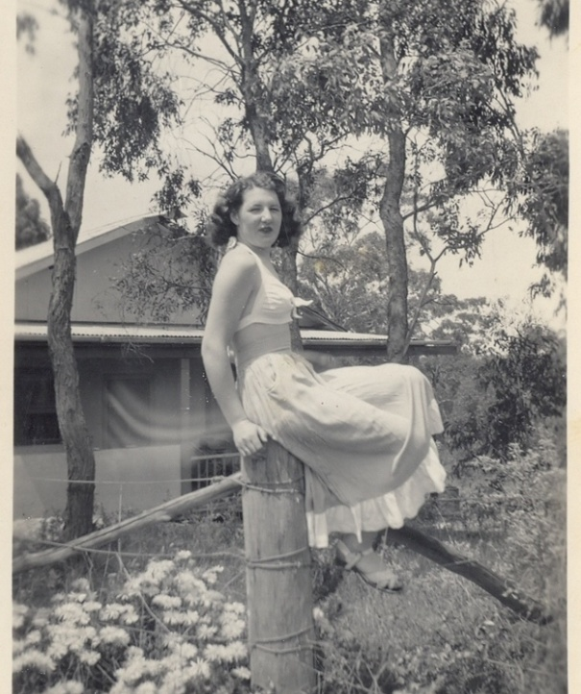
We would go ferreting over where Apollo Parkways is now, and we were always mucking around where the aqueduct is, but no one ever fell in it. It didn’t seem far when we were kids - when you go rabbiting you go where the burrows are. Sometimes we would light a fire and we’d take a billy with some water and tea and swish it around - I would drink that tea, but don’t drink tea now. We would also go yabbying at the dam. Betty and I would go mushrooming down the lane where Mrs. Brown’s house was and in Albion Crescent.
Before I got married I worked at the Government Aircraft factory down in Heidelberg Road, near Clifton Hill, but once you got married you didn’t go back to work.
These are the memories I have of my life in ‘early Greenhills’.

Gloria at 62 Greenhill Road

