The Inner Circle was a steam era suburban railway line (later electrified) in Melbourne, Australia. It served the inner-northern suburbs of Parkville, Carlton North, Fitzroy North, and Fitzroy and later expanded to outer suburbs. It opened in 1888. In this video, the viewer is taken on a train journey around the Melbourne rail network and also looks at the stations and lines that have since closed.

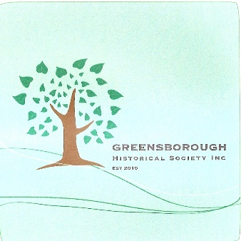

Property of:
Greensborough Historical Society Inc
Glenauburn Rd Lower Plenty

Item 2897
The Inner Circle Railway Line
