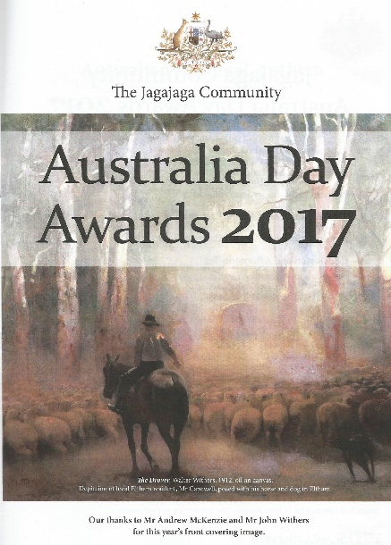
Australia Day Awards - 26th January 2017
by Rosie Bray
Greensborough Historical Society was well represented at the Australia Day Jagajaga Community Awards. Noel Withers and Jean Luxford were each worthy recipients of a Community Award to thank them for the many years of voluntary work freely given to the community.

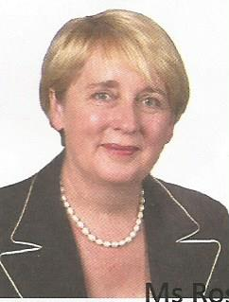
The event was hosted by Jenny Macklin MP Federal Member for Jagajaga and held at the Catholic Ladies’ College in Diamond Street Eltham at 2pm. In her opening address, Jenny Macklin said that Jagajaga was first proclaimed in 1984, and it has an extremely diverse electorate with many distinct and vibrant communities. There are over 400 community organisations alone, which is a testament to the strong community spirit.
Without the kind hearted and hard working volunteers there would be many tasks left ‘undone’. She went on to thank everyone, even those volunteers who did not receive awards that day for their dedication to the community.
The huge gathering enjoyed the beautiful voice of Mandy Lyn Brooks singing Waltzing Matilda and I still Call Australia Home. Mandy graduated from Monash University with a bachelor of Music (Honours) Arts and the Melbourne Opera Studio in the Performance stream. Mandy’s passion for music shone through her sincere singing of Australian songs.
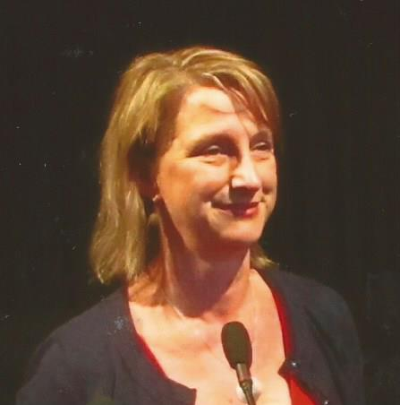
The Award citations were read by Vicki Ward State Member for Eltham pictured left and Community Australia Day Awards presented by Jenny Macklin Federal Member for Jagajaga.

Also present were Colin Brooks MP State Member for Bundoora, Mary Wooldridge MP State Member for Doncaster, Anthony Carbines MP State Member for Ivanhoe and Mayor of Banyule Cr Tom Melican.
The Awards were presented in alphabetical order
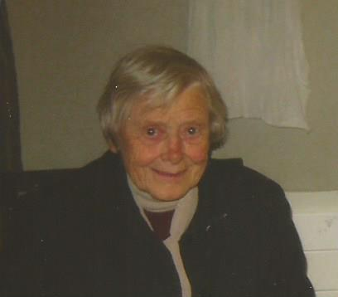
Jean Luxford (pictured left) a Greensborough Historical Society foundation member, was the first GHS nominee to receive her Australia Day Community Award.
Jean is a fount of information about the local area and its history.

The Citation Information
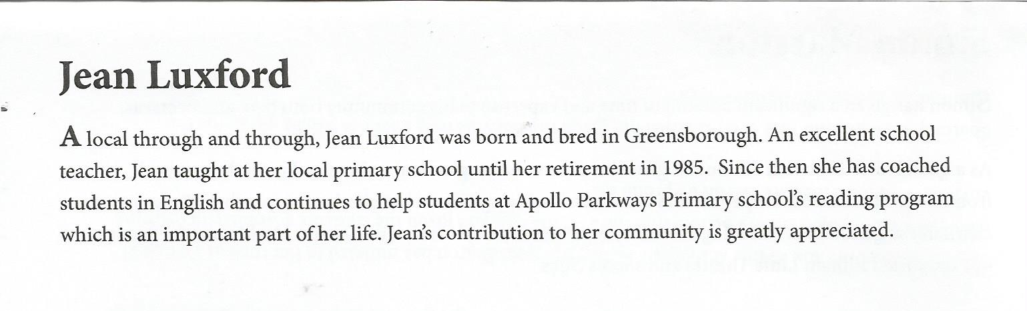
Jean found the citation information incorrect, and would like it corrected for the archives.
Jean was not born in Greensborough although she has lived there most of her life. Jean said that she was honoured and humbled to receive the Award, because she felt it was a privilege to have taught Religious Education in the Primary School for 30 years. It was when the RE program ceased at the end of 2015, the school asked Jean to stay on to help the school’s reading program.
Jean still loves to teach children.

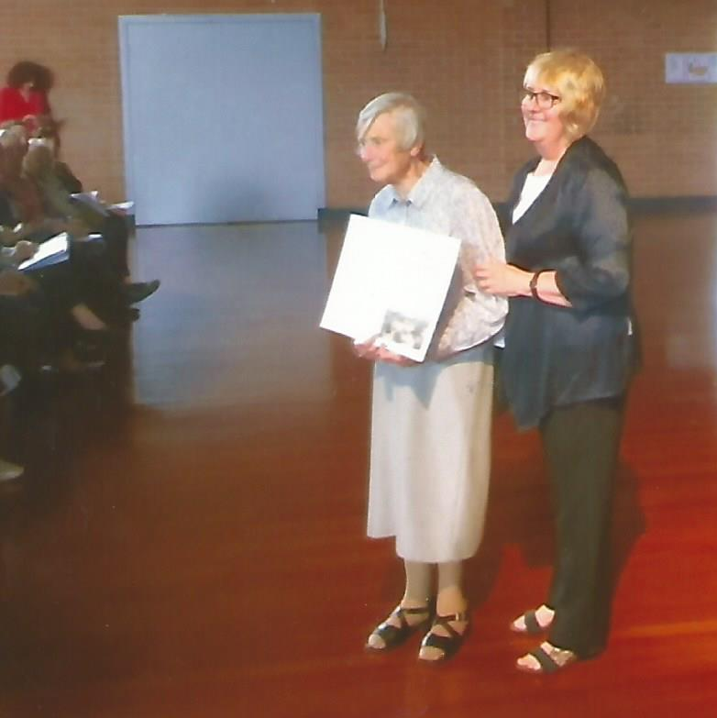
Jean Luxford receiving her Australia Day Community Award from Jenny Macklin MP.

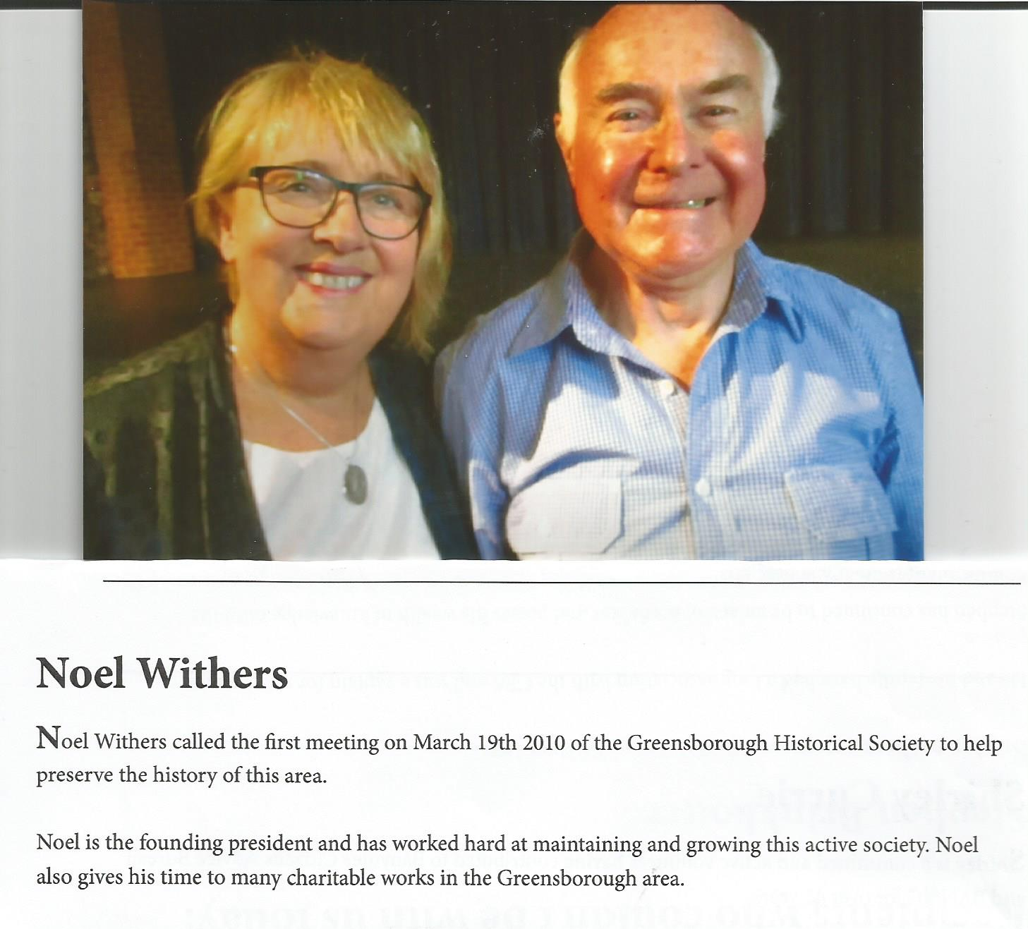
The Citation for Noel Withers (pictured left with Jenny Macklin) is definitely under stated.
Noel, British born and bred has always loved local history and when he and his wife Kath came to live in Greensborough, Noel took to finding out as much as he could about the local district. He ferreted in cemeteries, looked up old news papers and found as many older residents as he could. When people responded to an article printed in the Diamond Valley Leader (March 11 2010), “For interested people to meet with the view of preserving Greensborough’s past by forming an historical society”, little did he know the extent to which local passion arose from the pioneer families in the Greensborough area.
Noel has been the President since the first meeting in March 2010, and has steered the Society to the success it is today.

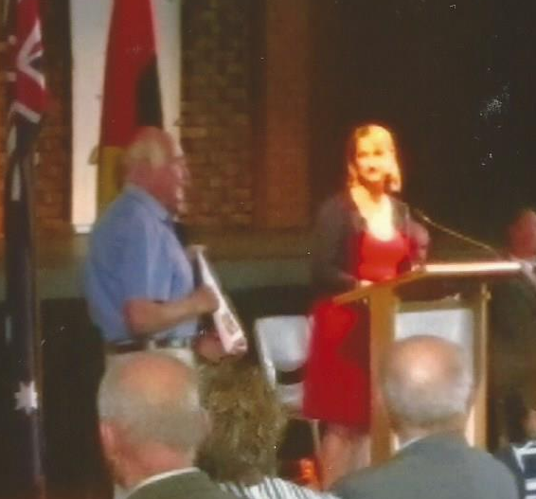
Noel Withers receiving his Award with Vicki Ward MP
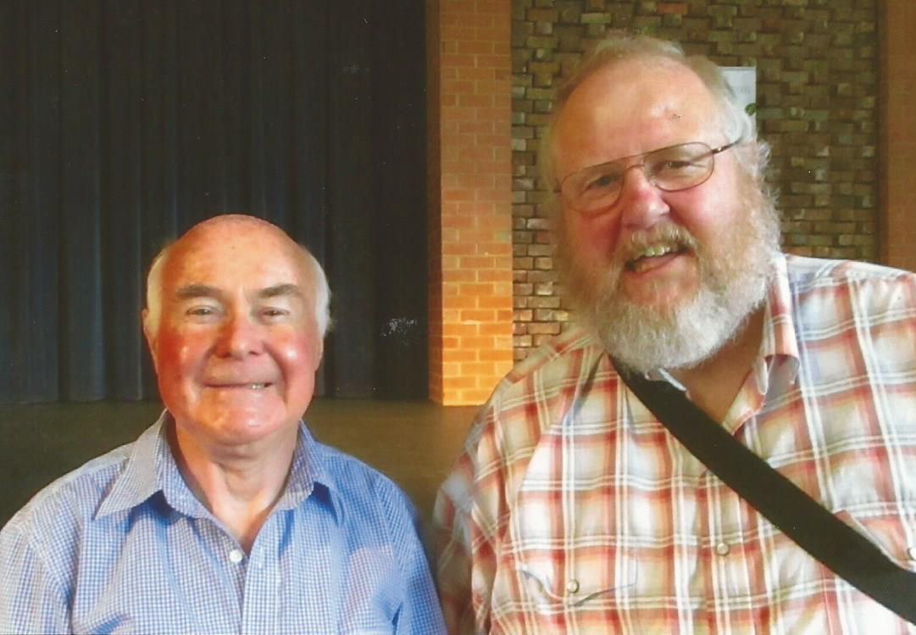
Noel Withers with Society’s Vice President Peter Van Eeken.

The afternoon concluded with a wonderful mass vocal group based in Eltham and Reservoir of mostly untrained singers led by Irene Bennetts (who also received an Australia Day Community Award). The choir sent the crowd away with some Australian Songs.
The Greensborough Historical Society congratulates Jean Luxford and Noel Withers as well deserved recipients of their 2017 Australia Day Community Awards.

