6 August 2016

**THE STORY OF EVELYN WAY, ST. HELENA**

**As told by Michael SCIBERRAS to Frank SOLOMON**

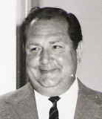

This gentleman is Werner Otto Fritz **HANUSCH**, who was born in Germany on 13 March 1927 and died on 24 February 1990 in St. Helena. He owned and operated the pig farm at the end of Evelyn Way, St. Helena.

Werner bought the land and started the pig farm sometime after arriving in Australia at the end of 1954. He came with his first wife Helga, nee VENTZ, but their marriage broke up, date unknown.

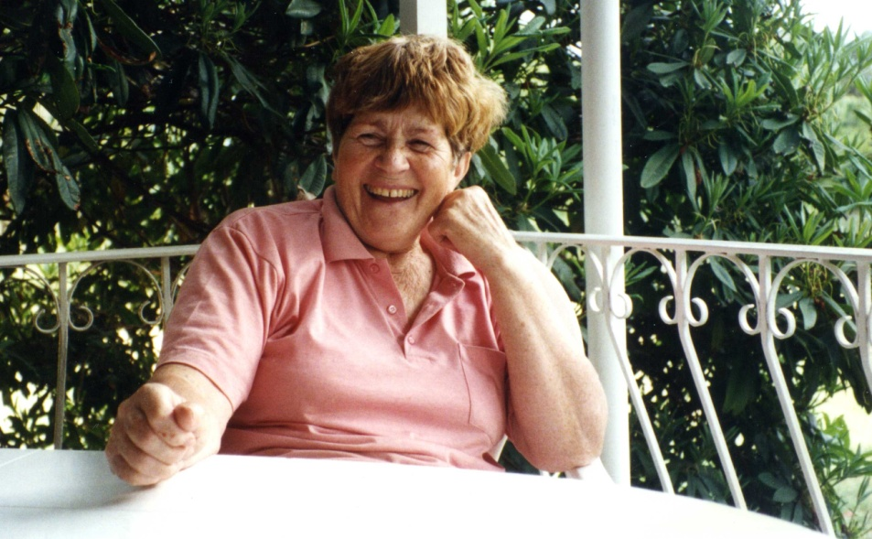

This lady is Johanna Maria (Hanni), nee BUHNER, Werner's second wife, who was born in Germany on 21 February 1927 and died on 23 March 2014.

The pig farm property actually ran northwards down the hill from roughly the line of Evelyn Way. Their other property, purchased later, which ran southwards from Evelyn Way, was used for other purposes, including a large quarry.

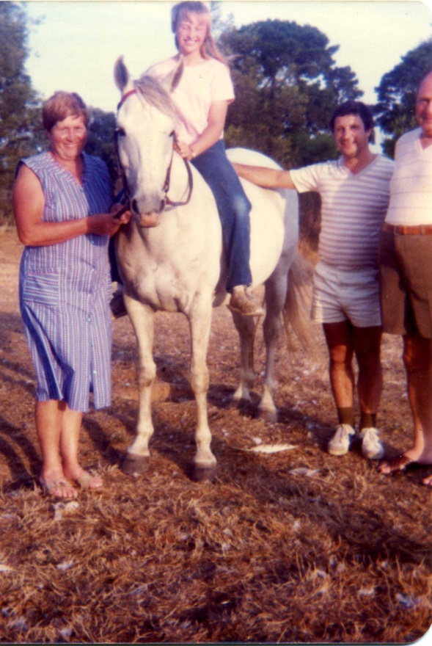

L to R: Hanni HANUSCH, Heidi SCIBERRAS (Michael's daughter), Michael SCIBERRAS, Werner HANUSCH

Michael SCIBERRAS and his family knew Werner and Hanni HANUSCH very well. Michael and his daughter, Heidi, did jobs for Werner and many chores, such as cleaning out the pig sheds and preparing the pigs for market.

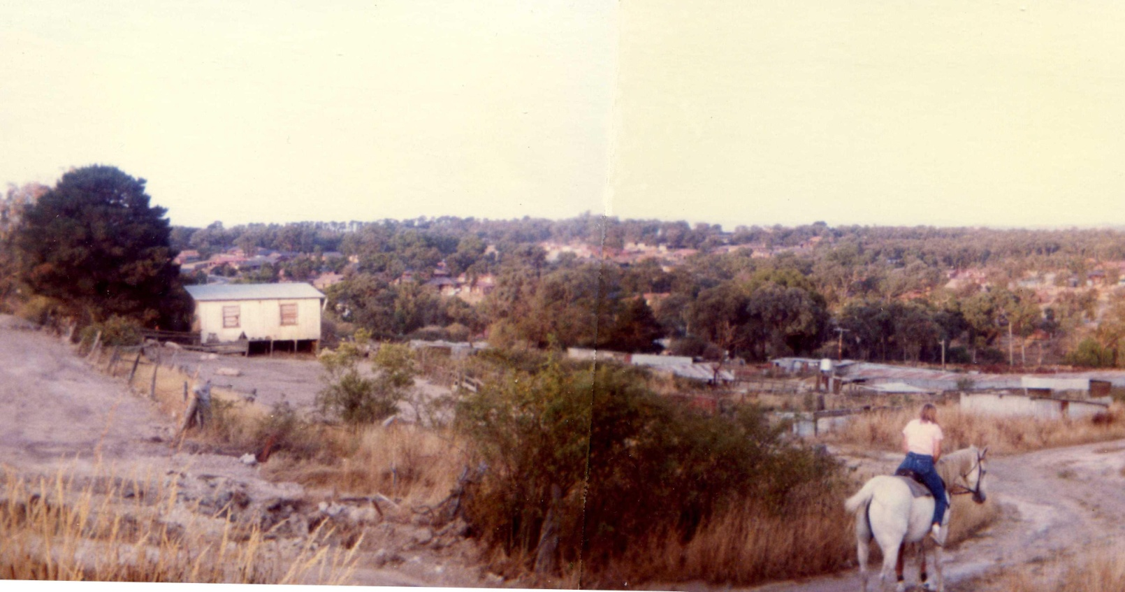

Pig farm panorama, with Heidi SCIBERRAS riding her horse, Snooker, along the track now called Evelyn Way.

The horse was given to Heidi by Werner, who named Evelyn Way after Michael's wife, Evelyn.

The building on the left was Werner's original residence. The pig sheds can be seen in the middle distance.

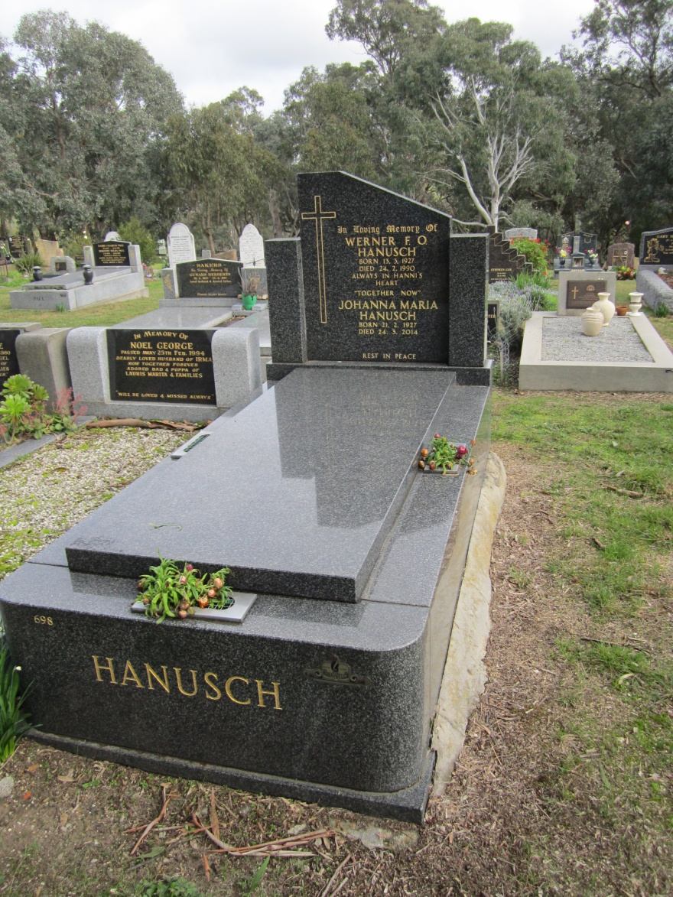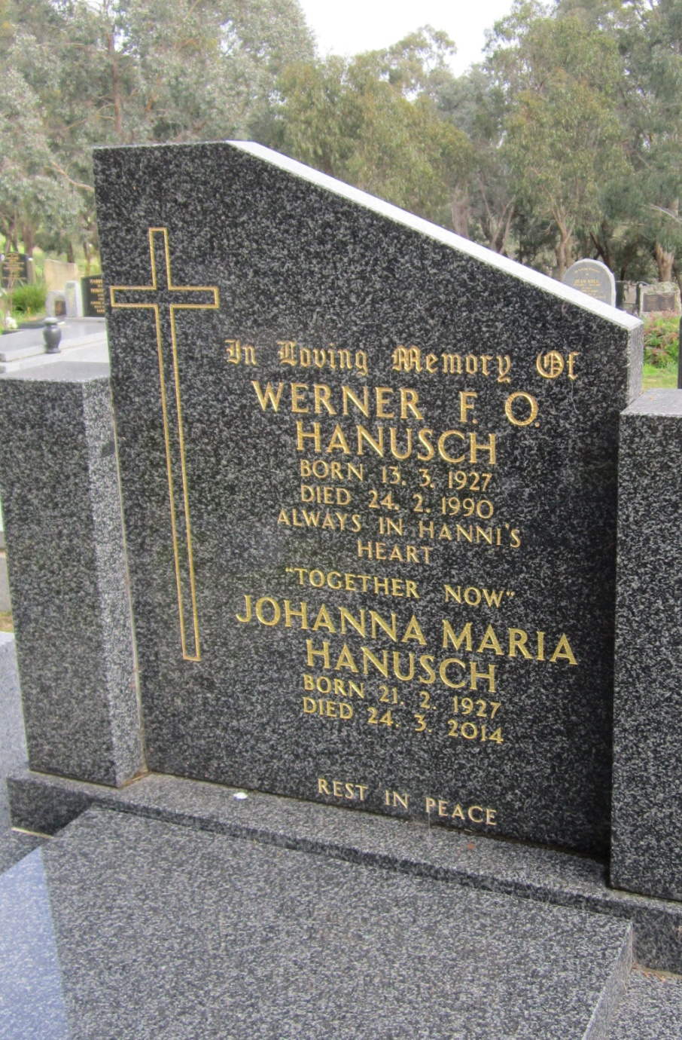

KANGAROO GROUND CEMETERY

NOTES

Johanna Maria (Hanni) HANUSCH

Listed on the 1977 and 1980 Electoral Rolls as living at 272 St. Helena Road, Greensborough

Cousin Heidi BUHNER has a Family Tree (NASH) in Ancestry.com

**Parents of Johanna Maria HANUSCH**

[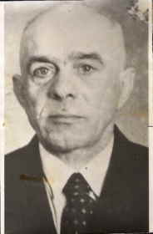](http://mv.ancestry.com.au/viewer/a7b0d1a2-8353-42d3-a8fa-8e73d75fe778/1845137/-1783305339)

Friedrich Wilhelm BUEHNER

Born: 8.11.1888 Germany

Died: 27.2.1953 Germany

[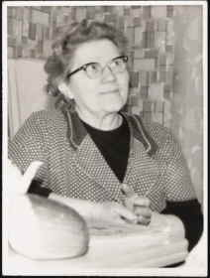](http://mv.ancestry.com.au/viewer/61f9de53-ac19-43a6-bff8-ce4c54e0fc7d/1845137/-1783306514)

Maria BUEHNER, nee MUELLER

Born: 20.1.1896 Germany

Died: 8.9.1972 Victoria, Australia