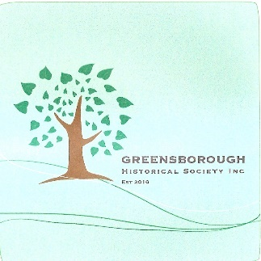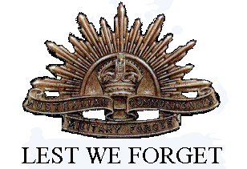Greensborough Historical Society

World War I Project

With the centenary of World War I, members of the Greensborough Historical Society have been researching the local lads who signed up to serve in the Great War. We have included Nurses from the area and those who served at Mont Park.

If you can help to expand the list or provide further information, please contact the Society.

The Greensborough and district soldiers listed in the World War I Project all had a connection with the area.

Names have been taken from the Fallen Soldier’s Memorial, Greensborough Primary School Honour Board, the Greensborough District Honour Board housed at the RSL and by searching through Australian War Memorial and National Archives of Australia records.

Some of our soldiers settled in and made great contributions to life in Greensborough after the War.

Descendants or relatives with further information are urged to contact the Society. Family stories and photographs would be appreciated. Suggestions for additions to the list are most welcome.

