Alfred George Abbott
Serial No. 4666
Rank: Private
Unit: 7th Battalion
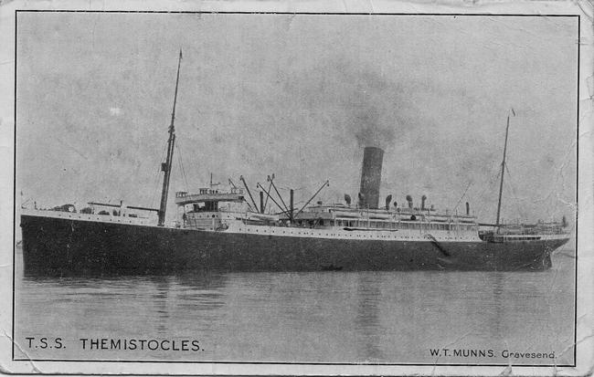
Alfred George Abbott was born in Fitzroy in 1882, the son of George Abbott and Emma Green. He married Eva May Pamment in 1912. At the time of his enlistment the family was living at Greensborough in the Mount Morey Estate. He was 30 years old and working as a storeman when he enlisted on 17th July 1915.
He travelled on HMAT Themistocles A32 and landed in Egypt. He saw active service in France.

Alfred Abbott received a medical discharge on 21st August 1917 and returned to Australia on HMT Runic A45 in 1917.
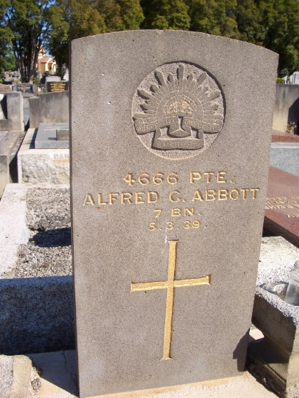
On his return, he lived in Richmond. Alfred Abbott died in 1939.
He was awarded the British War Medal and Victory Medal.

Alfred Abbott is commemorated in Greensborough on the Greensborough and District Honour Board at the Greensborough RSL.

