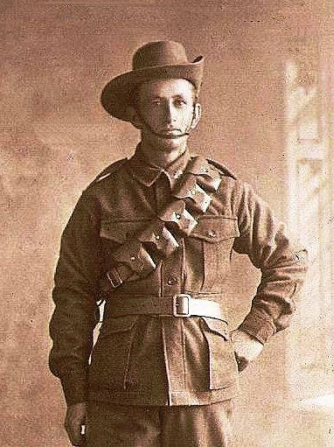
Lionel Almond
Service No: 3104
Rank: Driver
1st Field Artillery Brigade, 4th Div. Sanitary Section, 3rd Div. Sanitary Section, 4th Field Ambulance, 4th Division Dump and a number of temporary postings.
Lionel was born in Greensborough in 1888, the son of Richard Almond and Eleanor Mary Buck. At the time of his enlistment he was living in Evelyn. He was 26 years old and working as a Chainman when he enlisted on 19th September 1914.
He gave his next of kin as Richard Almond (Father) 581 Little Collins Street Melbourne.

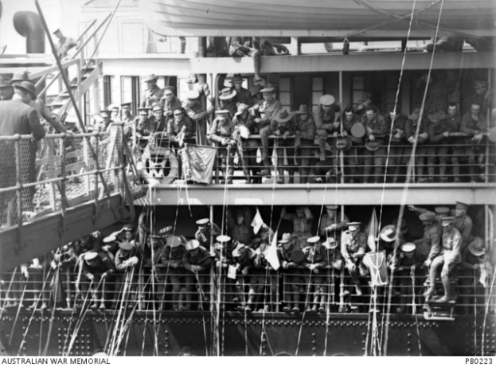
After training he embarked on HMAT Barambah A37 on 22nd December 1914 and landed in Cairo. He was taken on strength of the 1st Field Artillery Brigade where he served until 13th February 1916 when he was transferred to the 4th Division Sanitary Section at Tel-el-Kebir. Around this time, he also briefly served with the 3rd Division Sanitary Section and the 13th Field Ambulance before returning to 4th Division Sanitary Section.
HMAT Barambah A37

He remained in Egypt until 1st June 1916, when he embarked for Marseilles on the HMT Haverfora and disembarked there on 10th June for service in Europe.
On 6th July 1916, he was court martialled for conduct prejudice to good military discipline and sentenced to 28 days loss of pay.
On 28th August 1916, he was detached for temporary duty with Town Major Worloy.
On 1st October 1916, he was absent without leave and lost another day’s pay.
On 14th November 1916, he was transferred to the 4th Field Ambulance. Lionel served with this unit until he was admitted to hospital on the 6th February 1918 with parotitis. He was released from hospital on 15th February 1918 and returned to 4th Division Sanitary Section.
On 23rd March 1918, he was temporarily assigned to the 4th Division Dump before returning to his unit on 12th April 1918. More temporary assignments saw him with the 4th Field Ambulance, 11th Field Ambulance, and later the 7th Field Ambulance. He returned to the 4th Division Sanitary Section on 24th August 1918. On 15th September 1918, he was detached for duty with the Area Commandant in Buzanne. He stayed here until he received Special 1914 Leave to Australia on 6th October 1918.
He returned to Australia on the Durham D31 on 23rd December 1918 and was discharged 30th December 1919. It seems Lionel was an unhappy and disruptive soldier as his many postings allude to.
He received the 1914/15 Star, British War Medal and the Victory Medal.
Lionel Almond’s father married into the Buck family of Greensborough, Bucks dam is named after them. Lionel was a grandson of Charles Buck.
Lionel married Maud Victoria Jeffrey in 1920.
Lionel passed away in 1954 in Regent and Maud in 1963 in Reservoir.
