Percival Albert Amiet

Service No. 4005

Rank: Corporal

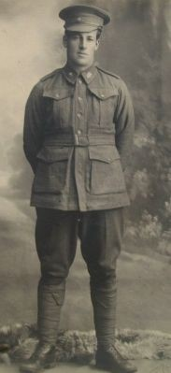Unit: 22nd Batt

Percival Albert Amiet was born in Inverleigh in 1881, the son of Charles Frederick Amiet and Sarah Nicholson. At the time of his enlistment the family was living at Korumburra. He was 34 years old and working as a Farmer when he enlisted on 29th July 1915.

Percival had married Agnes Berry in 1910, they had a son Claude Reginald Amiet born in June 1911, Agnes died in July 1911; she was 25 years old.

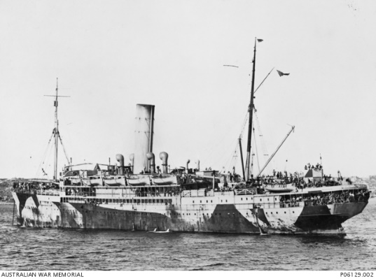At the time of his enlistment, Claude was living with his sister Mrs. Rose Mitchell at Greensborough. Rose was listed as his next of kin as well.

After training he embarked on HMAT Warilda A69 on 8th February 1916 and landed in France.

After serving in a number of training battalions he was taken on strength in the 22nd Battalion on 24th April 1916. He was promoted to Lance Corporal on 7th December 1916, to Temporary Corporal on 13th December 1916 and then Corporal on 1st March 1917.

On 29th April 1917, he was sent to hospital sick where he remained until 29th May 1917. On 8th August 1917, he was added to the Supernumerary list of the 22nd Battalion and appointed as a member of the permanent staff of the 6th Training Battalion. On 19th December 1917, he qualified as an assistant instructor after attending a course at Gas School.

On 30th January, he rejoined the 22nd Battalion in France where he remained until wounded - a gunshot wound in his right knee on 1st September 1918. He was admitted to the South African Military Hospital in Richmond Park, Surrey for treatment.

He returned to Australia on the Hospital Ship Morvada embarking on 4th January 1919 and arriving on 20th February 1919. He was discharged on 6th April 1919.

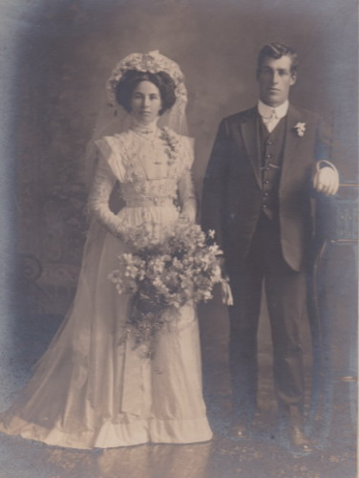He received the British War Medal and the Victory Medal.

Percival married Lillian Hawkes in 1930 in Korumburra and had another son.

He passed away 12th December 1980 in Korumburra, age 99.

Percival’s brother Leonard Alexander Amiet 4130 also served in WW1.

.

