Clifton William Anderson
Serial No. 4426
Rank: Private
Unit: 2nd Field Artillery Brigade
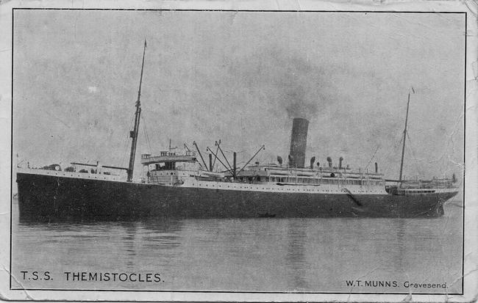
Clifton William Anderson was born in North Fitzroy in 1889, the son of William Philip Anderson and Annie Greenhorn; his wife was Matilda May Anderson. At the time of his enlistment the family was living at Clifton Hill. He was 25 years old and working as a poultry farmer when he enlisted on 19th March 1915.
He embarked on HMAT Themistocles and landed in Gallipoli 15th November 1915. He was transferred to 5th Division Artillery and saw active service in France.
Clifton Anderson was promoted to Corporal on 22nd March 1916, transferred to 13th Field Artillery Brigade on 11th April 1916 and promoted to Sergeant on 2nd May 1916. On 26th May 1916 he was promoted to Brigade Quartermaster Sergeant. On 16th June, he embarked on Tunisian for Marseilles and arrived there on 23rd June.
He was wounded on 27th October 1917 with a gunshot wound to his right arm and rejoined his unit in January 1918. He was wounded again on 27th May 1918, this time remaining on duty. On 15th December 1918, he reverted to the rank of Gunner at his own request. He returned to Australia on 7th May 1919 on the Kildonian Castle and was discharged on 6th July 1919.
He died on 14th September 1946 at Caulfield.
He was awarded the 1914/15 Star, British War Medal and Victory Medal.
Clifton Anderson is commemorated with his brother Philip Anderson on the Greensborough and District Honour Board at the Greensborough RSL.
