Philip David Anderson
Serial No. 3523
Rank: Gunner and Batman
Unit: 2nd Field Artillery Brigade and 1st Division Artillery Headquarters
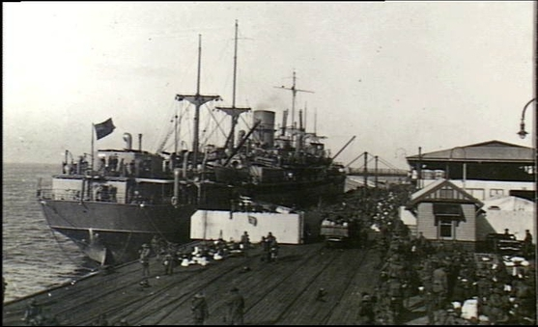
Philip David Anderson was born in North Fitzroy in 1884, the son of William Philip Anderson and Annie Greenhorn. At the time of his enlistment the family was living at Sherbourne Road Greensborough. He was 30 years old and working as a farmer when he enlisted on 21st August 1914.
He travelled on HMAT Shropshire A9 and left on 20th October 1914. His Service No. was 1012 and he was serving as a Batman attached to the 2nd Field Artillery Brigade HQ.
His service records show a varied career as Gunner August 1914, Batman September 1914 and Cook December 1914. On arrival in Egypt his Service No. was changed to 3523. He served at Gallipoli until 1st October 1915 when he was sent firstly to Malta and then to Mudros listed as sick with enteritis. He rejoined his unit on 28th December 1915 at Tel-el-Kebir.
On 22nd March 1916, he departed for Marseilles on the Zohemia arriving on 28th March. In France, he served with the 1st Division Artillery HQ until 8th July 1916 when he reported ill again and hospitalised. He rejoined his unit on 24th August 1916. On 14th November 1917, he was transferred to the 1st Division Artillery Brigade Trench Mortar battery.
He received 1914 Leave and left for Australia on 8th October 1918 on the Port Sydney and was discharged 31st January 1919.
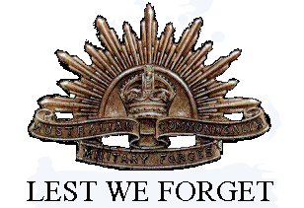
He was awarded the 1914/15 Star, British War Medal and Victory Medal.
In his final correspondence in 1931, he is living in Canterbury and requests a replacement ’Returned Soldier’s Badge’ for one he has lost.
Philip David Anderson is commemorated with his brother Clifton Anderson on the Greensborough and District Honour Board at the Greensborough RSL.

