Ivan Joseph Barnard
Service No. 1908
Rank: Private
Unit: 5/14th Battalion.
Ivan was born in Bulla in 1892, the son of Joseph Barnard and Mary Harrison. At the time of his enlistment the family was living at Bundoora with his mother. He was 22 years and 11 months old and working as a Dairyman when he enlisted on 18th January 1915. Ivan named his mother as Next of Kin, Mary Barnard, C/o PO Bundoora.
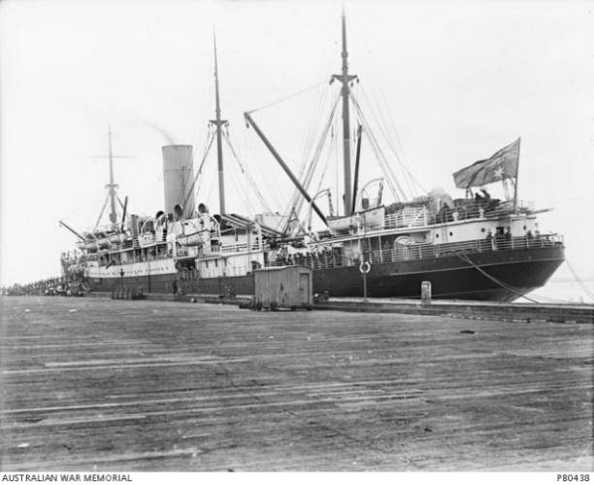
After training he embarked on HMAT Hororata A20 on 17th April 1915 with the 14th Battalion and saw active service in Gallipoli. He was twice charged with military offences and received punishments that included loss of pay and some detention. These occurred at Gallipoli and in Egypt.

On 3rd March 1916, he was transferred to the 46th Battalion. Later in March he was transferred to 12th Field Artillery Brigade and the 48th Battery.
On 2nd June 1916, he embarked on a ship destined for Marseilles and the Western Front.
Later in June 1916 he was transferred to the 24th Field Artillery Brigade. On 17th June, his Service number was changed to 1908A.
On 25th January 1917, he was transferred again, this time to 11th Field Artillery Brigade. Then on 23rd June 1917 Ivan was awarded the Military Medal.
‘This man showed great pluck and endurance during operations on 7th/8th June 1917 before Messines. He worked as runner during a period of 24 hours duty from F.O.O. to Group Headquarters bringing very important dispatches under heavy shell fire’ Source: ‘Commonwealth Gazette’ No. 219 Date: 20 December 1917.
Between late 1917 and his return to Australia in March 1919 he was hospitalised several times listed as sick.
He returned to Australia on the Cluny Castle on 21st July 1919.
He received the Military Medal, 1914/15 Star, BWM, and Victory Medal.
Ivan had two brothers who also served in WW1 namely, Private Gilbert Oliver Barnard and Lance Corporal Victor Alfred Barnard MM, 7th Battalion, who was killed in action on 9 August 1918.
All three are mentioned on the Epping District Honour Board.
Ivan married Ida Mellman in 1923, they had four sons. Sadly Ivan and Ida passed away in 1968.
