Victor Alfred Barnard
Serial No. 5473
Rank: Lance Corporal
Unit: 17th/7th Battalion
Victor Alfred Barnard was born in Geelong in 1889, the son of Joseph Barnard (a Bundoora farmer) and Mary Harrison and the husband of Gwenllian Barnard. At the time of his enlistment the family was living at Essendon. He was 27 years old and working as a carpenter when he enlisted on 31st March 1916.
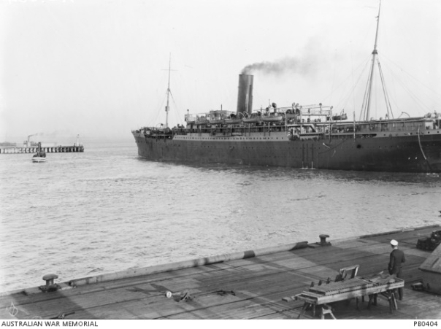
He embarked on HMAT Euripides A14 and saw active service in France and Belgium.
His brothers Gilbert (Bert) and Ivan were also on active service.
Victor Alfred Barnard was killed in action 9th August 1918 in France. He is buried/commemorated at Heath Cemetery.

He was awarded a Military Medal, British War Medal and Victory Medal and Memorial Plaque.
“Mrs. V. Barnard, of 17 William Street, Essendon, has been notified that her husband, Cpl. V. Barnard has gained the M.M., which distinction has also been conferred on his younger brother, Ivan. Another brother is on active service.” OUR SOLDIERS. (1918, February 21). The Essendon Gazette and Keilor, Bulla and Broadmeadows Reporter (Moonee Ponds, Vic. : 1914 - 1918), p. 3 Edition: Morning. Retrieved June 4, 2012, from http://nla.gov.au/nla.news-article74605136
Military Medal: Official Citation: “Lance Corporal Victor Barnard: Near Ypres on 4/5 October 1917, L/Cpl BARNARD displayed fine initiative and courage in assisting his Company commander to reorganise for attack on objective. On capture of the objective he was conspicuous for his leadership and control of his men in organisation and in consolidation of the whole of his company’s front.”
DEATHS ON ACTIVE SERVICE. “BARNARD. Officially reported killed in action, 9th August, somewhere in France, Lance-Corp, Victor A. Barnard, M.M., of the 7th Batt., after two years and five months' active service, the dearly beloved husband of Gwenllian, and dearly loved father of little Clara, of 17 William St., Essendon, and eldest son of Mr. and Mrs. J. Barnard, of Bundoora, and brother of Bert and Ivan. (M.M., on active service), and Ernest. Wilfred and Dorrie and the late Ruby. My beloved, my hero, he died as he lived - a man.” Family Notices. (1918, September 5). The Essendon Gazette and Keilor, Bulla and Broadmeadows Reporter (Moonee Ponds, Vic. : 1914 - 1918), p. 2 Edition: Morning. Retrieved August 10, 2012, from http://nla.gov.au/nla.news-article74607057

