James Richard Bell
Serial No. 7199A
Rank: Private
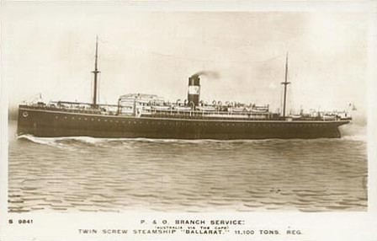
Unit: 7th Battalion and 4th Pioneers
James Richard Bell was born in Brunswick in 1890, the son of James Ballarat Bell and Annie Elizabeth Dufton.
At the time of his enlistment on 4th November 1916 he was married, 26 years old, living in Smith St, Thornbury and working as an engine driver.
He gave his wife Isabella Bell as his next of kin.
He embarked on HMAT Ballarat A70 on 19th February 1917 and disembarked on 25th April 1917 at Devonport England.
After completing his training in England and having some time in hospital with bronchitis, he was transferred to France on 20th August 1917 and placed with the 23rd Battalion. In October 1917, he suffered from trench foot and was briefly hospitalised.
In October 1918, he had a 14-day furlough to England and after the cessation of hostilities he attended some education courses in France until 16th May 1919 when he left France for England and eventually left England for Australia aboard the “Chemnitz” on 7th July 1919 where he disembarked on 5th September 1919.
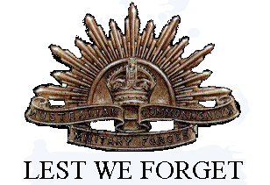
James was awarded the British War Medal and Victory Medal.
He died in November 1958 aged 68 and is buried at St Helena Cemetery.

