William Charles Bigmore
Serial No. 16755
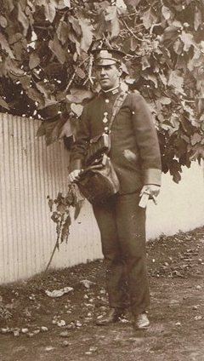
Rank: Private
Unit: 11th Field Ambulance
William Charles Bigmore was born in Bundoora in 1887, the son of John William Bigmore and Alethea Wood. He married Nellie Medwell on 14th October 1908 in Murray Bridge, South Australia. At the time of his enlistment William and Nellie were living at 40 Rundle St, Kent Town, South Australia.
He was 28 years old and working as a motorman when he enlisted on 17th July 1916.
William in his 'motorman' uniform
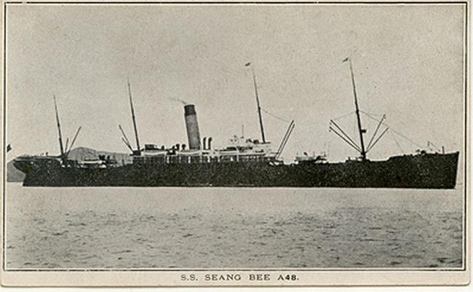
He embarked on HMAT Seeang Bee A48 from Adelaide on 10th February 1917 and arrived in England on 2nd May 1917.

On 21st June 1917, he was a taken onto the strength of the 11th Field Ambulance in France. William was appointed a Lance Corporal on 7th October 1918.
He returned to Australia in 29th August 1919 on the Friedrichsruh and was discharged on 6th October 1919.
William Bigmore was awarded the British War Medal and Victory Medal.
