Thomas James Bodycoat

Service No. V41569

Rank: Gunner

Unit: Field Artillery Brigade Reinforcements

Thomas James (Jim) Bodycoat was born in Greensborough in 1893, the son of Frederick Bodycoat and Ann Blacker. At the time of his enlistment the family was living at Diamond Creek. He was 22 years and 5 months.

Thomas trained for three months at Maribyrnong and served as a driver in the 119th Howitzer Battalion before being transferred to Field Artillery Reinforcements.

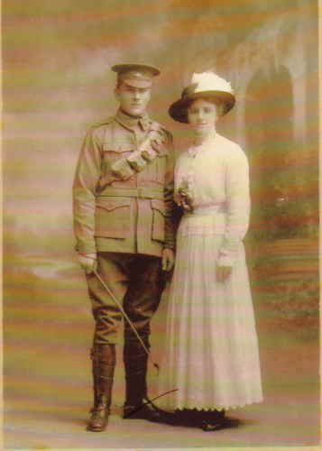Unfortunately, he was discharged in November 1916 as medically unfit due to a bout of pneumonia. Thomas did not have the chance to serve overseas.

Thomas married Amelia Elsie Olive (Elsie) Bodycoat in 1916.

Thomas Bodycoat is commemorated on the Greensborough Primary School Honour Board.

Post war, Jim and Elsie settled in Bacchus Marsh where he worked as a dairyman until the late 1940s. Thomas died in 1951.

