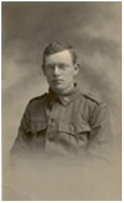
Jasper Lewis Bolton
Serial No. 3498
Rank: Private
Unit: 3rd Pioneers & 59th Battalion
Jasper Lewis Bolton was born in Hawthorn in 1895, the son of Thomas Bolton and Emma C. Bolton. At the time of his enlistment the family was living at Hamilton Victoria.
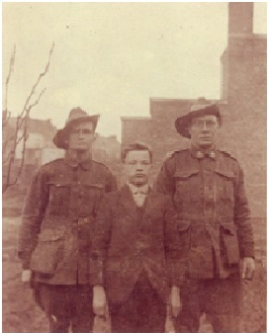

He was 21 years old and working as a well borer and handyman when he enlisted on 28th June 1917.
He embarked on HMAT Nestor on 21st November 1917 and on 18th May 1918 was added to the strength of the 59th Battalion in France where he served as stretcher bearer.

Jasper Bolton returned to Australia on 20th August 1919 on the Port Melbourne and moved to Briar Hill in the inter-war years.
He was discharged on 15th October 1919 and was awarded the British War Medal and Victory Medal.
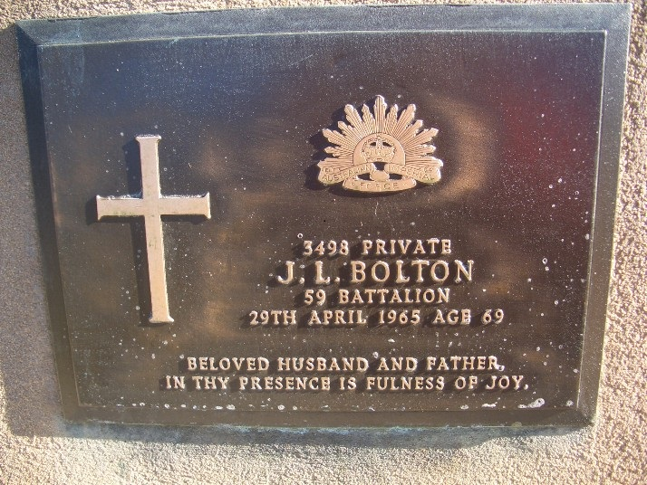
Jasper Lewis Bolton died in 1965.

His daughter Jo Petrovic writes “Our dad – Jasper Lewis Bolton – was 21^{1/2} years old when he joined the War effort. He had been raised in a strict, God-fearing farming family in Hamilton, Victoria, and believed he should do his bit to serve King and Country. However, he was a conscientious objector, and so rather than carry arms, he became a stretcher-bearer – and bravely went into the line of fire to lift off the dead and wounded. He never spoke about the war – the memories were so painful –

He passed away at age 69 from war-related wounds. My dad was a hero!”

Thanks to Jo for the photos of her father.

