Thomas Brock
Serial No. 23
Rank: Private
Unit: 2nd Brigade HQ
Thomas Brock was born in 1878 in Hokitika New Zealand. At the time of his enlistment on 30th August 1914, he was 36 years old, working as a miner, living in Newmarket and gave his next of kin as his brother Michael Brock of Greensborough.
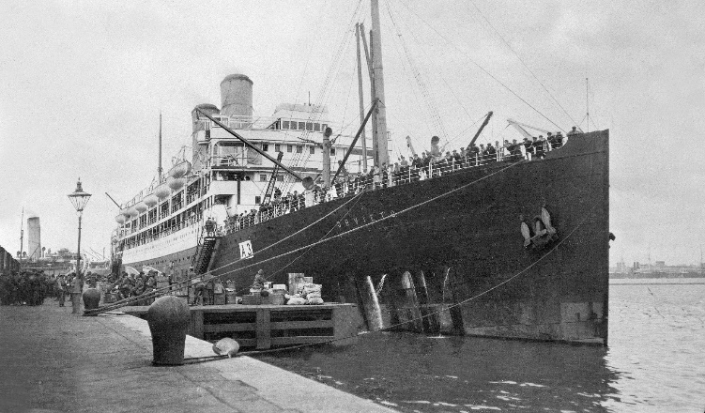
He embarked on HMAT Orvieto A3 on 21st October 1914 and saw active service at Gallipoli as a Driver with the 2nd Brigade HQ.
He was returned to Australia on 6th August 1915 on the Ballarat. Thomas received a medical discharge on 20th September 1915, but his war was not over.
In 22nd June 1917, Thomas Brock again enlisted with the Service No. 67059 as an Acting Sergeant in the Military Police. His next of kin, his wife (Evelyn Brock), was living in Northcote. Thomas was discharged on 31st January 1919.
He was awarded the 1914/15 Star, British War Medal and Victory Medal.

