George Augustus Broome
Serial No. 29707
Rank: Private
Unit: 12th Field Artillery
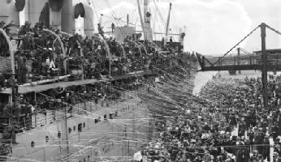
George Augustus Broome was born in Geelong in 1895, the son of George William Broome and Margaret McDonald Connor. At the time of his enlistment the family was living at Bundoora. He was 21 years old and working as a bank clerk when he enlisted on 22nd April 1916.
He embarked on HMAT Aeneas A60 on 2nd October 1916 and arrived in England on 19th November 1916.
On 26th January 1917, he joined the 4th Division Ammunition Column in France. Three days later he was transferred to the 12th Field Artillery Brigade.
In November 1917, he was hospitalised and returned to England for treatment. He was later diagnosed as having disturbed action of the heart (DAH).
George Broome was returned to Australia in 15th April 1918 on the HT Marathon and given a medical discharge in 24th July 1918.
He was awarded the British War Medal and Victory Medal.
