Edward Brownhill
Serial No. 4080
Rank: Private
Unit: 21st Infantry Battalion
Edward Brownhill was born in East Melbourne in 1897, the son of Charles Edward Brownhill and Eliza Howard.
At the time of his enlistment the family was living at Bundoora where they had a farm. He was 18 years old and working as a postal employee when he enlisted on 10th January 1916.
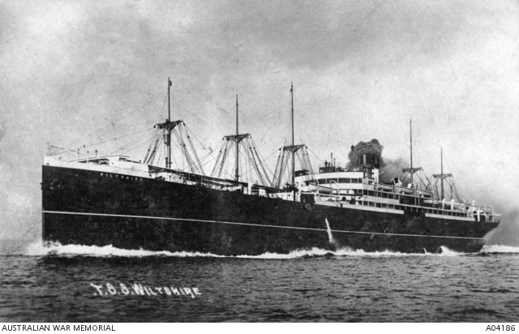
Edward embarked on HMAT Wiltshire A18 and saw active service in France joining his unit the 21st Battalion on 7th August 1916. On 28th August 1916 Edward was seriously wounded with gunshot wound to his right thigh.
This caused him to be evacuated to England and resulted in the amputation of his right leg. He was granted a medical discharge in 28th January 1918.
He was awarded the British War Medal and Victory Medal.
The Brownhill family were early settlers in Bundoora to the west of Plenty Road and helped establish the Bundoora and District Hall. (Kenna, Len “In the beginning there was only the land” Bundoora, Lions Club, 1988.) Brownhill Road is named after the family.
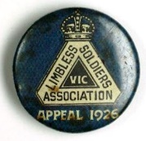
Edward Brownhill received an MBE in 1957. “Queen's Birthday Honours 1957: Edward Brownhill, of Greensborough, Victoria, in recognition of his devoted service to the Limbless Soldiers' Association of Australia.”
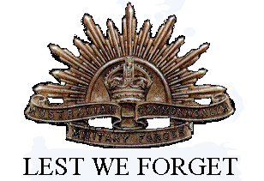
He died in Heidelberg in 1966, aged 69.

