Walter Bruce
Serial No. 40
Rank: Private
Unit: 1st Div Engineers 3rd Coy
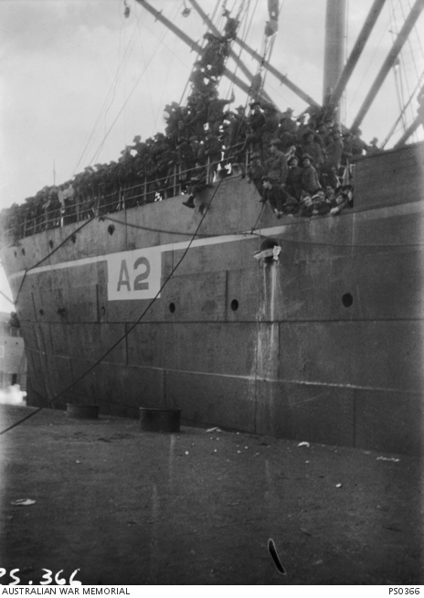
Walter Bruce was born in Dunedin, New Zealand on 3rd April 1886. He was 28 years old, living at Plenty Farm Greensborough and working as a carpenter when he enlisted on 25th August 1914 at Enoggera near Brisbane. He gave his next of kin as Mr J.H.Davey of Plenty Farm Greensborough. He had previously served with the militia in the 5th Infantry Regiment in Melbourne.
After training he embarked on HMAT Geelong A2 on 22nd September 1914. He was originally sent to Egypt and then onto Gallipoli on 1st June 1915, serving with the 3rd Field Engineers Company.
He suffered a bullet wound to his right hand in September 1915 and was hospitalised in the 1st Auxiliary Hospital at Heliopolis, Egypt. He returned to duty on 31st October 1915. In November he suffered from a bout of diarrhea and was sent to the 2nd Field Ambulance at Maadi in Egypt for a short period.
On 3rd April 1916, he disembarked at Marseilles enroute to the Western Front. He served in France and had a few bouts of drunkenness for which he was penalized a number of times.
On 29th September 1916, he was admitted to hospital with dysentery. This continued to trouble him for the remainder of 1916 and saw him variously in hospitals and rest camps for the remainder of his war service. During this time, he was removed from France to England. On 26th May 1917 his appendix was removed.
During his time in England in March 1917, he also broke out of the hospital and was duly punished for being AWOL.
He was returned to Australia suffering from dyspepsia in the Hospital Transport Nestor arriving on 22nd July 1917.
A medical board determined that this disability was deemed to be caused by ‘active service’, exposure and army rations.
In October 1917, he elected to receive 3 weeks private treatment for his ailment and he address at this time was c/o Mrs Davey, Plenty Farm, Greensborough.
He was later hospitalised at the 6th Australian General Hospital in Brisbane where he received a medical discharge on 4th January 1918.
Walter Bruce died in Rockhampton Queensland on 3rd May 1919.
Although eligible for the 1914/15 Star, British War Medal and Victory Medal, these were never claimed as Walter Bruce had no living relatives.
Mrs Davey of Greensborough’s claim for Walter’s war medals was rejected due to Mrs Davey not being a relative and Walter’s medals were placed on the ‘untraceable’ list to be published in Australia and New Zealand in hope of finding blood relatives.
Walter Bruce is commemorated in Greensborough on the Greensborough and District Honour Board at the Greensborough RSL, possibly due to the efforts of Mr Davey, whose sons are also commemorated on this board.
