William Bryant
Serial No. 544
Rank: Private
Unit: 7th Machine Gun Coy & 2nd Machine Gun Battalion
William Bryant was born in Bundoora in 1895, the son of William Bryant and Fanny Brompton. At the time of his enlistment the family was living at Abbotsford. He was 21 years old and working as a saddler and harness maker when he enlisted on 24th May 1916. Prior to the War, he served as a senior Cadet in the 55th Battalion Infantry, based in Abbotsford.
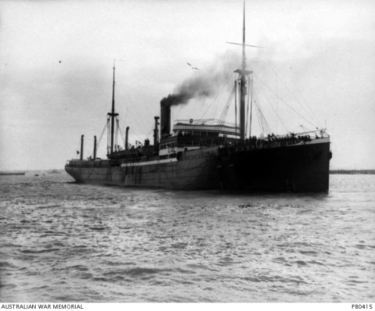
After training in Geelong with the 3rd Reinforcement, 2nd Cyclist Battalion, he embarked on HMAT Barambah A37.
He was court martialed for theft from a comrade in England and was sentenced to 84 days hard labour and the loss of payments for 96 days.
After he had served his time, he was transferred to the 4th Division Machine Gun Company Training battalion. After this he joined the 7th Machine Gun Company in France on 16th October 1917.
On 20th March 1918, he was hospitalised for 10 days. About this time his unit was redesignated as the 2nd Machine Gun Battalion.
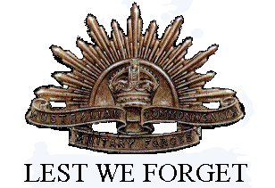
By the end of 1918, William was being treated for acute nephritis and returned to Australia on the Hospital Transport Shropshire on 16th May 1919 when he received a medical discharge.
He was awarded the British War Medal and Victory Medal.
William Bryant died on 14th September 1947 in Preston, aged 51.

