John Henry James Burrows
Service No. 13014
Rank: Driver
Unit: 2nd DMT Coy & 2nd Aust. Div. Supply Col.
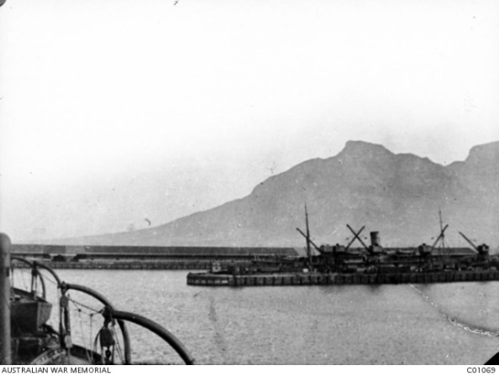
John Burrows was born in Greensborough in 1890, the son of Adam Burrows and Marian Purcell. At the time of his enlistment the family was living at Alphington. He was 26 years old and working as a Tram Grip man when he enlisted on 24th July 1916.
His next of kin Adam Burrows (Father) lived in Como Street, Alphington.
After training he embarked on HMAT Persic A34 on 22nd December 1916 and landed in England on 3rd March 1917.
On 20th June 1917, he was transferred to France and served as a driver with the 2nd Division Supply Column and 2nd Division Motor Transport company.
John was admitted to hospital in France on 18th February 1919 and then evacuated to a military hospital in England with bronco pneumonia. He was discharged from hospital on 31st March 1919 and granted a furlough.
He returned to Australia on the HT Runic A45 on 27th April 1919, reached Melbourne 10th June 1919, discharged from A.I.F 18th July 1919.
John received the British War Medal and the Victory Medal.
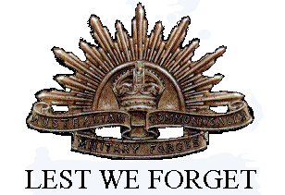
John Burrows is commemorated on the Greensborough State School Honour Board.
In 1923 John married Hettie Ferguson, they had one daughter.
Sadly John passed away in 1961 and Hettie in 1988.
John’s mother was Marian Purcell, three Purcell family members are buried in Greensborough Cemetery.

