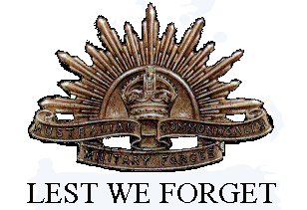George Campbell

Serial No. 1658

Rank: Private

Unit: 6th Battalion

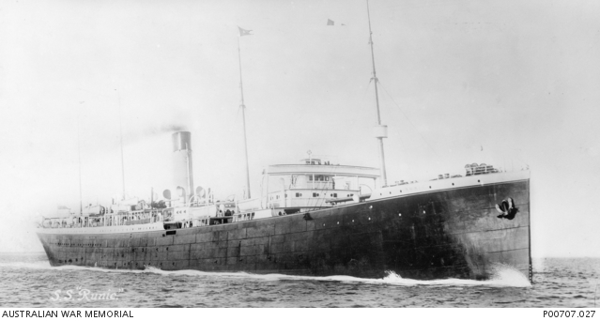George Campbell was born in Arbroath Scotland in 1886, the son of David Campbell. He served in the Royal Garrison Artillery for four years. At the time of his enlistment he was living at Greensborough. He was 29 years old and working as an engineer when he enlisted on 5th January 1915. He embarked from Australia in February 1915 on HMAT Runic A54.

He was wounded several times in Gallipoli, sent to England to recover and rejoined his battalion in France in August 1916.

George Campbell was promoted to Sergeant in December 1918 and twice awarded the Military Medal. *“Military Medal. For conspicuous gallantry near Merris [France] on the night of 5/6th [June 1918]. This linesman 1658 Lance-Corporal George Campbell laid new lines through a newly captured position under a very heavy barrage. For five hours he was out on the lines and through his great devotion to duty temporary communications were available.”* And, Military Medal and Bar. *“August 10, 1918: At Lihons, 10th August 1918 Lance Corporal Campbell laid telephone lines over exceptionally flat and open country under extremely heavy machine gun and rifle fire. He made repeated trips out into the open repairing broken wires and when the attacking troops pushed forward, accompanied them and succeeded in laying lines and maintaining communication between forward companies and battalion headquarters.”*

George was returned to Australia in March 1919.

He was awarded the Military Medal and Bar, 1914/15 Star, British War Medal and Victory Medal.

George Campbell is commemorated in Greensborough on the Greensborough and District Honour Board at the Greensborough RSL.

In 2021, GHS was contacted by George’s grandson John Graham who sent this further information on his grandfather’s life, along with the photo included here.

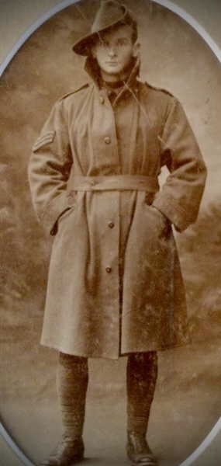George emigrated to Australia from Scotland shortly before the war, because of the lack of employment opportunities in Scotland.

Before he enlisted in the Australian army, George paid a deposit on a block of land in Greensborough. Having no family in Australia, he arranged to have a portion of his army pay diverted to a friend in Melbourne to be used to pay down the loan for the land. When he returned to Melbourne in 1919, George discovered that his “friend” had assumed that George would not survive the war and kept the money for himself. Consequently, George lost the block of land.

George married in 1921 and built a house in Middle Camberwell. He named the house “Ben Ledi” after a Scottish mountain he climbed as a boy. He had 2 daughters, one of whom is my mother who is alive today and who related to me these memories of George.

George worked at Swinburne Tech. (today Swinburne University), in nearby Burwood Road, Hawthorn, where he taught engineering until his retirement. He came home every afternoon for a quick dinner before returning to Swinburne to teach the evening classes. George Campbell was well regarded by George Swinburne, the school’s founder, who invited George and his wife to his home for dinner.

George never owned a car. He travelled to and from work by tram. The family’s annual holiday was a camping trip to the Frankston foreshore during the lengthy school holidays in summer. The family along with the tent which George made himself, was transported to and from Frankston in a furniture removal van owned by a friend with whom George had an arrangement. Clearly George knew the value of money; well, he was a Scotsman after all.

Apart from an occasional glass of whiskey, I remember that George liked to drink sauternes to the exclusion of any other wines. I have to wonder whether he developed the taste for sauterne on the battlefields of France, perhaps found in the cellar of an abandoned farm house.

George lived in the Camberwell home until his death in December 1977, aged 92. He is fondly remembered and never lost his Scottish brogue accent.