John Huxley Carse
Serial No. 2592
Rank: Bombardier
Unit: 25th Howitzer Brigade and 14th Field Artillery Brigade
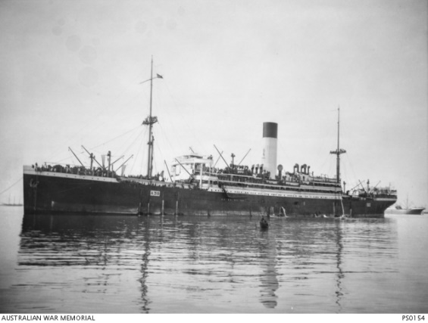
John Huxley Carse was born in Corryong in 1897, the son of Hubert William Carse and Margaret Carmody. At the time of his enlistment the family was living at Redcliffs via Mildura. He was 19 years old and working as a State School teacher when he enlisted on 16th July 1915. He travelled on HMAT Ulysses A38.
On 17th March 1916, he was transferred to the 5th Division Artillery, specifically with the 115th Battery of the 25th Howitzer Brigade. On 2nd June 1916, he was promoted to Bombardier. He was serving at Moascar, Egypt at the time.
On 19th June, he embarked for Marseilles and arrived on 25th June 1916. On 7th July 1916, he was transferred to the 114th Battery and two days later to the 14th Field Artillery Brigade.
While serving in France on 3rd September 1917, he received multiple wounds from shrapnel resulting in losing sight in his left eye, having his right leg amputated and paralysis of his right arm.
He was evacuated to England for treatment where on 28th February 1918, his right leg was amputated.
John Carse was returned to Australia 18th November 1918 on the Arawa. He received his Medical Discharge on 19th March 1920.
He was awarded the 1914/15 Star, British War Medal and Victory Medal.
He died at the Military Hospital Caulfield on 2nd October 1926 from war-related injuries.
“CARSE. On the 2nd October at Military Hospital, Kooyong Road, Caulfield, John Huxley, the beloved eldest son of Hubert and the late Margaret Carse, beloved brother of Edward, Gordon, Thomas, Frank, Maurice, Bombardier 114 H. Battery, late A.I.F. aged 29 years.” Argus, Vic., Mon 4 Oct 1926
John Huxley Carse is commemorated on the Essendon High School Honour Board and is buried in Greensborough Cemetery. John Carse’s father Hubert was Headmaster at Greensborough State School and lived in Greensborough until his death.

