Frederick William Chanter
Serial No. 4674
Rank: Private
Unit: 22nd Battalion
Frederick William Chanter was born in Wagga Wagga N.S.W. on the 25th September 1892 to Frederick and Maria Chanter. In 1915 he married Alice Evelyn Splatt of Greensborough; Alice was the daughter of Henry (Barl) and Alice (Memmott) Splatt.
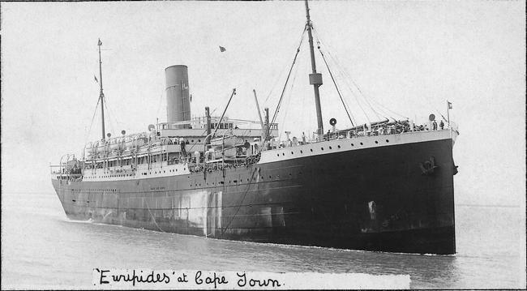
On the 22nd of June 1916 Fred Chanter together with his brother in law Vic Splatt, Fred Ely, Reg McDowell and John Poulter, all from Greensborough travelled to Melbourne to enlist in the 1st World War. All were signed up as members of the 22nd Battalion.
Along with fellow members of the 22nd Battalion Fred embarked for overseas on the 4th April, 1916 aboard HMAT Euripides.
Following his arrival in England Fred Chanter then proceeded to France in September 1916 and was taken on strength in the field. Fred’s brother Arthur who enlisted in New South Wales had been killed in action on the 25th July 1916.
Almost from the beginning Fred Chanter’s war did not go as planned, in November of 1916 for unknown reasons, his vision was impaired, then in December of 1916 he was hospitalized with Influenza and Mumps. His wife Mrs. Alice Chanter back in Greensborough was notified in January of 1917 that her husband Fred Chanter was on the seriously ill list with Mumps. In the same January Fred was returned to England and admitted to the 3rd Australian General Hospital suffering from severe nephritis (inflammation of the kidneys).
On the 9th of February 1917 Fred was returned to Australia and in August of that year was discharged from the A.I.F. as medically unfit due to War Service.
He was awarded the British War Medal and Victory Medal.

Returning to live in Greensborough with his wife and young daughter, Fred applied to join the Victorian Police and he was accepted on the 10th of October 1917. Fred was in the Police Force for six years and his annual reports showed him to be efficient and well conducted, he was attached to the Russell Street Depot on foot duty. That is until the 31st October 1923 when he joined the only strike by Policemen in the History of Australia. In the book Days of Violence, page 46 describing the scene it says “At 11am he (the constable on duty) was besieged by a large crowd including strikers Constables Cahill, Chanter and Haywood”.
Constable Chanter was discharged from the Police Force on the 2nd of November 1923 for refusing to work as part of the Police Strike.
Fred and Alice had a son Victor in 1921 and Fred resumed the occupation he had before the war, that of Timber Stacker, the family moved to their new home at 35 Kelvin Road Alphington and were still living there when Fred Chanter died in 1962.
Fred played one game of league football with Fitzroy Football Club, but son Vic Chanter went on to play 108 games with Fitzroy.
Frederick William Chanter is commemorated in Greensborough on the Greensborough and District Honour Board at the Greensborough RSL.

Greensborough Historical Society World War I Project thanks Val Wilson for her article on Fred Chanter

