Henry Thomas Chappell
Serial No. 2288
Rank: Private
Unit: 4th and 39th Battalion
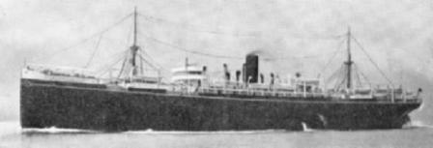
Henry Thomas Chappell was born in 1873 in Birregurra Victoria, the son of Charles Chappell and Sarah Ann Moffat. He gave his next of kin as his brother Alfred Chappell of Yarrawonga. At the time of his enlistment he was living at Greensborough. He was 42 years old and working as a carpenter when he enlisted on 4th September 1916.
On 20th October 1916, he embarked on HMAT Port Lincoln A17 and completed his training in England with the 10th Training Battalion at Durrington.
On 25th April 1917, he was transferred to France where he joined the 39th Battalion.
Henry was gassed on 7th June 1917 and evacuated to England. As his case was severe, he was returned to Australia in September 1917 and discharged on 26th January 1918.
He was awarded the British War Medal and Victory Medal.
Henry died in December 1937.
Henry Thomas Chappell is commemorated in Greensborough on the Greensborough and District Honour Board at the Greensborough RSL.
