Argus (Melbourne, Vic. : 1848 - 1957), Saturday 2 February 1907, page 6

PROCESSION OF THE FRUIT.
By BLAMIRE YOUNG.
Whenever it is possible, I like to pass these short summer nights out of doors. It is cool and pleasant, and the 'possums in the apple tree scarcely interfere with my slumbers unless they drop a particularly large apple near my head. From where I sleep I can see the lights of the market carts as they appear in the cutting, and I can hear the rumble of the wheels cease as they pull up at the water-troughs at the corner. Then follow the voices of the drivers as they speak to their horses, and I can catch bits of their conversation while they wait their turn. So they pass towards the lights of Melbourne, that flare all night in the southern sky doing collectively the great work of feeding this great city - doing this so ably, so methodically, while Melbourne sleeps. And just in this way, through countless ages, all the great cities that have arisen and declined have been fed by a patient never-ending stream of market carts, and always whilst they slept. Beyond small differences of detail of harness, of dress, of speech, and perhaps, of weights and measures and of coinage, the process has been carried out in the very some way Alexandria and Memphis and Nineveh slept, as it were, with their mouths wide open as Melbourne does while the fertile holdings round about them poured in their endless stream of provisions, in a vain attempt to satisfy their demand for food.
These carts that pass my garden come from the most romantic and beautiful districts of all those that contribute to Melbourne's temporal needs. St Helena, Diamond Creek, Christmas Hills, Kangaroo Ground, Panton Hills, are all represented, and after living on the route for long enough you come to know many of the more regular ones by sight. At night you can tell a market cart from a wood cart by its light. The market cart boasts of a smart lamp with a reflector, while the wood cart is satisfied with a bit of candle in a battered lantern. On still nights your sense of smell will sometimes tell you a good deal for instance, if you catch the delicious smell of raspberries you know that the cart must have come a long way from above Queenstown or Upper Diamond. Most of the peaches come from Diamond Creek, but the apples and apricots take a wider range. I know many of the orchards and farms, especially the more picturesque ones, from visits I have paid them on sketching expeditions, and their owners are always kind and hospitable, and humorously tolerant of the whims of the painter, for there is no one who takes so many liberties about a place is a painter - the dairy inspector alone excepted - and they are almost invariably indulgent to my pictures. Indeed, when these alleged pictures have claimed to portray the form or features of the farmer himself, or, perhaps, of some of his womankind. I have not found their resentment either violent or permanent.
This old fashioned market cart comes from a little five-acred orchard between Greensborough and Bundoora. For more than fifty years have these five acres been supplying Melbourne with their bi-weekly contribution of fruit and vegetables, and hale and hearty still is the pleasant old gentleman, who has worked them single-handed all that time. I love well to call at the old place, and hear him talk in the very broadest Midland dialect. He is over eighty now, and has been a colonist for more than fifty years; but he has not modified a syllable of his homely speech by contact with new people in all that time. I have noticed with what strange tenacity English people, who learnt to speak in England, retain the local accent of their particular county, while their children, grandchildren, and in the case of this octogenarian, great-grandchildren, are love making and gossiping around their knees in quite another language - Australian to wit - and yet they shorten not a tick the generous length of their vowels. I think they are right for the older dialect is often the more vigorous of the two.
Our old friend carries his thoroughness into his gardening, and never a weed will you find inside his four sweet-briar hedges.
His old barns and fruit-houses were built solidly in the early days, but some of them have a decided list towards the north-east.
He will tell you that one season he had a "terrible" crop of onions, which he was obliged to store above the rafters overhead. There were tons and tons of them, and when he got them safely up the "stee" a great wind began to blow from the south-west, and gratefully canted. The old building over to the position it now occupies. However, it makes a capital storehouse still, and when it is full of Rhymers and Ribston Pippins it has an aroma about it that could not be bettered by any grey old grange that nestles beneath the Cotswold Hills.
This large new van is full of strawberries, my nose tells me, and it bears a German name. It has come by roundabout ways from the upper reaches of the Plenty, where an original and constructive mind has set itself to master the irrigation mind has an intricate system of syphons, pipes, dams, and suspended aqueducts, and, judging from the size and flavour of the fruit, the question has been solved in a perfectly satisfactory manner. The house is quaintly and happily perched on an elbow of rock, overlooking the river, and reconstructs, in miniature a castle of the storied Rhine.
The next cart has seen better days. I know it well, for Pomona drives it as a rule. “Pomona” is not her real name, but as it suites her we will call her by it. A bend of the Diamond Creek hides her home - the sweetest home you ever saw. Great white gums and grey rocks and a legion of wattles clothe the high banks of the river, where Pomona and her father dwell. They are as remote from the world as though they were pioneering in the heart of Gippsland, with snows of the Baw Baw looking down on them through the towering branches of the messmates. And yet I do not suppose they are more than fifteen miles from the General Post Office as the crow flies. Just about two acres of fertile soil they have coaxed from the river bed, and they cultivate fruit and vegetables with a flavour and quality of their own, as good as any that find their way to market. The tomatoes are quite celebrated. Not of your great bulgy multi cylindered red sort, but round, smooth, and delicious with a flavour reminiscent of guavas and bananas. Her father is a tall, picturesque figure, whom you may see occasionally at the market. He always wears a red handkerchief round his neck, and has a face like John the Baptist.
As Pomona drives through the dark to market she sings or I think I ought to say chants not of battles long ago but certainly I think, of “old forgotten far off things.” I have caught but few of the words of her song, but I think it is a kind of litany, something like this, that she likely learnt from her mother as a child -
When I watch and stir the pot
Jesu, watch me slumber not.
When the rooms I sweep and clean
Jesu sweep ill thoughts unseen.
When I clean each dish and knife,
Jesu, clean from sin, my life.
And so on. I doubt if I have it very correctly, but each couplet drags in a poor kind of play upon words that is a little quaint in its archaism. There is a distinct Puritan atmosphere about Pomona that is welcome these racy days for its rarity, but she sings only fairly. She says the old horse likes it and goes better for the litany. Well it certainly wants a little encouragement, poor old nag.
Pomona brings quantities of egg to market. She gathers three or four dozen a day. I asked her once what sort of hens she slept. She said, “No particular sort, just hens." She sets at defiance with the happiest results each and every of the one hundred and fifteen commandments that are tabulated by those gifted gentlemen who write our poultry guides for us. Her hens always lay. They positively can’t stop. They lay when our silver-laced, winter laying, rose-combed, bone fed, yellow legged, ginger-dosed, green-lustred, fancy-priced and haughty humbugs are trying to pass off pot eggs as desirable breakfast food.
She grows roses too. Not such varieties as bear so modestly the splendid names of the daughters of France but just roses, and right freely do they flower, too, for it is seldom, indeed, she passes our lane-end without a few bunches stowed under the seat.
And when I tell you that Pomona makes wine, I suppose you will have instant visions of a rounded arm stained with the foaming must, or do see her tending her grapes that blacken through the summer days? In either case you wrong. She grows no grapes. Pomona’s wine is not such that frets us whilst it lingers “under the curse of the seventies," for it is made from red currants. It “has not spoken yet," and will not speak. But when Pomona mixes it with her well-water and ministers to the thirst that the hot winds can give you among the hills, then you would not change it for the noblest vintage that ever oozed from Lusitanian presses.
I wonder what would happen to Melbourne if the market carts or their drivers were to strike for eight hours a day. You may take twenty-four hours as a fair average for the double journey in this district, and that is without counting of course, the loading and picking of the fruit. Twenty four solid hours, but Pomona thinks nothing of it. She goes on methodically, year in, and year out, bringing her little store of provisions to help feed the hungry Melbourne mouths - Apples and eggs, and roses, it's all the same to her, as she chants her litany:-
When I set the midday meal, Jesu, set on me thy seal
When at last my work is done, Jesu, bless me, gentle one.
But Pomona's work is never done!

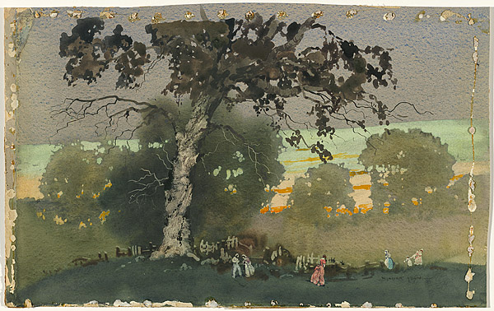

Blamire YOUNG The old gum tree [Orange and grey [before reworked]] c.1921,
reworked c.1925
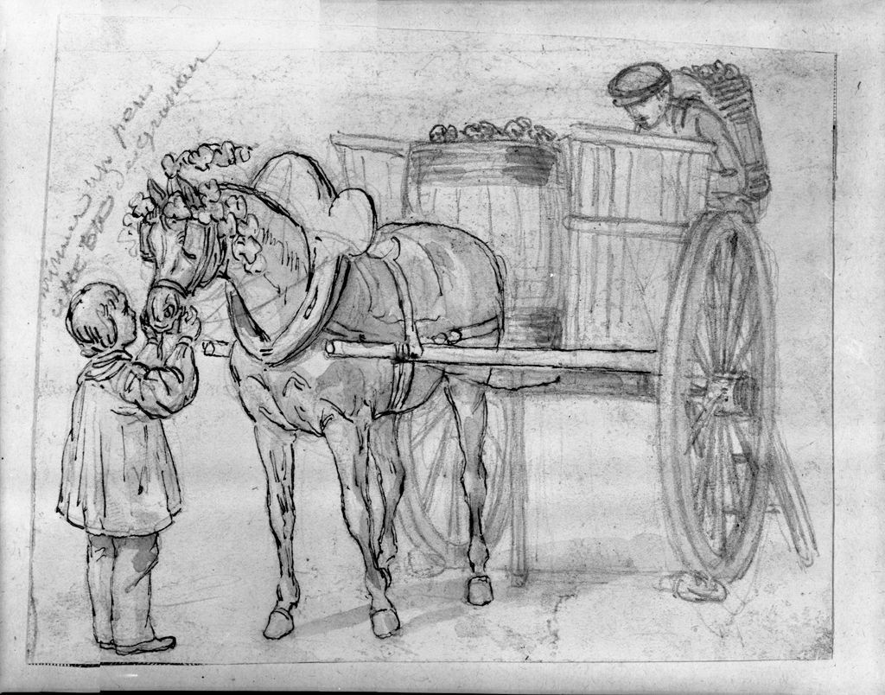

Harvesting Grapes with horse and wagon.
Fruit and Vegetable peddler.
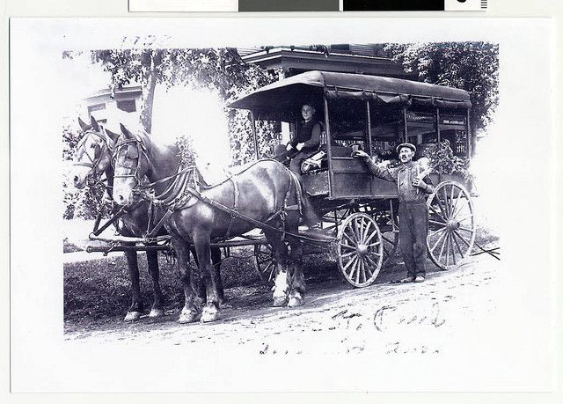

Apple harvest – Wagon loaded ready for the trip to market:
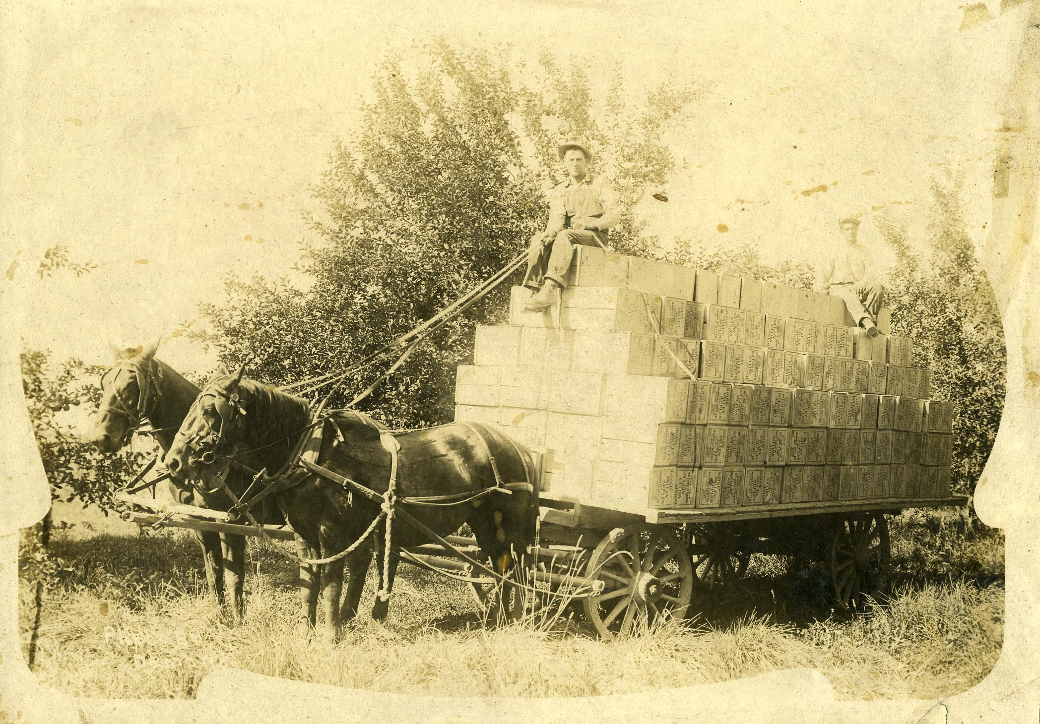
Loading the grape harvest:
