GRANDVIEW GUEST HOUSE
- Grant Barrett who lives in Greenhills saw the advert on eBay and as he does quite often contacts GHS to see if we had seen it and wondering where it was.
- Dawn:
Yes, I do know that place......& it is still there! Changed a little, but still there. It's in Greenhills Road. Number 57....right next to the lane. It was owned by a family called Attoni (Alice & Jim) when I was living in Greenhills (1950 - 1970's).
- Bill:
During the mid to late 1950s I delivered groceries to Grandview Guest House at about no. 61 Greenhills Rd. Boro'.
It was owned, I think, and run by a Mrs Glastonbury. I don't recall ever seeing any guests but recall the name very well. And the picture certainly looks familiar.

- Elaine Drakeford (nee Roberts) wrote a story for GHS. In part:
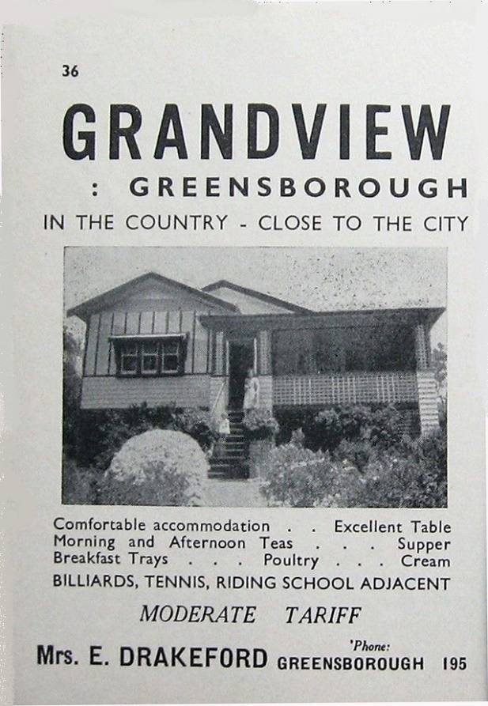
“I went to work at the Egg Co-op, at the then Watsonia camp and my boss was Bernie Drakeford, at that time he boarded with Mr. and Mrs. Harris in Broad Street, and became friends with Maurie and Ruth Heavens and family. Other mates were Lindsay and Dora Neilson, from Montmorency. Bernie helped to show films at the Greensborough Picture Theatre. Bernie’s mum and dad, Fred and Ethel Drakeford, had a guest house in North Eltham.”
Apparently the Drakeford’s moved to Eltham North from Greenhills.

