Edward Rae Cordner
Rank: Major
Unit: 6th Field Ambulance AAMC
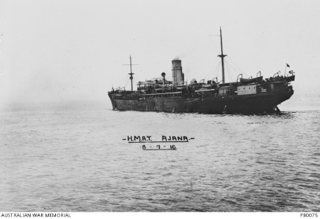
Edward Rae Cordner was born in Bendigo in 1887, the son of E.J. Cordner and Helen Rae. At the time of his enlistment the family was living at Toorak. He was 27 years old and working as a surgeon and physician when he enlisted 29th March 1915. His brother Harry Cordner, also a doctor was overseas at the time war broke out and was commissioned as a Captain in the Royal Australian Medical Corps.
Edward travelled on HMAT Ajana A31 and served in Gallipoli, Egypt, France and Belgium.
From the Melbourne Grammar School website: The relevance of the school’s beneficial effect on the morale of its old boys serving, can be gleaned from a letter written by one E R Cordner who wrote from Gallipoli on September the 22nd 1915:
“Four days ago, we had our baptism of fire. Mapleston and I were each at our posts, when the Turks began a furious bombardment of the trenches for nearly an hour. The valley behind became infernos from overshoots of every description. It made one’s heart swell to see the stretcher bearers step out from comparative safety, their burden to carry him down to the beach. They are doing magnificent work, although there is little chance of promotion for them, nor of much kudos for spectacular bravery. One simply said “next pair”, and out that pair stepped, and, beyond a slight tightening of the jaw muscles, there was no sign about them that anything unusual was going on and then they went down the hill with not the slightest care about themselves, for that was all for their patient. No quickening of the step, no hurrying, and no swaying. It was fine… [And after mentioning a large number of names of fellow Old Melburnians with whom he was serving, he then added]:
So you see the Old Melburnian’s badge is to the fore very much here. I am very sorry to say that I found it the other night inside the tunic of a man who came down from the trenches shot dead through the head. His name I am not allowed to mention, but he died a soldier’s death. I couldn’t help thinking with pride that I also had one in my tunic that I belong to a School that could train such men as he was.”

He served at Gallipoli and on 6th December 1915, he was moved to the 1st Casualty Clearing Station at Gallipoli with appendicitis. His appendix was removed on a hospital ship and then he was he was sent to the Convalescence Camp at Mudros. While he recovered from the operation, he was moved back to Egypt and had more time in hospital as a patient.
On 19th March 1916, he embarked for Marseilles arriving there on 26th March. He served in France with the 6th Field Ambulance and then the 1st Australian General Hospital. On 29th January 1917, he was promoted to Major.
He returned to Australia on the “Osterley” in September 1919 and “struck off strength” on 9th October 1919.
He was awarded the 1914/15 Star, British War Medal and Victory Medal.
Edward continued to serve in the Reserve Forces until 19th December 1944.
“After World War I, Dr E R Cordner returned to Australia with his English bride (formerly Margaret Pruen, a V.A.D. (Voluntary Aid Detachment) whom he had met and worked with in France) and their infant son, Ted, and in 1920 he set up medical practice in Diamond Creek, where he originally practiced from Broad Gully Road. In mid 1922 Dr Cordner moved into his weatherboard residence and consulting rooms which had been built at the corner of Wensley Street and Main Road, and which, over the next 50 years, became such a well known landmark. He originally traveled around on a motor bike and side car before purchasing one of the first cars - a T model Ford - in the district. Despite poor roads he traveled far and wide to see patients and an old account form from 1925 shows that he regularly visited (at least once a week) rooms at each of ten centres - Doreen, Nutfield, Mernda, Hurstbridge, Panton Hill, Kinglake, Tanck’s Corner (Yarrambat), Greensborough, Eltham and Kangaroo Ground.” http://www.racgp.org.au/yourracgp/organisation/history/general-practice-histories/diamond-creek/
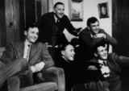
E. R. Cordner played two games of AFL football with the Melbourne Football Club in 1905 and is the father of Don Cordner (Brownlow Medalist 1946), Dennis Cordner, Ted Cordner and John Cordner who all played for Melbourne in the 1940s. Don and Ted also followed their father into medicine.
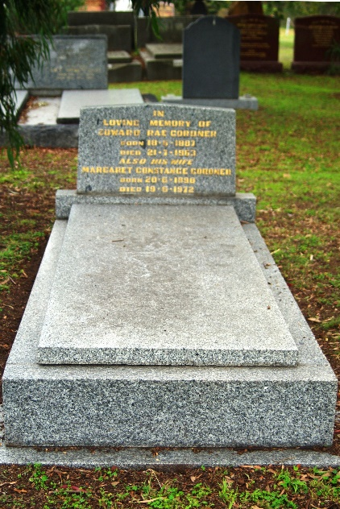
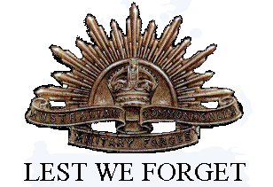
Edward Rae Cordner died in 1963 and is buried at St Katherine’s Cemetery St Helena.

