Hugh Norman Coventry

Service No. 3787

Rank: Private

Unit: 24th Battalion.

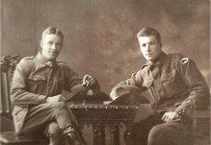Hugh Norman Coventry (Norm), who was known by the nickname ‘Oak’, was born in Greensborough in 1891, he was the 5th born child of William Henry Coventry and Jane Henrietta Spencer. At the time of his enlistment the family was living at Diamond Creek. He was 20 years and 7 months old and working as a Quarryman when he enlisted on 1st December 1915. According to family legend Hugh “was every bit as good a footballer as his two younger brothers, Syd and Gordon (Nuts) – and I guess that meant he was very good”.

Norm and Tom Coventry

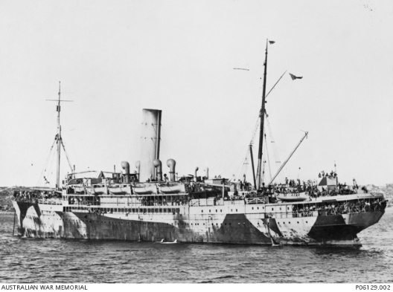After training he embarked on HMAT Warilda A69 on 8th February 1916 and landed in France. He was taken on strength in the 24th Battalion and saw active service on the Western Front in France.

Hugh named his father William Henry Coventry as his next of kin living in Diamond Creek. Hugh married Coral Clara Trawin in 1916, they had a son (Norman Arthur).

Sadly Hugh was killed in action on the 5th August, 1916, in France. Hugh’s two brothers also served in WW1 - John Thomas Coventry 172 and Thomas Coventry 3786, both returned to Australia.

Hugh Norman Coventry received the British War Medal, Victory Medal and Memorial Plaque.

He died while acting as a volunteer stretcher bearer and received an MID (Mention in Despatches) for this: “Gallant devotion to duty stretcher-bearer under heavy fire. (Pozieres)”.

A family story relates that “My Grandma, Ellen Emma (Nelly) always said that while the boys were away, you lived in fear of seeing the Vicar walking up the road towards your house. Unfortunately, the Vicar had to do just that to the Coventry’s one day in 1916.”

Hugh Coventry is commemorated on the Greensborough State School Honour Roll.

*Thanks to Bruce McDowell for family photo and anecdotes.*

*