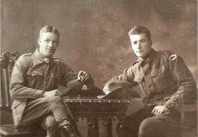
Thomas Coventry
Service No. 3786
Rank: Private
Unit: 24th Battalion
Thomas Coventry was born in Diamond Creek/ Greensborough in 1897, the son of William Henry Coventry and Jane Henrietta Spencer. At the time of his enlistment the family was living at Diamond Creek. Thomas named his father as next of kin.
Norm and Tom Coventry
He was 18 years and 5 months old and working as a labourer when he enlisted on 1st December 1915.
After training Tom embarked on HMAT Warilda A69 on 8th February 1916 and landed in France. He was taken on strength in the 24nd Battalion and saw active service on the Western Front in France.
In August 1916, Tom was wounded in action (left foot and arm).
He returned to Australia on the Delta on 3rd September 1919.
Tom Coventry received the British War Medal and the Victory Medal.
Thomas had two brothers also serving in World War I, John Thomas Coventry and Hugh Norman Coventry who was killed in action on 5th August 1916 at Pozieres.
Thomas is commemorated on the Greensborough Primary School Honor Board.
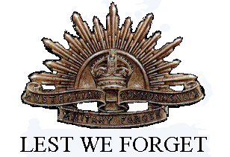
Thomas married Olyve Eagland in 1919, they had five children. They settled in Montmorency; Tom worked as a public servant and part-time orchardist. Coventry Street behind Montmorency Primary School was named after Tom.
Tom & Ollie moved to Kangaroo Flat, near Bendigo, in their final years.
Thomas passed away in 1970 and Olyve in 1979.

