Stephen Cox
Service No. 2443
Rank: Sapper
Unit: 2nd Tunneling Company
Stephen Cox was born in Long Gully near Bendigo in 1888, the son of William Cox and Winifred Cotton.
At the time of his enlistment on 10th December 1915 he was 27 years old and working as a miner. He gave his mother as next of kin.
He was transferred to the Mining Reinforcements and did his training at Langwarrin.
On 31st March 1916 he embarked on HMAT Star of Victoria A16 and was taken on strength of the 2nd Tunneling Company in France on 3rd September 1916.
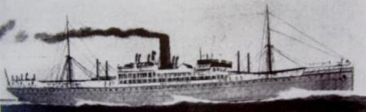
On 14th July 1917 he was injured accidently whilst unloading timber from a truck. He rejoined his unit on 10th August 1917. He was later hospitalised in England with synovitis (inflammation of the joints). He was back in France in February 1918. Six weeks later he was injured in another accident and hospitalised again.
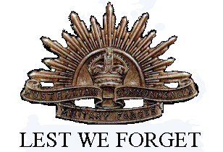
He spent most of 1918 in and out of hospitals before returning to the front in August where he received a gunshot wound to his left leg and foot. Stephen Cox was returned to Australia in 15th May 1919 on the Dunluce.
He was awarded the British War Medal and Victory Medal.
Stephen lived in St Helena in the inter-war years. He died at the Caulfield Repatriation Hospital in 1946 and is buried at St Helena Cemetery.

