Donald James Creighton

Service No. 5317

Rank: Lance Corporal

Unit: 21st Battalion

Donald James Creighton was born in Bundoora (near Preston) in 1893, the son of Timothy Creighton and Sarah Davey. His younger brothers John (born 1899) enlisted 1918 and Harold (born 1895) enlisted in 1916. At the time of Donald’s enlistment the family was living at Tungamah (Telford), Goulburn Valley.

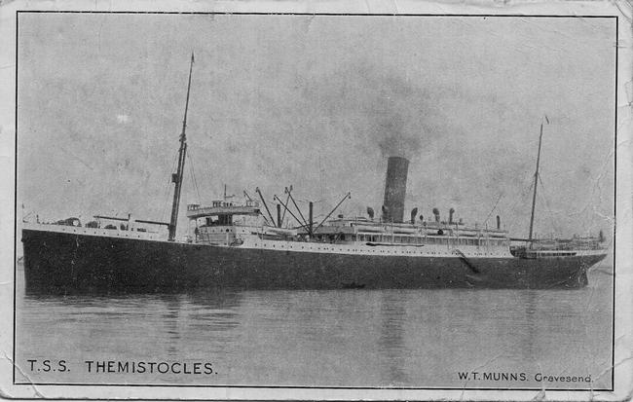He was 22 years old and working as a farm hand when he enlisted on 10th April 1916.

After training in Royal Park he travelled on HMAT Themistocles A32 and arrived at Plymouth on 11th September 1916. His brother Harald was on the same ship.

He completed his training in England and on 31st December 1916 he proceeded to France. Here he was transferred to the 21st Battalion on 26th January 1917. On 4th October 1917 he was wounded in action and admitted to the 64th Field Ambulance and then moved to the 24th General Hospital. He was evacuated to England on 13th October and admitted to the 2nd Southern General Hospital. He was suffering from a shrapnel wound to his right leg and back.

After recovering and being retrained, Donald rejoined the 21st Battalion on 13th February 1918 and was appointed Lance Corporal on 23rd May of that year.

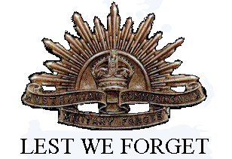Unfortunately, on 6th July he suffered a severe gunshot wound to his face and neck and once again invalided to England. When he was discharged from hospital for a month’s furlough ending on 15th September 1918. He reported back in September and after a brief period was granted another month’s furlough. This was repeated in November and on 4th January 1919 he sailed for Australia on the Morvada where he arrived at Melbourne on 20th February 1919. Donald was discharged as medically unfit on 19th May 1919.

He received the British War Medal and the Victory Medal.

Donald Creighton died in 1958 at Moorabbin.