Frederick Geoffrey Ely
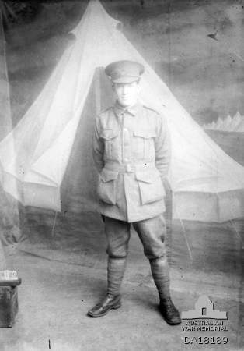
Service No. 4693
Rank: Private
Unit: 22nd Battalion & 2nd Division Salvage Company
Frederick Geoffrey Ely was born in Greensborough in 1890, the son of Frederick Ely and Elizabeth Poulter who had seven girls and five boys including Frederick. His next of kin was listed as his mother, Elizabeth Ely who was the daughter of Mary and William Poulter.
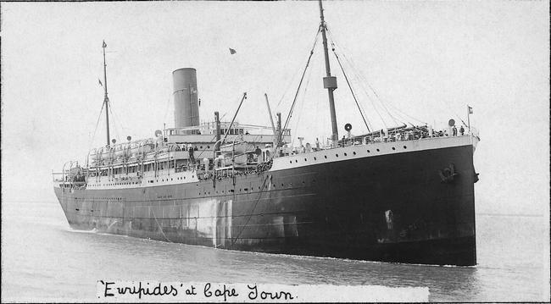
At the time of his enlistment the family was living at Main Road, Greensborough. Fred was 25 years old and working as a labourer when he enlisted on 22nd January 1916.
After training he embarked on HMAT Euripedes A14 on 4th April 1916 and landed in France. He was taken on strength in the 22nd Battalion and saw active service on the Western Front in France.

His war started with a damaged ankle for which he was hospitalised at Rollestone in July 1916. After release he went to France on 10th September 1916.
On 5th October 1916, he was taken on strength in the 22nd Battalion. Later that month he was hospitalised with diphtheria and tonsillitis until January 1917. On 24th January he was transferred to the 2nd Division Salvage Company. On the same day he was promoted to Lance Corporal.
In this unit he served in both France and Belgium. On 1st January 1918 he was appointed as Acting Corporal and on 15th January to Extra Regimental Corporal.
He served part of March 1918 with the 6th Infantry Brigade and rejoined his unit on 30th March.

Fred Ely returned to Australia on the Chemnitz on 5th September 1919 and was discharged on 28th October 1919.
He received the British War Medal and the Victory Medal.
Frederick Ely is commemorated on the Greensborough District Honor Board at the Greensborough RSL and Greensborough State School Honor Roll.
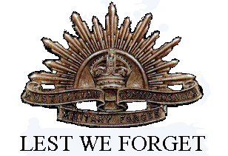
Frederick passed away 1968.

