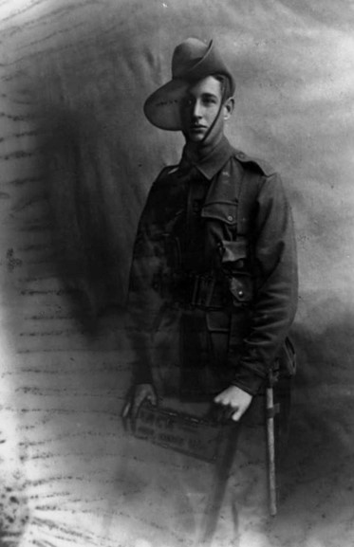John Granville Evans

Service No. 304

Rank: Private later promoted to Lieutenant

Unit: 1st Pioneers, 6th Battalion & 8th Battalion.

John Granville Evans was born in Albury NSW on 14th January 1896. He was the son of Tyrell George Evans and Clara Augusta Collins. John was working as a clerk at the time of his enlistment on 17th August 1914. He was aged 18 years 7 months. He gave his mother Clara Augusta Evans of 3 Highbury Grove, Kew as next of kin.

After his training he embarked on HMAT Hororata A20 on 5th April 1915 with the 6th Battalion, landed in Egypt in May 1915 and was attached to the Middle East Force (MEF).

On 25th April 1915 he was wounded in the right thigh at Gallipoli and hospitalised in the 15 AGH at Alexandria. On 5th July 1915 he rejoined his unit at Gallipoli.

On 14th September 1915 he was admitted to the 2nd Australian Stationery Hospital on Lemnos with tonsillitis and later with diphtheria. He returned to his unit again on 9th October 1915.

After the evacuation of Gallipoli by Australian Forces he served in Egypt until 26th March 1916 when embarked on the HMAT Ballarat for Marseilles and the Western Front where he arrived on 2nd April 1916.

On 10th March 1916 he was promoted to Sergeant and on 25th May 1916 he was transferred to the 1st Pioneer Battalion.

On 29th August 1917 he was transferred to the Cadet Training School in England and was appointed as a 2nd Lieutenant on 19th December 1917. On 12th January 1918 he was posted to the 8th Battalion in France and on 6th May 1918 was promoted to Lieutenant.

In June 1918 he attended Lewis Gun School and after this he served as an Intelligence and Lewis Gun Officer.

On 1st February 1919 he was awarded the Military Cross for gallantry and devotion to duty on 23rd August 1918 in the attack on Harleville Wood. “… *as intelligence and Lewis-gun officer. He maintained direction and kept in touch with the situation, pressing forward to the hottest part of the fighting to locate enemy guns. When many of our guns were put out of action he moved across the whole front under heavy fire, collecting and organizing guns and crews. When the battalion sector was subjected to gas shelling he reconnoitred for positions for the battalion where the concentration of fire was not so intense. He showed fine energy and resource.”* (Extract from Department of Defence notification of award).

John returned to Australia on the HMAT Euripides arriving on 7th September 1919 and was discharged on 19th December 1919.

He received the Military Cross, 1914/15 Star, British War Medal and the Victory Medal.

In Greensborough, John is commemorated on the Greensborough Primary School Honour Board.

In the post war period, he continued to serve as an Officer in the Australian Army rising to the rank of Major on 16th February 1930. He lived at 1 Chelsea St, Middle Brighton.

John passed away in 1959 at Brighton aged 62.