George Fineran
Service No. 2641
Rank: Corporal
Unit: 7th Battalion
George was born in Lucknow near Bairnsdale in 1880. He was the son of Patrick Fineran and Rebecca Roberts. He was living in Yan Yean Road, Plenty and working as an orchardist at the time of his enlistment on 2nd August 1915 and was aged 35 years 3 months. He gave his wife Beatrice Maud Fineran as next of kin.
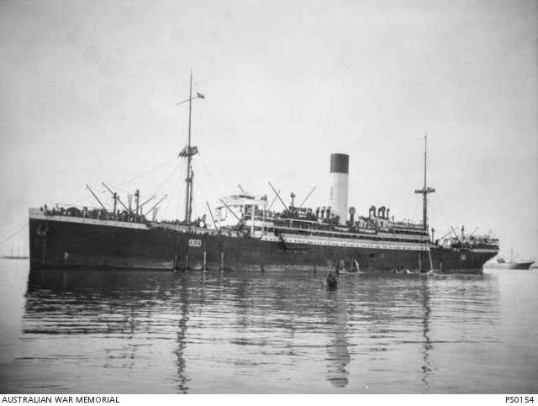
After training he embarked on HMAT Ulysses A38 on 27th October 1915 and landed in England in December 1915.
He commenced service in France on 24th June 1916 with the 7th Battalion.
On 25th July 1916 he was killed in action serving in France.
His widow received the 1914/15 Star, British War Medal, the Victory Medal and the Memorial Scroll & Plaque.
