Thomas John Finnigan
Service No. 29458
Rank: Farrier Sergeant
Unit: 118th Howitzer Battery/ 1st Australian Division Ammunition Column
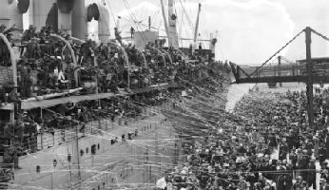
Thomas Finnigan was born in Belfast, Northern Ireland in 1889 and was trained as a farrier. He was a farrier at the time of his enlistment in Melbourne on 13th March 1916 and was aged 26 years 4 months. He gave his father Thomas Finnigan of Smithborough, County Monaghan as next of kin. He gave his address as in Port Melbourne but when he embarked it was recorded as Mont Park.
Initially Thomas was allocated to the 29th Battery in Australia’s 8th Field Artillery Brigade. Some time after starting training he became a member of the 118th Howitzer Battery and embarked with that unit on HMAT Aeneas A60 on 3rd October 1916 and landed in England on 19th November 1916.
After arrival in France on 10th January 1917 his unit was disbanded and the men reallocated. He commenced service in France on 12th January 1917 with the 1st Australian Division Ammunition Column with which he served for the rest of the war.
On 6th January 1919, he had a hernia operation in England.
Tom returned to Australia on the Port Darwin arriving on 27th July 1919. He was discharged on 3rd September 1919.
He received the British War Medal and the Victory Medal.
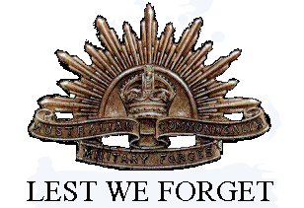
Tom worked as an attendant at Mont Park Hospital for many years after the War.
He passed away in 1951 at Mont Park aged 61.

