Thomas John Finnigan – The Missing Gunner
by John Gibson

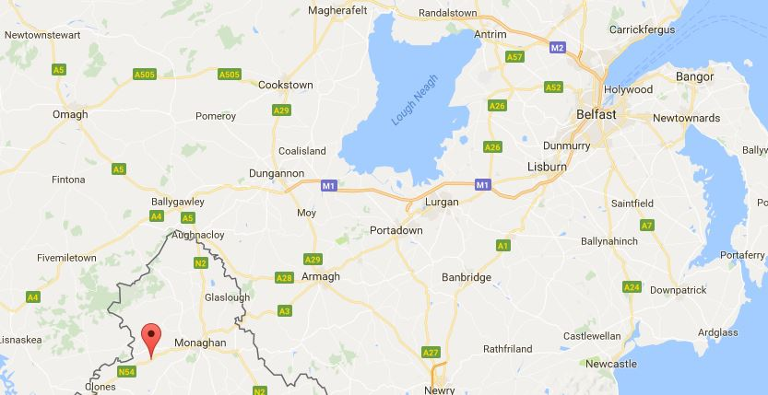
Tom was born in Belfast, Northern Ireland in late 1889. He was a farrier and was 26 years old when he enlisted in the Australian Imperial Force in Melbourne on 13 March 1916. Tom declared he was unmarried and recorded his father Thomas Finnigan of Smithborough, County Monaghan, Ireland as next of kin, though interestingly he first tried to state that Smithborough was in Victoria. In fact it was outside Ulster, 70 kilometres southwest of Belfast. He gave his address as in Port Melbourne, as though recently off a ship, but when he later embarked it was recorded as Mont Park. He was it seems a man with a few secrets.

Map showing Smithborough, in County Monaghan, in relation to Belfast

Initially Tom was allocated to the 29th Battery in Australia’s 8th Field Artillery Brigade. He was sent to Maribyrnong Camp in July and passed an examination in September to be promoted to Farrier Sergeant. At some point after starting training he became a member of the 118th Howitzer Battery, embarked with that unit on A60 HMAT Aeneas on 3 October 1916 and landed in England at Plymouth on 19 November 1916.

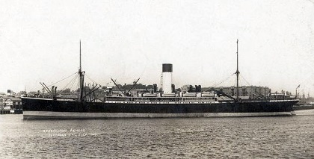

A60 HMAT Aeneas

The Australian War Memorial holds two photos of men of the 118th Howitzer Battery on the dock at Port Melbourne waiting to board the Aeneas. These two photos include about half of the unit, so there’s a good chance that Tom is in one of them.
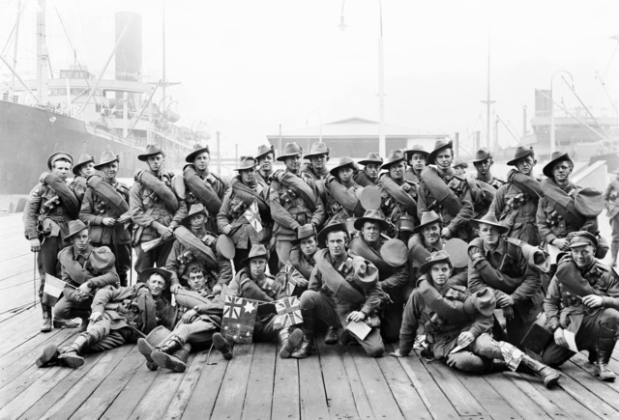
The Australian War Memorial’s photos of the 118th Howitzer Battery on 3 October 1916
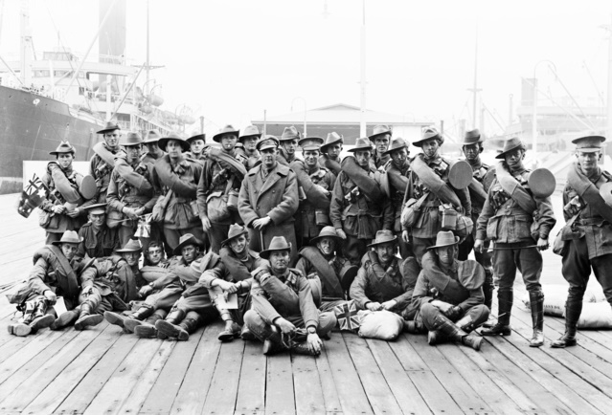
After arrival in France on 10 January 1917 his unit was disbanded and the men reallocated. Tom then commenced service in France on 12 January 1917 with the 1st Australian Division Ammunition Column (1ADAC) with which he served for the rest of the war.
The reason his unit was disbanded was that after the retreat from Gallipoli in December 1915, Australia had to completely reorganise its forces to accommodate the great influx of recruits that had been arriving in Egypt. We had only two infantry divisions at Gallipoli. Five were organised for the Western Front.
To provide enough guns to support these, the Australian divisional field artillery was reorganised between March and July 1916. Each division included four field artillery brigades, three of which comprised three batteries of 18 pounder quick firing field guns and one battery of 4.5” quick firing howitzers. The fourth comprised three batteries of 18 pounder quick firing field guns.

This great expansion resulted in 1916 in a total of 75 field artillery batteries within our five divisions. Initially we were critically short of trained artillerymen for these units, so it is no surprise that Tom and the men of his unit were reallocated to existing units on their arrival in France.
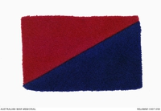
The 1st Division wore rectangular colour patches on their shoulders. Those of the artillery, including 1ADAC, were red obliquely over blue.

1ADAC colour patch

1ADAC consisted of a headquarters and three sections, and usually totalled around 700 men as can be seen by the report below from the unit’s commander in the month Tom arrived. It was tasked with keeping the 1st Division supplied with ammunition by horse drawn wagons and by pack animal.

As the only Farrier Sergeant of No.2 Section, Tom was responsible for the shoeing and condition of all the feet of No.2 Section’s then 272 horses by his six Shoeing Smiths. Every morning he and his men would have walked through the unit’s horse lines inspecting all hooves and shoes for damage. He was probably also required to conduct the humane dispatch of wounded or gravely sick horses.

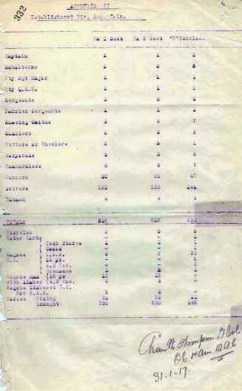
Extract from 1ADAC War Diary, January 1917

In January 1918 Tom enjoyed two weeks of leave in England before rejoining 1ADAC.

After the war had ended he went to England again on leave on 27 November, rejoining 1ADAC on Christmas Day. Six days later he was sent to hospital suffering from an inguinal hernia in the groin. On 6th January 1919, he was sent from France to Edmonton Special Military Surgical Hospital in England and duly had a hernia operation.

Having recovered, he was discharged from Edmonton on 24 March and granted another furlough. Tom finally left England on 12 June on the transport Port Darwin arriving in Australia on 27 July.

He was discharged from service on 3 September 1919 and went back to civilian life. After his hernia injury he was perhaps no longer fit to be a farrier and so ended up working as an attendant at Mont Park Mental Hospital.

That though isn’t quite the end of Tom’s story.

In September 1921 the Army’s Base Records in Melbourne received the following letter from Mrs Susan Finnigan in Belfast.

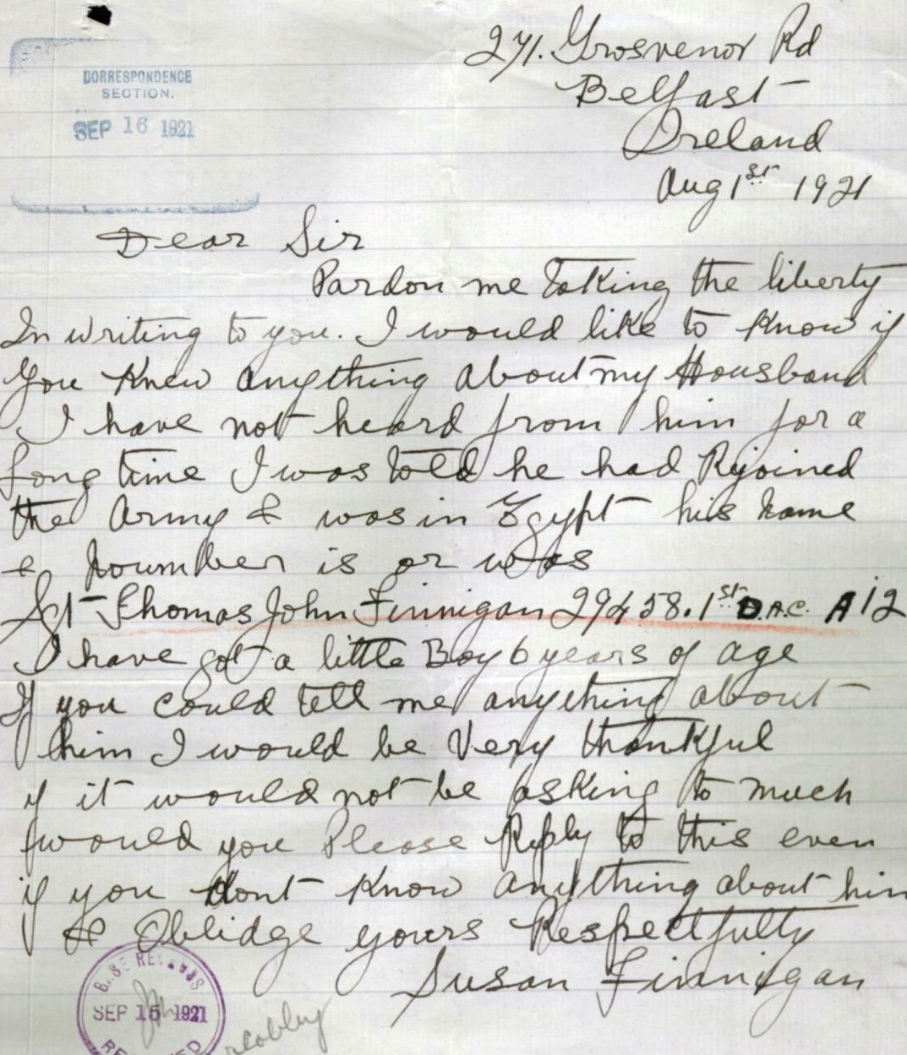

From this it seems likely that Tom took ship to Australia in early 1915 and abandoned his wife and future child soon after she became pregnant in Ireland. Having done this explains why on his enlistment in 1916 he had attempted to cover his tracks by initially incorrectly giving his father’s address as in Victoria. Base Records was quick to send poor Susan his Mont Park address but we don’t know what, if anything came of it.

Tom received the British War Medal and the Victory Medal, both together on 15 November 1922.

With the war long behind him, Thomas John Finnigan passed away in 1951 at Mont Park, aged 61.

We can only wonder whether the missing gunner who had begun in an artillery battery but transferred to another unit in 1917, and who had abandoned his fledgling family so long before, thought of them before he died.

References

Thomas John Finnigan (Service No. 29458) WW1 Service History

1st Australian Division Ammunition Column (4ADAC) War Diary 1917
Australian War Memorial & National Australian Archive websites

‘The Gunners – A History of Australian Artillery’ by David Horner, Allen & Unwin, Sydney 1995

Google maps

